UNITED STATES

SECURITIES AND EXCHANGE COMMISSION
Washington, D.C. 20549

SCHEDULE 14A

Proxy Statement Pursuant to |  | Section 14(a) of
the Securities Exchange Act of 1934 |  | (Amendment No. |  | )

Filed by the Registrant ☒

Filed by a Party other than the Registrant ☐

Check the appropriate box:

- Preliminary Proxy Statement

- Confidential, for Use of the Commission Only (as permitted by Rule 14a-6(e)(2))

☒ Definitive Proxy Statement

- Definitive Additional Materials

- Soliciting Material under §240.14a-12

CALIFORNIA RESOURCES CORPORATION

(Name of Registrant as Specified In Its Charter)

(Name of Person(s) Filing Proxy Statement, if other than the Registrant)

Payment of Filing Fee (Check all boxes that apply):

- No fee required.

- Fee paid previously with preliminary materials.

- Fee computed on table in exhibit required by Item 25(b) per Exchange Act Rules 14a-6(i)(1) and 0-11.



Proxy Statement 2024 and Notice of Annual Meeting A Different Kind of Energy Company California Resources Corporation



Letter to Shareholders from the Chair of the Board

Dear Shareholders,

During 2023 California Resources Corporation (NYSE: CRC) achieved robust financial results, saw strong performance from our conventional energy business, exercised discipline in our capital investments and materially advanced our carbon management business, Carbon TerraVault (CTV). Our strong results were recognized by the market with CRC’s common stock outperforming nearly all its peers, as well as the S&P 500 and the S&P Exploration and Production Index (XOP).

At all levels, we continue to prove that CRC is a different kind of energy company. We are leading the energy transition in California and, through CTV, we are providing innovative solutions to help California achieve its ambitious decarbonization goals. CRC is advantaged today with high-quality conventional energy assets and a growing carbon management business with proposed energy projects uniquely positioned near key markets.

Our solid operating results in 2023 drove exceptional financial performance. CRC generated $653 million of net cash from operating activities and $ 468 million of free cash flow¹. Net income was $564 million, or $7.78 per diluted share and adjusted net income¹ was $372 million, or $5.13 per diluted share. With better-than-expected performance from our reservoirs, our full-year average net production was 86 thousand barrels of oil equivalent per day (MBoe/d). Oil production averaged 52 thousand barrels of oil per day (MBo/d).

We took steps to enhance our future profitability and efforts to reduce general and administrative (G&A) and non-energy operating costs are paying dividends. Recent actions better align our resources with strategic priorities and improve operational efficiencies. These savings positively impacted our financial results late in the year and are sustainable. Going forward, we see approximately $65 million of sustainable annual savings in non-energy operating costs and G&A expenses.

Returning significant cash to shareholders is paramount to our investment proposition. Due to our high-quality asset base, we were able to fund this year’s $185 million capital program using less than half of our cash flow from operations. We returned $279 million to shareholders through share repurchases, debt repurchases and dividends.

The cornerstone of our carbon management business today is our proposed CTV Clean Energy Park at Elk Hills. Here, we have five active greenfield and brownfield CCS projects underway today. We are expecting the EPA’s issuance of California’s first Class VI well permits for our 26R reservoir later this year. This will allow us to move forward with other important projects totaling up to 655 thousand metric tons per year (KMTPA) of carbon dioxide (CO₂) injection. We are very encouraged by the market’s interest in our carbon management solutions and

look forward to reporting on our progress throughout the year.

The pages of this proxy highlight the importance of Sustainability, which comprises 30% of the annual incentive related to company performance. We achieved several key targets related to Environmental, Social and Governance initiatives in 2023:

- Advanced carbon management EPA Class VI permit applications totaling a combined 51 million metric tons (MMT) of CO₂ storage potential

- Announced new Carbon Development Management Agreements and projects totaling 860 KMTPA

- Eliminated 269 gas venting pneumatics, keeping CRC on track with its 2030 methane reduction ESG goal

- Delivered more than 113 million barrels of water for agricultural use, or more than 3 times the amount for CRC's internal use

- Abandoned and remediated more than 600 idle wells across the Company’s portfolio, exceeding stringent local and state requirements

- Achieved our second-best total recordable incident rate (TRIR) in the Company’s history or CRC’s best since the 2020 COVID period

CRC has an active and engaged Board of Directors and we have frequent dialogue with our shareholders to ensure our interests are aligned. Over the last year, we added new leadership to key roles within CRC, including the CEO. Francisco Leon, elevated from his prior role as Executive Vice President and Chief Financial Officer, led CRC’s talented workforce to achieve our strong results. In addition, Nelly Molina joined CRC as Executive Vice President and Chief Financial Officer, making CRC the sole publicly traded U.S. energy company with such inclusive leadership.

In closing, I want to mention the importance of our pending merger with Aera Energy, LLC, announced in February 2024. With the targeted deal close in the second half of 2024, CRC will be California’s leading energy company with the country’s most advanced carbon management platform, in our view. We will have the scale, assets, proven teams, and business model to unlock the significant value we see in our equity, while meeting today’s energy needs and helping decarbonize California.

Thanks for your investment in CRC.
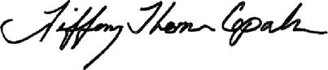

Tiffany (TJ) Thom Cepak

Independent Chair of the Board
California Resources Corporation

_________________________________________________________________________________________________

¹Represents a non-GAAP measure. For all historical non-GAAP financial measures please see the Investor Relations page at www.crc.com for a reconciliation to the nearest GAAP equivalent and other additional information. Free cash flow is equal to net cash provided (used) by operating activities less capital investments.

PLEASE NOTE: This letter and the Proxy Statement contain forward-looking statements that involve risks and uncertainties that could materially affect our expected results of operations, liquidity, cash flows and business prospects. For a discussion of these risks and uncertainties, please refer to the “Risk Factors” and “Forward-Looking Statements” described in our Annual Report on Form 10-K. Words such as “anticipate,” “believe,” “continue,” “could,” “estimate,”

“expect,” “goal,” “intend,” “likely,” “may,” “might,” “plan,” “potential,” “project,” “seek,” “should,” “target,” “will” or “would” and similar words that reflect the prospective nature of events or outcomes typically identify forward-looking statements. Such statements are based on management's expectations as of the date of this filing, unless an earlier date is specified, and involve many risks and uncertainties that could cause our actual results to differ materially from those expressed or implied in our forward-looking statements. Given these risks and uncertainties, readers are cautioned not to place undue reliance on such forward-looking statements. Readers are urged to carefully review and consider the various disclosures made in our Form 10-K and in other documents we file from time to time with the SEC that disclose risks and uncertainties that may affect our business. Any forward-looking statement speaks only as of the date on which such statement is made and we undertake no obligation and expressly disclaim any duty to correct or update any forward-looking statement, except as required by applicable law.

We have included in this letter and the Proxy Statement certain voluntary disclosures regarding our Sustainability Goals, Sustainability Reports and related matters because we believe these matters are of interest to our investors; however, we do not believe these disclosures are “material” as that concept is defined by or construed in accordance with the securities laws or any other laws of the U.S. or any other jurisdiction, or as that concept is used in the context of financial statements and financial reporting. These disclosures speak only as of the date on which they are made, and we undertake no obligation and expressly disclaim any duty to correct or update such disclosures, whether as a result of new information, future events or otherwise, except as required by applicable law. Additionally, please note that these disclosures are for information purposes only, and no environmental, social, or governance (“ESG”) or sustainability-related information found and/or provided in the Company’s Sustainability Reports or on the Company’s website in general is intended or deemed to be incorporated by reference in this Proxy Statement.

California Resources Corporation

1 World Trade Center, Suite 1500 | Long Beach | California 90831

California Resources Corporation

Notice of the 2024 Annual Meeting of Stockholders

Meeting Date:

May 3, 2024

Meeting Time:

11:00 a.m., Pacific Time

Location:

Virtual meeting at https://www.virtualshareholdermeeting.com/CRC2024

Record Date:

March 15, 2024

Purposes of the 2024 annual meeting of stockholders:

- To elect the nine director nominees named in this proxy statement, each to a one-year term;

- To ratify the appointment of KPMG LLP as our independent registered public accounting firm for the year ending December 31, 2024; and

- To hold an advisory vote to approve named executive officer compensation.

Information relevant to these matters is set forth in the accompanying proxy statement.

The close of business on March 15, 2024, was fixed as the record date for the determination of stockholders entitled to receive notice of and to vote at the annual meeting or any adjournment or postponement thereof. Only our stockholders of record or their legal proxy holders as of the record date or our invited guests may attend the annual meeting.

The annual meeting will be held in a virtual meeting format only at https://www.virtualshareholdermeeting.com/CRC2024. You will not be able to attend the annual meeting in person. If you wish to attend the annual meeting, you must follow the instructions under “Attending the Annual Meeting” on page 70 of the proxy statement. We have also provided information regarding how stockholders can engage during the annual meeting, including how they can vote, ask questions, request technical support and access information following the annual meeting within this proxy statement.

Beginning on March 22, 2024, we mailed a Notice of Internet Availability of Proxy Materials to our stockholders containing instructions on how to access the proxy statement and vote online and made our proxy materials available to our stockholders over the Internet.

By Order of the Board of Directors,
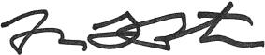

Michael L. Preston

Executive Vice President, Chief Strategy Officer and General Counsel
Corporate Secretary

IMPORTANT VOTING INFORMATION

If you owned shares of our common stock at the close of business on March 15, 2024, you are entitled to one vote per share upon each matter presented at our 2024 annual meeting of stockholders to be held on May 3, 2024. In order for stockholders whose shares were held in an account at a brokerage firm, bank or other nominee (i.e., in “street name”) as of March 15, 2024, to vote their shares at the 2024 annual meeting, they will need to obtain a legal proxy from the broker, bank or other nominee that holds their shares authorizing them to vote at the annual meeting.

If you hold shares in “street name,” unless you provide specific instructions by completing and returning the voting instruction form or following the instructions provided to you to vote your shares via telephone or the Internet, your broker is only permitted to vote on your behalf on ratification of the appointment of KPMG LLP as our independent registered public accounting firm for fiscal year 2024, and may not vote on the election of directors and other matters to be considered at the annual meeting. For your vote to be recognized, you will need to communicate your voting decisions to your broker, bank or other nominee before the date of the annual meeting.

YOUR VOTE IS IMPORTANT

Your vote is important. Our Board of Directors strongly encourages you to exercise your right to vote. Voting early helps ensure that we receive a quorum of shares necessary to hold the annual meeting.

QUESTIONS

If you have any questions about the proxy voting process, please contact Broadridge at (800) 579-1639. The Securities and Exchange Commission also has a website (https://www.sec.gov/spotlight/proxymatters) with more information about your rights as a stockholder. You also may contact our Investor Relations Department by phone at (818) 661-3731 or by e-mail at IR@crc.com.

ATTENDING THE ANNUAL MEETING

The annual meeting will be held in a virtual meeting format only at https://www.virtualshareholdermeeting.com/CRC2024. You will not be able to attend the annual meeting in person. If you wish to attend the annual meeting, you must follow the instructions under “Attending the Annual Meeting” on page 70 of the proxy statement.

IMPORTANT NOTICE REGARDING THE INTERNET AVAILABILITY OF PROXY MATERIALS FOR THE STOCKHOLDER MEETING TO BE HELD ON MAY 3, 2024

The Notice of the 2024 Annual Meeting of Stockholders, the Proxy Statement for the 2024 Annual Meeting of Stockholders and the 2023 Annual Report to Stockholders (which includes the Annual Report on Form 10-K for the fiscal year ended December 31, 2023) of California Resources Corporation are available at http://www.proxyvote.com. You will need the 16-digit control number included on the Notice that was mailed to you, on your proxy card or on the instructions that accompanied your proxy materials.

 |  |  |  |  |  |  |  |  |  |  |  |  |  |  |  | 2024 PROXY STATEMENT
Table Of Contents
Table of Contents
 | Notice of the 2024 Annual Meeting of Stockholders
 | Proxy Statement Summary |  |  |  |  |  |  |  |  |  |  |  |  |  |  |  |  |  |  |  |  |  |  |  |  |  |  |  |  |  |  |  |  |  |  |  |  |  |  |  |  |  |  |  |  |  |  |  |  |  |  |  |  |  |  | 1
 | Board of Directors and Corporate Governance |  |  |  |  |  |  |  |  |  |  |  |  |  |  |  |  |  |  |  |  |  |  |  |  |  |  |  |  |  |  |  |  |  |  |  |  |  |  |  |  |  |  |  |  |  |  |  |  |  |  |  |  |  |  | 5
 |  | Our Board of Directors and Director Nominees |  |  |  |  |  |  |  |  |  |  |  |  |  |  |  |  |  |  |  |  |  |  |  |  |  |  |  |  |  |  |  |  |  |  |  |  |  |  |  |  |  |  |  |  |  |  |  |  |  |  |  |  |  | 5
 |  | Board Refreshment and Evaluation |  |  |  |  |  |  |  |  |  |  |  |  |  |  |  |  |  |  |  |  |  |  |  |  |  |  |  |  |  |  |  |  |  |  |  |  |  |  |  |  |  |  |  |  |  |  |  |  |  |  |  |  |  | 13
 |  |  |  |  | Identifying and Evaluating Nominees for Director |  |  |  |  |  |  |  |  |  |  |  |  |  |  |  |  |  |  |  |  |  |  |  |  |  |  |  |  |  |  |  |  |  |  |  |  |  |  |  |  |  |  |  |  |  |  |  |  |  |  | 13
 |  |  |  |  | Director Criteria, Qualifications and Experience |  |  |  |  |  |  |  |  |  |  |  |  |  |  |  |  |  |  |  |  |  |  |  |  |  |  |  |  |  |  |  |  |  |  |  |  |  |  |  |  |  |  |  |  |  |  |  |  |  |  | 13
 |  |  |  |  | Overboarding Policy |  |  |  |  |  |  |  |  |  |  |  |  |  |  |  |  |  |  |  |  |  |  |  |  |  |  |  |  |  |  |  |  |  |  |  |  |  |  |  |  |  |  |  |  |  |  |  |  |  |  | 13
 |  |  |  |  | Board Diversity |  |  |  |  |  |  |  |  |  |  |  |  |  |  |  |  |  |  |  |  |  |  |  |  |  |  |  |  |  |  |  |  |  |  |  |  |  |  |  |  |  |  |  |  |  |  |  |  |  |  | 14
 |  |  |  |  | Board Evaluations and Incumbent Directors |  |  |  |  |  |  |  |  |  |  |  |  |  |  |  |  |  |  |  |  |  |  |  |  |  |  |  |  |  |  |  |  |  |  |  |  |  |  |  |  |  |  |  |  |  |  |  |  |  |  | 14
 |  |  |  |  | Board Education |  |  |  |  |  |  |  |  |  |  |  |  |  |  |  |  |  |  |  |  |  |  |  |  |  |  |  |  |  |  |  |  |  |  |  |  |  |  |  |  |  |  |  |  |  |  |  |  |  |  | 14
 |  |  | Director Independence Determinations |  |  |  |  |  |  |  |  |  |  |  |  |  |  |  |  |  |  |  |  |  |  |  |  |  |  |  |  |  |  |  |  |  |  |  |  |  |  |  |  |  |  |  |  |  |  |  |  |  |  |  |  | 14
 |  |  | Board Leadership Structure and Committees |  |  |  |  |  |  |  |  |  |  |  |  |  |  |  |  |  |  |  |  |  |  |  |  |  |  |  |  |  |  |  |  |  |  |  |  |  |  |  |  |  |  |  |  |  |  |  |  |  |  |  |  | 15
 |  |  |  |  | Chair |  |  |  |  |  |  |  |  |  |  |  |  |  |  |  |  |  |  |  |  |  |  |  |  |  |  |  |  |  |  |  |  |  |  |  |  |  |  |  |  |  |  |  |  |  |  |  |  |  |  | 15
 |  |  |  |  | Board Meetings and Attendance |  |  |  |  |  |  |  |  |  |  |  |  |  |  |  |  |  |  |  |  |  |  |  |  |  |  |  |  |  |  |  |  |  |  |  |  |  |  |  |  |  |  |  |  |  |  |  |  |  |  | 15
 |  |  |  |  | Executive Sessions of the Board |  |  |  |  |  |  |  |  |  |  |  |  |  |  |  |  |  |  |  |  |  |  |  |  |  |  |  |  |  |  |  |  |  |  |  |  |  |  |  |  |  |  |  |  |  |  |  |  |  |  | 15
 |  |  |  |  | Committees of the Board |  |  |  |  |  |  |  |  |  |  |  |  |  |  |  |  |  |  |  |  |  |  |  |  |  |  |  |  |  |  |  |  |  |  |  |  |  |  |  |  |  |  |  |  |  |  |  |  |  |  | 15
 |  |  |  |  | CTV Holdings Board of Directors |  |  |  |  |  |  |  |  |  |  |  |  |  |  |  |  |  |  |  |  |  |  |  |  |  |  |  |  |  |  |  |  |  |  |  |  |  |  |  |  |  |  |  |  |  |  |  |  |  |  | 18
 |  | The Board’s Role in Risk Oversight |  |  |  |  |  |  |  |  |  |  |  |  |  |  |  |  |  |  |  |  |  |  |  |  |  |  |  |  |  |  |  |  |  |  |  |  |  |  |  |  |  |  |  |  |  |  |  |  |  |  |  |  |  | 19
 |  | Compensation Committee Interlocks and Insider Participation |  |  |  |  |  |  |  |  |  |  |  |  |  |  |  |  |  |  |  |  |  |  |  |  |  |  |  |  |  |  |  |  |  |  |  |  |  |  |  |  |  |  |  |  |  |  |  |  |  |  |  |  |  | 20
 |  | Communications with Directors |  |  |  |  |  |  |  |  |  |  |  |  |  |  |  |  |  |  |  |  |  |  |  |  |  |  |  |  |  |  |  |  |  |  |  |  |  |  |  |  |  |  |  |  |  |  |  |  |  |  |  |  |  | 20
 |  | Availability of Corporate Governance Documents |  |  |  |  |  |  |  |  |  |  |  |  |  |  |  |  |  |  |  |  |  |  |  |  |  |  |  |  |  |  |  |  |  |  |  |  |  |  |  |  |  |  |  |  |  |  |  |  |  |  |  |  |  | 20
 |  | Certain Relationships and Related Transactions |  |  |  |  |  |  |  |  |  |  |  |  |  |  |  |  |  |  |  |  |  |  |  |  |  |  |  |  |  |  |  |  |  |  |  |  |  |  |  |  |  |  |  |  |  |  |  |  |  |  |  |  |  | 20
 |  |  |  |  | Policies and Procedures |  |  |  |  |  |  |  |  |  |  |  |  |  |  |  |  |  |  |  |  |  |  |  |  |  |  |  |  |  |  |  |  |  |  |  |  |  |  |  |  |  |  |  |  |  |  |  |  |  |  | 20
 |  |  |  |  | Related Party Transactions |  |  |  |  |  |  |  |  |  |  |  |  |  |  |  |  |  |  |  |  |  |  |  |  |  |  |  |  |  |  |  |  |  |  |  |  |  |  |  |  |  |  |  |  |  |  |  |  |  |  | 21
 | Environment, Social and Governance Goals |  |  |  |  |  |  |  |  |  |  |  |  |  |  |  |  |  |  |  |  |  |  |  |  |  |  |  |  |  |  |  |  |  |  |  |  |  |  |  |  |  |  |  |  |  |  |  |  |  |  |  |  |  |  | 22
 | Audit Committee Report |  |  |  |  |  |  |  |  |  |  |  |  |  |  |  |  |  |  |  |  |  |  |  |  |  |  |  |  |  |  |  |  |  |  |  |  |  |  |  |  |  |  |  |  |  |  |  |  |  |  |  |  |  |  | 23
 | Compensation Discussion and Analysis |  |  |  |  |  |  |  |  |  |  |  |  |  |  |  |  |  |  |  |  |  |  |  |  |  |  |  |  |  |  |  |  |  |  |  |  |  |  |  |  |  |  |  |  |  |  |  |  |  |  |  |  |  |  | 24
 |  | Compensation Objectives and Process |  |  |  |  |  |  |  |  |  |  |  |  |  |  |  |  |  |  |  |  |  |  |  |  |  |  |  |  |  |  |  |  |  |  |  |  |  |  |  |  |  |  |  |  |  |  |  |  |  |  |  |  |  | 25
 |  |  |  |  | Executive Compensation Objectives |  |  |  |  |  |  |  |  |  |  |  |  |  |  |  |  |  |  |  |  |  |  |  |  |  |  |  |  |  |  |  |  |  |  |  |  |  |  |  |  |  |  |  |  |  |  |  |  |  |  | 25
 |  |  |  |  | Compensation Program Best Practices |  |  |  |  |  |  |  |  |  |  |  |  |  |  |  |  |  |  |  |  |  |  |  |  |  |  |  |  |  |  |  |  |  |  |  |  |  |  |  |  |  |  |  |  |  |  |  |  |  |  | 25
 |  |  |  |  | Role of Compensation Committee |  |  |  |  |  |  |  |  |  |  |  |  |  |  |  |  |  |  |  |  |  |  |  |  |  |  |  |  |  |  |  |  |  |  |  |  |  |  |  |  |  |  |  |  |  |  |  |  |  |  | 26
 |  |  |  |  | Role of Management |  |  |  |  |  |  |  |  |  |  |  |  |  |  |  |  |  |  |  |  |  |  |  |  |  |  |  |  |  |  |  |  |  |  |  |  |  |  |  |  |  |  |  |  |  |  |  |  |  |  | 26
 |  |  |  |  | Role of Independent Compensation Consultants |  |  |  |  |  |  |  |  |  |  |  |  |  |  |  |  |  |  |  |  |  |  |  |  |  |  |  |  |  |  |  |  |  |  |  |  |  |  |  |  |  |  |  |  |  |  |  |  |  |  | 26
 |  |  |  |  | Use of Compensation Data |  |  |  |  |  |  |  |  |  |  |  |  |  |  |  |  |  |  |  |  |  |  |  |  |  |  |  |  |  |  |  |  |  |  |  |  |  |  |  |  |  |  |  |  |  |  |  |  |  |  | 26
 |  |  |  |  | Stockholder Outreach |  |  |  |  |  |  |  |  |  |  |  |  |  |  |  |  |  |  |  |  |  |  |  |  |  |  |  |  |  |  |  |  |  |  |  |  |  |  |  |  |  |  |  |  |  |  |  |  |  |  | 27
 |  | Stockholder Approval of Executive Compensation |  |  |  |  |  |  |  |  |  |  |  |  |  |  |  |  |  |  |  |  |  |  |  |  |  |  |  |  |  |  |  |  |  |  |  |  |  |  |  |  |  |  |  |  |  |  |  |  |  |  |  |  |  | 27
 |  | 2023 Compensation Program |  |  |  |  |  |  |  |  |  |  |  |  |  |  |  |  |  |  |  |  |  |  |  |  |  |  |  |  |  |  |  |  |  |  |  |  |  |  |  |  |  |  |  |  |  |  |  |  |  |  |  |  |  | 27
 |  |  |  |  | Benefits |  |  |  |  |  |  |  |  |  |  |  |  |  |  |  |  |  |  |  |  |  |  |  |  |  |  |  |  |  |  |  |  |  |  |  |  |  |  |  |  |  |  |  |  |  |  |  |  |  |  | 39
 |  |  |  |  | 2024 Compensation Program Actions |  |  |  |  |  |  |  |  |  |  |  |  |  |  |  |  |  |  |  |  |  |  |  |  |  |  |  |  |  |  |  |  |  |  |  |  |  |  |  |  |  |  |  |  |  |  |  |  |  |  | 41
 |  | Other Compensation Matters |  |  |  |  |  |  |  |  |  |  |  |  |  |  |  |  |  |  |  |  |  |  |  |  |  |  |  |  |  |  |  |  |  |  |  |  |  |  |  |  |  |  |  |  |  |  |  |  |  |  |  |  |  | 41
 |  |  |  |  | Stock Ownership Guidelines |  |  |  |  |  |  |  |  |  |  |  |  |  |  |  |  |  |  |  |  |  |  |  |  |  |  |  |  |  |  |  |  |  |  |  |  |  |  |  |  |  |  |  |  |  |  |  |  |  |  | 41
 |  |  |  |  | Clawback Policies |  |  |  |  |  |  |  |  |  |  |  |  |  |  |  |  |  |  |  |  |  |  |  |  |  |  |  |  |  |  |  |  |  |  |  |  |  |  |  |  |  |  |  |  |  |  |  |  |  |  | 41
 |  |  |  |  | Anti-Hedging and Anti-Pledging Policy |  |  |  |  |  |  |  |  |  |  |  |  |  |  |  |  |  |  |  |  |  |  |  |  |  |  |  |  |  |  |  |  |  |  |  |  |  |  |  |  |  |  |  |  |  |  |  |  |  |  | 41
 |  |  |  |  | Compensation Risk Management |  |  |  |  |  |  |  |  |  |  |  |  |  |  |  |  |  |  |  |  |  |  |  |  |  |  |  |  |  |  |  |  |  |  |  |  |  |  |  |  |  |  |  |  |  |  |  |  |  |  | 42
 |  |  |  |  | Tax Considerations |  |  |  |  |  |  |  |  |  |  |  |  |  |  |  |  |  |  |  |  |  |  |  |  |  |  |  |  |  |  |  |  |  |  |  |  |  |  |  |  |  |  |  |  |  |  |  |  |  |  | 42
 | Compensation Committee Report |  |  |  |  |  |  |  |  |  |  |  |  |  |  |  |  |  |  |  |  |  |  |  |  |  |  |  |  |  |  |  |  |  |  |  |  |  |  |  |  |  |  |  |  |  |  |  |  |  |  |  |  |  |  | 43
 | Executive Compensation Tables |  |  |  |  |  |  |  |  |  |  |  |  |  |  |  |  |  |  |  |  |  |  |  |  |  |  |  |  |  |  |  |  |  |  |  |  |  |  |  |  |  |  |  |  |  |  |  |  |  |  |  |  |  |  | 44
 |  |  |  | Summary Compensation Table |  |  |  |  |  |  |  |  |  |  |  |  |  |  |  |  |  |  |  |  |  |  |  |  |  |  |  |  |  |  |  |  |  |  |  |  |  |  |  |  |  |  |  |  |  |  |  |  |  |  |  | 44
 |  |  |  | Grants of Plan-Based Awards |  |  |  |  |  |  |  |  |  |  |  |  |  |  |  |  |  |  |  |  |  |  |  |  |  |  |  |  |  |  |  |  |  |  |  |  |  |  |  |  |  |  |  |  |  |  |  |  |  |  |  | 46
 |  |  |  | Narrative Disclosure to Summary Compensation Table and Grants of Plan-Based Awards Table |  |  |  |  |  |  |  |  |  |  |  |  |  |  |  |  |  |  |  |  |  |  |  |  |  |  |  |  |  |  |  |  |  |  |  |  |  |  |  |  |  |  |  |  |  |  |  |  |  |  |  | 47
 |  |  |  | Outstanding Equity Awards at December 31, 2023 |  |  |  |  |  |  |  |  |  |  |  |  |  |  |  |  |  |  |  |  |  |  |  |  |  |  |  |  |  |  |  |  |  |  |  |  |  |  |  |  |  |  |  |  |  |  |  |  |  |  |  | 48
 |  |  |  | Option Exercises and Stock Vested in 2023 |  |  |  |  |  |  |  |  |  |  |  |  |  |  |  |  |  |  |  |  |  |  |  |  |  |  |  |  |  |  |  |  |  |  |  |  |  |  |  |  |  |  |  |  |  |  |  |  |  |  |  | 49
 |  |  |  | 2023 Nonqualified Deferred Compensation Table |  |  |  |  |  |  |  |  |  |  |  |  |  |  |  |  |  |  |  |  |  |  |  |  |  |  |  |  |  |  |  |  |  |  |  |  |  |  |  |  |  |  |  |  |  |  |  |  |  |  |  | 49
 |  |  |  | Potential Payments upon Termination or Change in Control |  |  |  |  |  |  |  |  |  |  |  |  |  |  |  |  |  |  |  |  |  |  |  |  |  |  |  |  |  |  |  |  |  |  |  |  |  |  |  |  |  |  |  |  |  |  |  |  |  |  |  | 50
 |  |  |  | CEO Pay Ratio |  |  |  |  |  |  |  |  |  |  |  |  |  |  |  |  |  |  |  |  |  |  |  |  |  |  |  |  |  |  |  |  |  |  |  |  |  |  |  |  |  |  |  |  |  |  |  |  |  |  |  | 56
 |  |  |  | Pay Versus Performance Disclosures |  |  |  |  |  |  |  |  |  |  |  |  |  |  |  |  |  |  |  |  |  |  |  |  |  |  |  |  |  |  |  |  |  |  |  |  |  |  |  |  |  |  |  |  |  |  |  |  |  |  |  | 57
 | Director Compensation |  |  |  |  |  |  |  |  |  |  |  |  |  |  |  |  |  |  |  |  |  |  |  |  |  |  |  |  |  |  |  |  |  |  |  |  |  |  |  |  |  |  |  |  |  |  |  |  |  |  |  |  |  |  | 61
 |  | Program Objectives |  |  |  |  |  |  |  |  |  |  |  |  |  |  |  |  |  |  |  |  |  |  |  |  |  |  |  |  |  |  |  |  |  |  |  |  |  |  |  |  |  |  |  |  |  |  |  |  |  |  |  |  |  | 61
 |  | Program Elements |  |  |  |  |  |  |  |  |  |  |  |  |  |  |  |  |  |  |  |  |  |  |  |  |  |  |  |  |  |  |  |  |  |  |  |  |  |  |  |  |  |  |  |  |  |  |  |  |  |  |  |  |  | 61
 |  | 2023 Compensation of Directors |  |  |  |  |  |  |  |  |  |  |  |  |  |  |  |  |  |  |  |  |  |  |  |  |  |  |  |  |  |  |  |  |  |  |  |  |  |  |  |  |  |  |  |  |  |  |  |  |  |  |  |  |  | 62

CALIFORNIA RESOURCES CORPORATION i

 |  |  |  |  |  |  |  |  |  |  |  |  |  |  |  |  |  |  |  |  |  |  | 2024 PROXY STATEMENT
 |  |  |  |  |  |  |  |  |  |  |  |  |  |  |  |  |  |  |  |  |  |  | Table Of Contents
 | Stock Ownership Information |  |  |  |  |  |  |  |  |  |  |  |  |  |  |  |  |  |  |  |  |  | 63
 |  | Security Ownership of Directors, Management and Certain Beneficial Holders |  |  |  |  |  |  |  |  |  |  |  |  |  |  |  |  |  |  |  |  | 63
 | Proposals Requiring Your Vote |  |  |  |  |  |  |  |  |  |  |  |  |  |  |  |  |  |  |  |  |  | 65
 |  | Proposal 1: Election of Directors |  |  |  |  |  |  |  |  |  |  |  |  |  |  |  |  |  |  |  |  | 65
 |  | Proposal 2: Ratification of the Appointment of the Independent Registered Public Accounting Firm |  |  |  |  |  |  |  |  |  |  |  |  |  |  |  |  |  |  |  |  | 65
 |  | Proposal 3: Advisory Vote to Approve Named Executive Officer Compensation |  |  |  |  |  |  |  |  |  |  |  |  |  |  |  |  |  |  |  |  | 66
 | General Information |  |  |  |  |  |  |  |  |  |  |  |  |  |  |  |  |  |  |  |  |  | 67
 |  | Voting Procedures |  |  |  |  |  |  |  |  |  |  |  |  |  |  |  |  |  |  |  |  | 67
 |  |  | Record Date |  |  |  |  |  |  |  |  |  |  |  |  |  |  |  |  |  |  |  | 67
 |  |  | Appointment of Proxy Holders |  |  |  |  |  |  |  |  |  |  |  |  |  |  |  |  |  |  |  | 67
 |  |  | Quorum and Discretionary Authority |  |  |  |  |  |  |  |  |  |  |  |  |  |  |  |  |  |  |  | 67
 |  |  | How to Vote Shares Registered in Your Name |  |  |  |  |  |  |  |  |  |  |  |  |  |  |  |  |  |  |  | 68
 |  |  | How to Vote Shares Held in “Street Name” |  |  |  |  |  |  |  |  |  |  |  |  |  |  |  |  |  |  |  | 68
 |  |  | Revoking or Changing a Proxy |  |  |  |  |  |  |  |  |  |  |  |  |  |  |  |  |  |  |  | 69
 |  |  | Required Vote and Method of Counting |  |  |  |  |  |  |  |  |  |  |  |  |  |  |  |  |  |  |  | 69
 |  |  | Method and Cost of Soliciting and Tabulating Votes |  |  |  |  |  |  |  |  |  |  |  |  |  |  |  |  |  |  |  | 70
 |  |  | Attending the Annual Meeting |  |  |  |  |  |  |  |  |  |  |  |  |  |  |  |  |  |  |  | 70
 |  | Notice of Internet Availability of Proxy Materials |  |  |  |  |  |  |  |  |  |  |  |  |  |  |  |  |  |  |  |  | 71
 |  | Stockholder Proposals and Director Nominations |  |  |  |  |  |  |  |  |  |  |  |  |  |  |  |  |  |  |  |  | 72
 |  | Householding of Proxy Materials |  |  |  |  |  |  |  |  |  |  |  |  |  |  |  |  |  |  |  |  | 72
 |  | 2023 Annual Report |  |  |  |  |  |  |  |  |  |  |  |  |  |  |  |  |  |  |  |  | 73
 | Annex A – Reconciliation of Non-GAAP Measures |  |  |  |  |  |  |  |  |  |  |  |  |  |  |  |  |  |  |  |  |  | A-1

CALIFORNIA RESOURCES CORPORATION ii

2024 PROXY STATEMENT

Proxy Statement Summary

Proxy Statement Summary

This summary highlights information contained in the proxy statement. This summary does not contain all of the information you should consider, and you should read the entire proxy statement carefully before voting. California Resources Corporation, together with its subsidiaries, is referred to herein as “we,” “our,” “us,” the “Company” or “CRC.” The 2024 annual meeting of stockholders described below is referred to herein as the “Annual Meeting.”

2024 Annual Meeting of Stockholders

Date: May 3, 2024

Time: 11:00 a.m., Pacific Time

Place: Virtual meeting at https://www.virtualshareholdermeeting.com/CRC2024

Record Date: March 15, 2024

The Annual Meeting will be held in a virtual meeting format only at https://www.virtualshareholdermeeting.com/CRC2024. You will not be able to attend the Annual Meeting in person. If you wish to attend the Annual Meeting, you must follow the instructions under “Attending the Annual Meeting” below.

A Notice of Internet Availability of Proxy Materials, which contains instructions on how to access the proxy statement and vote online, was mailed to our stockholders beginning on March 22, 2024, and also made available to our stockholders over the Internet on the same date.

Agenda and the Board’s Recommendation on Voting Matters

The following table summarizes the items that will be brought for a vote of our stockholders at the Annual Meeting, along with the recommendation of our Board of Directors as to how stockholders should vote on each item.

Agenda |  | Board’s
Item | Description | Recommendation


1. | Proposal 1 | Election of the nine director nominees named in this proxy statement each
 |  | for a one-year term
2. | Proposal 2 | Ratification of the appointment of KPMG LLP as our independent registered
 |  | public accounting firm for 2024
3. | Proposal 3 | Advisory vote to approve named executive officer compensation

FOR EACH NOMINEE

FOR

FOR

Voting: Stockholders as of the record date are entitled to vote. Each share of common stock entitles its holder to one vote for each director nominee and one vote for each of the proposals to be voted on.

CALIFORNIA RESOURCES CORPORATION 1

2024 PROXY STATEMENT

Proxy Statement Summary

Directors

The Board of Directors is currently comprised of seven independent directors, plus Mr. McFarland and Mr. Leon. Each of our independent directors, other than Mr. Quintana, and Mr. McFarland and Mr. Leon will stand for re-election at our Annual Meeting. Mr. Kendall will also stand for election at the Annual Meeting. Assuming each of our nominees is elected, the Board of Directors will continue to be comprised of seven independent directors, plus Mr. McFarland and Mr. Leon, following the Annual Meeting. The following table provides summary information about each of our current directors and director nominees and whether the Board of Directors considers each of them to be independent under the New York Stock Exchange’s (“NYSE”) independence standards.

 |  |  |  | Director |  |  | Committees
 |  |  |  | Director |  |  |  | Nominating &
Director/Director Nominees | Positions | Age | Independent | Since | Audit | Compensation | Finance | Governance | Sustainability
Andrew B. Bremner |  | 33 | Yes | 2021 |  | ● | ● |  | ●
Tiffany (TJ) Thom Cepak | Chair | 51 | Yes | 2020 |  |  | ●
James N. Chapman |  | 61 | Yes | 2020 |  | Chair | Chair
Christian S. Kendall |  | 57 | Yes | N/A
Francisco J. Leon | President & CEO | 47 | No | 2023
Mark A. (Mac) McFarland |  | 54 | No | 2020
Nicole Neeman Brady |  | 43 | Yes | 2021 |  | ● |  |  | ●
Julio M. Quintana * |  | 64 | Yes | 2020 | ● |  |  | Chair
William B. Roby |  | 64 | Yes | 2020 | ● |  |  | ● | Chair
Alejandra (Ale) Veltmann |  | 56 | Yes | 2021 | Chair |  |  | ●

- Mr. Quintana is not standing for reelection, and his term will expire at the Annual Meeting. Mr. Quintana's decision not to stand for reelection was not due to any disagreements with the Company on any matter regarding its operations, policies or practices.

Corporate Governance Highlights

Majority voting. In 2022, the Board submitted for approval, and the stockholders approved, proposals to amend the Company’s Certificate of Incorporation to reduce the prior supermajority voting thresholds to majority thresholds.

7 out of 9 Board members are independent. The Board has determined 7 out of 9 current Board members, and 7 out of 9 director nominees, are independent within the meaning of NYSE listing standards.

Anti-Hedging and Anti-Pledging Policy. In response to feedback in prior years, our Insider Trading Policy specifically prohibits the hedging or pledging of our securities.

Overboarding Policy. We maintain a policy to restrict directors from serving on more than three other public company boards without approval.

Clawback Policy. We maintain a comprehensive, standalone policy that covers cash, equity, equity-based and other awards under our incentive compensation programs.

Board is not classified. Our directors are elected on an annual basis.

Independent Board committees. Our standing committees are made up of independent directors. Each standing committee operates under a written charter that has been approved by the Board and is available to stockholders on our website.

Each committee has the authority to retain independent advisors.

Frequent executive sessions of independent directors. In 2023, the independent directors held executive sessions on a regular basis.

No stockholder rights plan (“poison pill”) in effect.

Whistleblower reports. Our VP Internal Audit informs the Audit Committee about whistleblower reports and other communications that are received on our anonymous compliance hotline or through other channels. The Audit Committee Chair also has direct access to such whistleblower reports.

CALIFORNIA RESOURCES CORPORATION 2

2024 PROXY STATEMENT

Proxy Statement Summary

Director evaluation process. Each year, each of the Board committees and the full Board of Directors undertakes a self-assessment of its performance.

CEO and management evaluation process. The Board of Directors conducts an annual performance review of management, including the CEO, and regularly reviews succession planning for the CEO and senior management.

Compensation Program Highlights

Our 2023 compensation program further aligns our executives' interests with those of our stockholders by allocating 60% of the long-term incentives to performance-based stock awards and 40% to time-vested stock awards. The performance-based awards use both cumulative total shareholder returns and total shareholder returns compared to the companies in the XOP Index as the basis for payouts, linking the realizable value for a majority of executives' compensation to both the stock price and shareholder returns.

Compensation Program Practices

Our executive compensation program is designed to motivate our executives to take actions that are aligned with our short- and long-term strategic objectives, appropriately balancing risk versus potential reward. It is designed to incorporate compensation best practices and is governed by our Compensation Committee. Our annual incentive awards and long-term incentive plans are performance-based and intended to align with the long-term best interests of stockholders and to retain our management team.

The Compensation Committee has engaged in best practices to align executive pay with Company performance and to ensure good governance in the following ways:
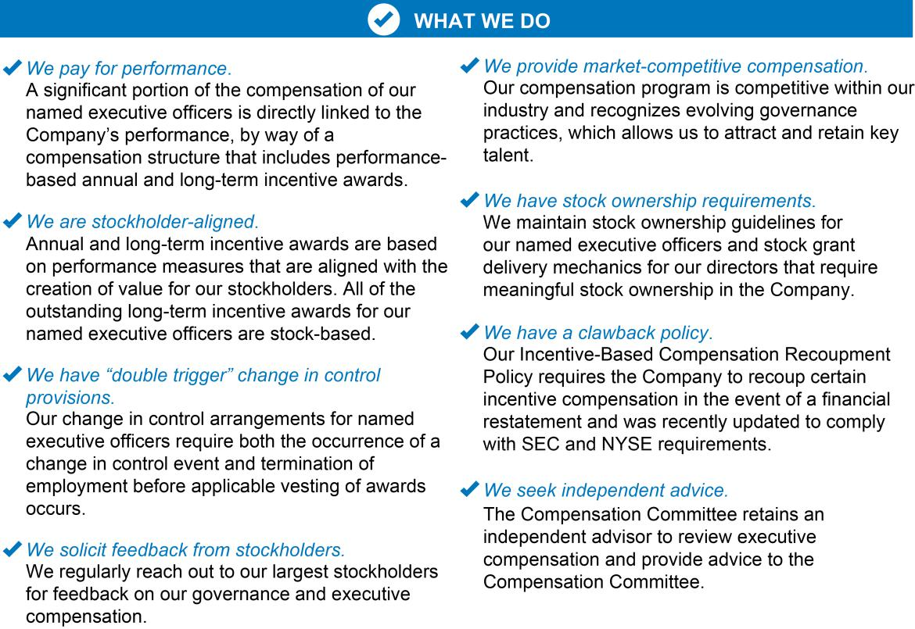

CALIFORNIA RESOURCES CORPORATION 3

2024 PROXY STATEMENT

Proxy Statement Summary
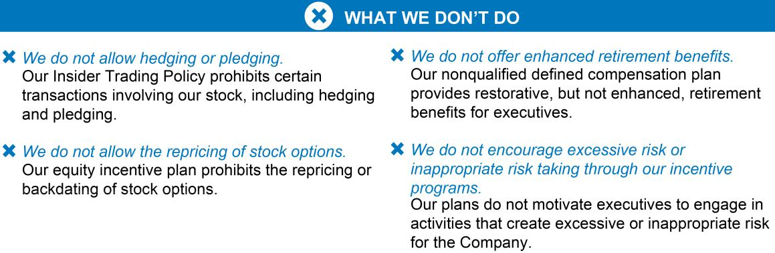

CALIFORNIA RESOURCES CORPORATION 4

2024 PROXY STATEMENT

Board of Directors and Corporate Governance

Board of Directors and Corporate Governance

Our Board of Directors and Director Nominees

Our Board values and exhibits an effective mix of diversity, perspective, skills and experience. Currently, one-third of the Board are women and 44% of the Board are diverse from a race/ethnicity standpoint.

Assuming each of our nominees is elected, one-third of the Board will be women and one-third of the Board will be diverse from a race/ethnicity standpoint following the Annual Meeting, as shown in the following charts:
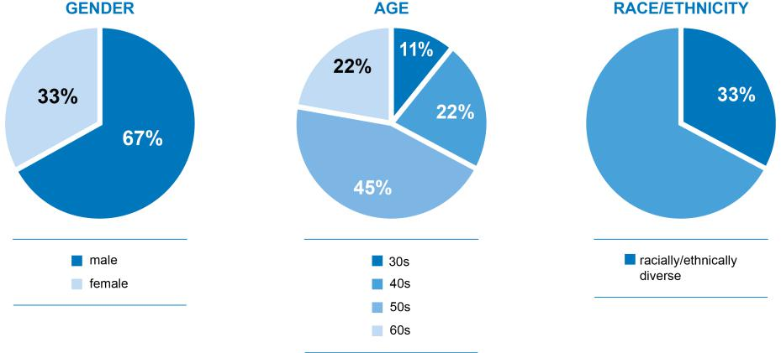

CALIFORNIA RESOURCES CORPORATION 5

2024 PROXY STATEMENT

Board of Directors and Corporate Governance

Set forth below is a chart that summarizes the specific experience, qualifications, attributes and skills of our directors and director nominees and biographical information regarding each of our directors and director nominees. Each of the individuals below is standing for reelection at the Annual Meeting except for Mr. Quintana. There are no family relationships between any of our directors, director nominees and executive officers. There are no ongoing arrangements or understandings between any of our executive officers, directors or director nominees and any other person pursuant to which any person will be selected as a director or an executive officer.

Director and Director Nominee Skills and Qualifications
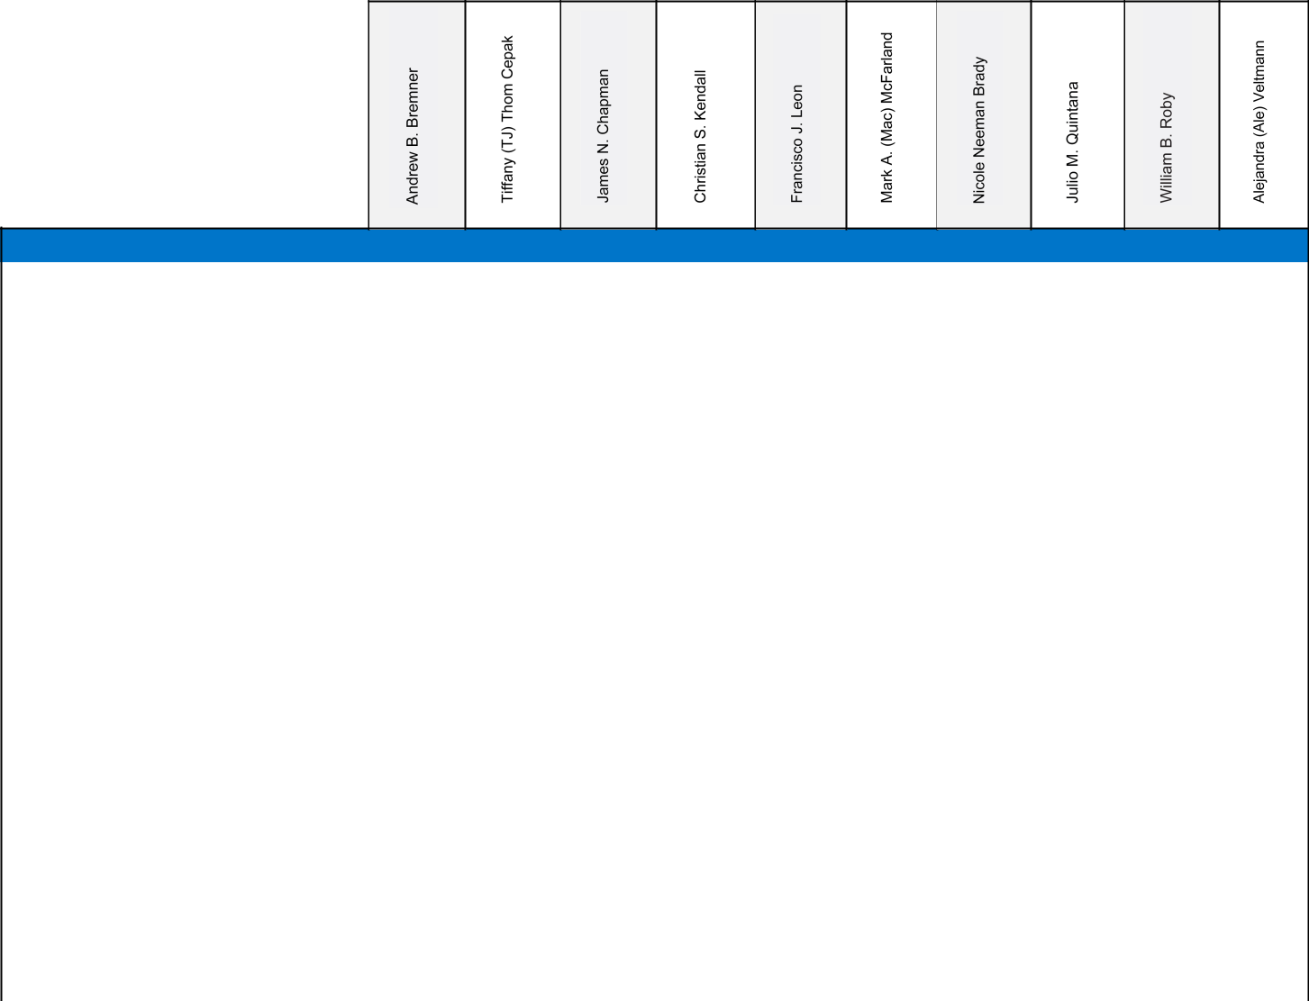

Summary of Director and Director Nominee Qualifications and Experience

SKILLS & EXPERIENCE

Board of Directors Experience |  | X | X | X |  | X | X | X | X | X
CEO Experience |  |  |  | X |  | X |  | X
Senior Executive Experience | X | X |  | X | X | X | X | X | X | X
Oil and Gas Industry Experience | X | X |  | X | X | X |  | X | X | X
Financial/Capital Markets Expertise |  | X | X | X | X | X | X | X |  | X
Mergers & Acquisitions Experience | X | X | X | X | X | X | X | X | X | X
Engineering/Technology Expertise | X | X |  | X |  | X |  | X | X
Compensation Expertise |  | X | X | X |  | X |  | X |  | X
Health & Safety Experience |  | X |  | X |  | X |  | X | X
Environmental/Sustainability Experience | X |  |  | X |  | X | X | X | X | X
Risk Management Experience |  | X | X | X | X | X |  | X
Government/Regulatory Affairs |  |  |  | X |  | X | X | X | X
Experience |  |  |  | X

CALIFORNIA RESOURCES CORPORATION 6

2024 PROXY STATEMENT

Board of Directors and Corporate Governance


Andrew B. Bremner

Director since: 2021

Age: 33

- Partner of JB Energy Partners, LP

- VP, Oil & Gas of Jaco Oil Company
- Formerly Portfolio Management & Strategic Planning for California Resources Corporation

- Member of the Compensation Committee

- Member of the Finance Committee
- Member of the Sustainability Committee

Mr. Bremner, 33, has served as a member of California Resources Corporation's Board of Directors since May 2021. Since 2019, Mr. Bremner has served as a partner of JB Energy Partners, LP (JBEP) and is the Vice President of Oil & Gas for Jaco Oil Company. In these roles Mr. Bremner leads the acquisition and management of a substantial portfolio of energy and alternative assets. From 2013 to 2019, Mr. Bremner worked for California Resources Corporation in various engineering roles, and most recently in Portfolio Management & Strategic Planning. Mr. Bremner earned his M.B.A. from the University of California, Los Angeles, and has a Bachelor of Science degree in Mechanical Engineering from California Polytechnic State University San Luis Obispo.

Tiffany (TJ) | • | Director of Patterson-UTI, Baytex Energy Corp.
Thom Cepak | • | Director of Patterson-UTI, Baytex Energy Corp.
Thom Cepak |  | and EnLink Midstream, LLC
Independent Board Chair | • Former CFO of Energy XXI Gulf Coast Inc., KLR Energy and EPL Oil
Director since: 2020 |  | & Gas, Inc.
Age: 51 | • | Former Director of Yates Petroleum Corporation


• Member of the Finance Committee

Ms. Cepak, 51, is the Independent Chair of California Resources Corporation’s Board of Directors and has served as a member since October 2020. Ms. Cepak has 29 years of energy industry experience, including both financial and operational appointments. She has served as a director of Patterson-UTI, a company that provides land drilling and pressure pumping services, directional drilling, rental equipment and technology, since August 2014 and as a director of Baytex Energy Corp., an independent oil and gas company, since June 2023. She had served as a director of Baytex's predecessor, Ranger Oil Corporation, from September 2019 until its merger with Baytex. In addition, Ms. Cepak has been a member of the Board of Directors of EnLink Midstream, LLC, since December 2021. Ms. Cepak served as the Chief Financial Officer of Energy XXI Gulf Coast Inc. from August 2017 to October 2018. Ms. Cepak served as the Chief Financial Officer of KLR Energy

CALIFORNIA RESOURCES CORPORATION 7

2024 PROXY STATEMENT

Board of Directors and Corporate Governance

(and, subsequent to its business combination, Rosehill Resources Inc.) from January 2015 to June 2017. Ms. Cepak served as a director of Yates Petroleum Corporation from October 2015 to October 2016. Ms. Cepak served four years as the Chief Financial Officer of EPL Oil & Gas, Inc., and was further appointed Executive Vice President in January 2014, and she served in those roles until June 2014, when EPL was sold. Ms. Cepak originally joined EPL as a Senior Asset Management Engineer, a position she held until she was appointed Director of Corporate Reserves in September 2001. Ms. Cepak was named EPL’s Director of Investor Relations in April 2006 and Vice President, Treasurer and Investor Relations in July 2008. In July 2009, Ms. Cepak was designated as EPL’s Principal Financial Officer and, in September 2009, she was appointed Senior Vice President. Prior to joining EPL, she was a Senior Reservoir Engineer with Exxon Production Company and ExxonMobil Company with operational roles including reservoir engineering and subsurface completion engineering for numerous offshore Gulf of Mexico properties. Ms. Cepak holds a B.S. in Engineering from the University of Illinois and an M.B.A. in Management with a concentration in Finance from Tulane University.

James N. Chapman | • | Advisory Director of SkyWorks Capital, LLC
James N. Chapman | • | Director Arch Resources, Inc.
Director since: 2020 | • | Former Director of Denbury, Inc.
Age: 61 | • | Over 35 years of investment banking experience


- Chair of the Compensation Committee

- Chair of the Finance Committee

Mr. Chapman, 61, has served as a member of California Resources Corporation’s Board of Directors since October 2020. Mr. Chapman serves as a non-executive Advisory Director of SkyWorks Capital, LLC, an aviation and aerospace management consulting services company based in Greenwich, Connecticut, which he joined in December 2004. Prior to SkyWorks, he was associated with Regiment Capital Advisors, LP, an investment advisor based in Boston specializing in high yield investments, which he joined in January 2003. Prior to Regiment, Mr. Chapman acted as a capital markets and strategic planning consultant with private and public companies, as well as investment advisers and hedge funds (including Regiment), across a range of industries. Prior to establishing an independent consulting practice, Mr. Chapman worked for The Renco Group, Inc. (a multi-billion dollar private corporation with diverse investment holdings located throughout the world) from December 1996 to December 2001. Prior to Renco, he was a founding principal of Fieldstone Private Capital Group, Inc. in August 1990 where he headed the Corporate Finance and High Yield Finance Groups. Prior to joining Fieldstone, Mr. Chapman worked for Bankers Trust Company from July 1985 to August 1990, most recently in the BT Securities capital markets area. Mr. Chapman has over 35 years of investment banking experience in a wide range of industries including aviation/airlines, metals/mining, natural resources/energy, automotive/general manufacturing, financial services, real estate and healthcare. Mr. Chapman served on the Board of Directors of Denbury, Inc. from September 2020 until its acquisition in November 2023. In addition, Mr. Chapman has served on the Board of Directors of Arch Resources, Inc. since 2016, and as its Lead Independent Director since April 2020. Mr. Chapman received an M.B.A. degree with distinction from Dartmouth College in 1985 and was elected an Edward Tuck Scholar. He received his BA degree, with distinction, magna cum laude, at Dartmouth College in 1984 and was elected to Phi Beta Kappa, in addition to being a Rufus Choate Scholar.

CALIFORNIA RESOURCES CORPORATION 8

2024 PROXY STATEMENT

Board of Directors and Corporate Governance

Christian S. Kendall | • | Former President & CEO and Director of Denbury Inc.
Director Nominee | • | Former Senior VP Global Operations Services of
Age: 57 |  | Noble Energy


Mr. Kendall, 57, was the President and Chief Executive Officer of Denbury Inc., and a member of Denbury's Board of Directors, from July 2017, through its 2020 bankruptcy and emergence therefrom, until November 2023, when it was acquired by ExxonMobil Corporation. Mr. Kendall joined Denbury as Chief Operating Officer in September 2015 and was named President in October 2016. Prior to joining Denbury, Mr. Kendall was with Noble Energy, most recently serving as Senior Vice President, Global Operations Services. Over the course of his 14-year tenure at Noble Energy, he held a wide range of international and domestic leadership positions, primarily in the Eastern Mediterranean, Latin America and the Gulf of Mexico regions. Mr. Kendall began his career at Mobil Oil Corporation in 1989. Mr. Kendall earned his Bachelor of Science degree in Engineering, Civil Specialty, from the Colorado School of Mines and is a graduate of the Advanced Management Program at the Harvard Business School. He is also a member of the National Petroleum Council.


 | • | President & CEO of California Resources Corporation
Francisco J. Leon | • | President of Carbon TerraVault
President and CEO | • Prior Executive Vice President and CFO of CRC
President and CEO | • | Prior Executive Vice President, Corporate Development & Strategic
Director since: 2023 |  | Planning of CRC
Age: 47 | • | Prior Vice President – Portfolio Management and Strategic Planning
of CRC

Mr. Leon, 47, is the President and Chief Executive Officer of California Resources Corporation and has served on its Board of Directors since April 2023. He previously served as the Executive Vice President and Chief Financial Officer of CRC from August 2020 to April 2023. Mr. Leon originally joined CRC in 2014 during the spin-off from Occidental Petroleum as Vice President of Portfolio Management and Strategic Planning. In 2018, Mr. Leon was named Vice President of Corporate Development where he oversaw all acquisition and divestiture activities for the company. Prior to joining CRC, Mr. Leon worked at Occidental Petroleum Corporation where he held various roles in Finance, Planning and U.S. and International Business Development areas. Mr. Leon started his career with Petrie Parkman & Co., Inc., an energy-focused boutique investment banking firm. Mr. Leon holds an M.B.A. from the University of Texas, Austin and a Bachelor of Arts in International Business from San Diego State University and CETYS Universidad in Mexico. From 2019 to 2022, he served on the Board of the Union Rescue Mission of Los Angeles which is one of the largest

CALIFORNIA RESOURCES CORPORATION 9

2024 PROXY STATEMENT

Board of Directors and Corporate Governance

privately run homeless shelters in the U.S. Since the Fall of 2022, Francisco serves on the Board of the American Red Cross - LA Chapter and on the Advisory Board of the McCombs School of Business.


 | • Former President and CEO of CRC
Mark A. (Mac) McFarland | • | President, CEO and Director of Talen Energy Corporation
Mark A. (Mac) McFarland | • | Director of GenOn Energy, Inc.
Director since: 2020 | • | Former Director of Bruin E&P Partners, LLC, TerraForm Power, Inc.
Age: 54 |  | and Chaparral Energy, Inc.
 | • Former CEO of GenOn Energy, Inc. and Luminant Holding Company
LLC

Mr. McFarland, 54, has served on the Board of Directors of California Resources Corporation since October 2020 and previously served as its President and Chief Executive Officer from December 2020 until April 2023. Since May 2023, Mr. McFarland has served as the President and Chief Executive Officer and a member of the Board of Directors of Talen Energy Corporation. Mr. McFarland is the former Executive Chairman of GenOn Energy, an independent power producer. From April 2017 to December 2018, he was the President and Chief Executive Officer of GenOn and served on its Board until September 2022. From 2013 to 2016, he served as Chief Executive Officer of Luminant Holding Company LLC, a subsidiary of Energy Future Holdings Corporation, and a large independent power producer. From 2008 to 2013, he served as both Chief Commercial Officer of Luminant and Executive Vice President, Corporate Development and Strategy of Energy Future Holdings. From 1999 to 2008, Mr. McFarland served in various roles at Exelon Corporation, including as Senior Vice President, Corporate Development. He previously served on the Boards of Bruin E&P Partners (an independent company), TerraForm Power, and Chaparral Energy. Mr. McFarland earned his Masters of Business Administration from the University of Delaware and a Bachelor of Science degree in Civil Engineering (Environmental Concentration) from Virginia Polytechnic Institute and State University. He received his professional engineer license in 1995.

Nicole Neeman | • Leadership roles at Renewable Resources Group
Brady | • Vice President of LA Board of Water and Power Commissioners
Director since: 2021 | • | Prior CEO and Director of Sustainable Development Acquisition
Director since: 2021 |  | Corp.
Age: 43 | • | Prior Officer of Edison International


- Member of the Compensation Committee

- Member of the Sustainability Committee

Ms. Neeman Brady, 43, has served as a member of California Resources Corporation’s Board of Directors since August 2021. She is a business leader with deep roots in the public and private sectors of water, agriculture and power throughout Western US. Most recently, she was CEO and Board Director of Sustainable

CALIFORNIA RESOURCES CORPORATION 10

2024 PROXY STATEMENT

Board of Directors and Corporate Governance

Development Acquisition I Corp. She is currently a Senior Advisor to Renewable Resources Group (RRG), a Board Member of Mitigation Investment Holdings and Vice President and Commissioner for the Los Angeles Board of Water and Power Commissioners. Since 2017, she has held various investment roles at RRG including Principal, COO and member of the Investment Committee. Ms. Neeman Brady joined RRG following its acquisition of Edison Water Resources where she was President and Founder and an Officer of Edison International. From 2008 until 2015, Ms. Neeman Brady served in several operational and managerial roles at Southern California Edison, including Director, Energy Procurement, Power Supply from 2014 to 2015; Director, Asset Optimization and Trading, Power Supply from 2013 to 2014; Director, Contracts, Renewable and Alternative Power from 2011 to 2013. Prior to that, Ms. Neeman Brady held various finance and strategic planning positions for McKinsey and Company, Twentieth Century Fox and Goldman Sachs. Ms. Neeman Brady currently also serves on the Board of the Library Foundation of Los Angeles. She previously served as Chairwoman of the Board of Fishpeople and the Boards of Blue Ocean Mariculture, CalBio Energy, Enbala Networks, Emrgy and the Colorado River Board of California. Ms. Neeman Brady holds dual Bachelor’s degrees in Business Economics and History of Architecture, with honors, from Brown University and an MBA, with distinction, from Harvard University.


Julio M. Quintana

Director since: 2020

Age: 64

(Mr. Quintana is not standing for reelection at the Annual Meeting)

- Chair of the Nominating and Governance Committee

- Member of the Audit Committee

- Former Chairman of Basic Energy Services

- Director of SM Energy, Newmont Mining
- Prior Director and CEO of Tesco Corporation
- Extensive experience in the oil and gas industry

Mr. Quintana, 64, has served as a member of California Resources Corporation’s Board of Directors since October 2020. Mr. Quintana served as the President and Chief Executive Officer of Tesco Corporation, an oilfield services company, from 2005 until his retirement in January 2015, and was a member of Tesco’s Board of Directors from September 2004 to May 2015. Prior to his appointment as President and Chief Executive Officer, Mr. Quintana served as Executive Vice President and Chief Operating Officer at Tesco beginning in September 2004. Prior to his tenure at Tesco, Mr. Quintana worked for Schlumberger Corporation as Vice President of Integrated Project Management and Vice President of Marketing for the Americas from November 1999 to September 2004. Prior to Schlumberger, Mr. Quintana worked from June 1980 to November 1999 for Unocal Corporation, an integrated E&P company. Mr. Quintana held various operational and managerial roles in production, drilling and asset management. His last roles at Unocal were Asset Manager for the MidContinent Region and Asset Manager for Deepwater Gulf of Mexico. Mr. Quintana brings 42 years of experience in various aspects of the oil and gas exploration and production industry, including strong experience in upstream operations, a deep understanding of drilling and asset management technologies, and broad human resources management skills and experience. He is a member of the Board of Directors of SM Energy since July 2006 and a member of the Board of Directors of Newmont Mining since October 2015. He previously served as Chairman of the Board of Basic Energy Services and as a member of its Board of Directors from December 2016 until October 2021. Mr. Quintana has a degree in Mechanical Engineering from the University of Southern California and is a Licensed Petroleum Engineer in California.

CALIFORNIA RESOURCES CORPORATION 11

2024 PROXY STATEMENT

Board of Directors and Corporate Governance

William B. Roby | • CEO of Shepherd Energy, LLC
Director since: 2020 | • | Director of Vermilion Energy Inc.
Age: 64 | • | Extensive experience in the oil and gas industry


- Chair of the Sustainability Committee

- Member of the Audit Committee
- Member of the Nominating and Governance Committee

Mr. Roby, 64, has served as a member of California Resources Corporation’s Board of Directors since October 2020. Since 2015, Mr. Roby has served as the Chief Executive Officer of Shepherd Energy, LLC, Mr. Roby’s consulting company. From 2013 to 2014, he acted as Chief Operating Officer of Sheridan Production Company, LLC. From 2000 to 2013, he held a number of U.S. and international management positions with Occidental Petroleum Corporation, most recently as Senior Vice President, Worldwide Operations and Production/Facility Engineering. Prior to his work at Occidental, he was Vice President of Operations of Altura Energy Ltd., a joint venture between Shell Oil Company and Amoco Corporation in the Permian Basin, following 15 years of various managerial and engineering roles with Shell Oil. Mr. Roby has served as a member of the Board of Directors of the international E&P firm Vermilion Energy Inc. since 2017. He has a bachelor’s degree in mechanical engineering from Louisiana State University.


 | • | Director of NET Power, Inc.
Alejandra (Ale) Veltmann | • | Founder, Senior Advisor, former CEO and Director of ESG Lynk
Alejandra (Ale) Veltmann | • | Former Board Member of Structural Integrity Associates
Director since: 2021 | • | Former VP and Chief Accounting Officer of Paragon Offshore Plc
Age: 56 | • | Former Controller, VP and Chief Accounting Officer
 |  | of Geokinetics, Inc.
• Formerly with KPMG LLP and Arthur Andersen LLP

- Chair of the Audit Committee

- Member of the Nominating and Governance Committee

Ms. Veltmann, 56, has served as a member of California Resources Corporation's Board of Directors since December 2021. Ms. Veltmann has 32 years of experience that includes financial leadership of publicly-listed entities, private entrepreneurial companies and global auditing firms. She has served as a director of the Board of NET Power, Inc., a clean technology company dedicated to the development of clean, reliable, and low cost energy, since 2023. Ms. Veltmann also serves as Senior Advisor of ESG Lynk, a sustainability reporting company she founded and sold, and served as CEO from 2018 to 2023. From 2021 to its acquisition in 2022, Ms. Veltmann served as board member of Structural Integrity Associates, a specialty engineering and services company providing services to the nuclear, fossil, renewables and critical infrastructure industries.

CALIFORNIA RESOURCES CORPORATION 12

2024 PROXY STATEMENT

Board of Directors and Corporate Governance

From 2015 to 2018, she was Vice President and Chief Accounting Officer of Paragon Offshore Plc., an offshore drilling company. From 2010 to 2015, she worked in various roles including Corporate Controller and Vice President and Chief Accounting Officer at Geokinetics, Inc., formerly one of the world’s largest independent land and seafloor geophysical companies. She also worked in various auditor capacities at KPMG LLP from 1995 to 2002 and before that at Arthur Andersen LLP from 1992 to 1995. She served as a Board member of The University of New Mexico Robert O. Anderson School of Management from 2018 to 2022, and as an Advisory Council member of the K.B. Hutchison Center for Energy, Law & Business at The University of Texas at Austin from 2019 to 2021. Ms. Veltmann is a certified public accountant and holds the FSA Credential from the Sustainability Accounting Standards Board (SASB). She has a BBA degree in Accounting from The University of New Mexico and is an alumna of the Advanced Management Program at Harvard Business School.

Board Refreshment and Evaluation

Identifying and Evaluating Nominees for Director

Our Nominating and Governance Committee is responsible for leading the search for individuals qualified to serve as directors and for recommending to the Board nominees as directors to be presented for election at meetings of the stockholders or of the Board of Directors. Our Nominating and Governance Committee evaluates candidates for nomination to the Board of Directors, including those recommended by stockholders, and conducts appropriate inquiries into the backgrounds and qualifications of possible candidates. The Board values having unique and complementary backgrounds and perspectives in the boardroom and considers candidates who can provide diverse perspectives and add unique value through skills highly relevant to our corporate strategy.

The Nominating and Governance Committee may retain outside consultants to assist in identifying director candidates in its sole discretion, but it did not engage any outside consultants in connection with selecting the nominees for election at the Annual Meeting.

Director Criteria, Qualifications and Experience

Our Corporate Governance Guidelines contain qualifications that apply to director nominees recommended by our Nominating and Governance Committee. In the event that a vacancy on the Board of Directors arises, the Nominating and Governance Committee will consider and review the candidate’s following qualifications, relevant skills and experience:

- independence under applicable standards;

- business judgment;

- service on boards of directors of other companies;

- personal and professional integrity, including commitment to the Company’s core values;

- willingness to commit the required time to serve as a Board of Directors member;

- familiarity with the Company, its industry and strategy; and

- such other matters as the committee deems appropriate.

Overboarding Policy

Our Corporate Governance Guidelines also includes an overboarding policy with respect to our directors' service on other boards. Without approval of the Nominating and Governance Committee, no director may simultaneously serve on the board of directors of more than three other public companies. When a director serves on multiple boards in the same fund complex or on the boards of two related public companies, such service will be counted as service on one board for purposes of this guideline unless the Nominating and Governance Committee determines that the boards should be considered separate. The Nominating and Governance Committee considers the director's leadership positions (e.g., committee chair) on the other

CALIFORNIA RESOURCES CORPORATION 13

2024 PROXY STATEMENT

Board of Directors and Corporate Governance

public company boards as part of such determinations. The Nominating and Governance Committee reviews potential overboarding issues as part of its process of considering director nominations for the annual shareholders meeting. All of the Company's directors are currently compliant with the Company's overboarding policy.

Board Diversity

The Board recognizes the value of having directors from a wide variety of backgrounds who bring diverse opinions, perspectives, skills, experiences, backgrounds and orientations to its discussions and its decision-making processes. A diverse board enables a more balanced, wide-ranging discussion in the boardroom, and is also important to the Company’s stockholders, its management and employees. For these reasons, the Nominating and Governance Committee also will consider the diversity of, and the optimal enhancement of, the current mix of talent and experience on the Board of Directors. Currently, one-third of the Board are women and 44% of the Board are diverse from a race/ethnicity standpoint. Additionally, one-third of our director nominees are women and one-third of our director nominees are diverse from a race/ethnicity standpoint.

Board Evaluations and Incumbent Directors

Our Board believes that a robust annual evaluation process is an important part of its governance practices. For this reason, the Nominating and Governance Committee oversees an annual evaluation of the performance of the Board. The committee distributes written evaluation surveys to each director. The Chair shares the results of the surveys and interviews with the full Board for consideration with respect to director nominees, and Board and committee structure, composition and effectiveness.

With respect to the reelection of an existing director, the Nominating and Governance Committee will consider the results of the evaluation process and review the director’s:

- past Board and committee meeting attendance and performance;

- length of Board service;

- personal and professional integrity, including commitment to the Company’s core values;

- relevant experience, skills, qualifications and contributions that the existing director brings to the Board;

- independence under applicable standards; and

- such other matters as the committee deems appropriate.

Board Education

The Board of Directors engages in various activities to obtain additional insight into our business and industry, beneficial perspectives on the performance of the Company, the Board and our management, and on the Company’s strategic direction. From time to time, the full Board receives presentations from its committees, and internal and external advisors, regarding current topics of interest. The Company also makes resources available to individual directors, including access to director education from third party providers.

Director Independence Determinations

To qualify as “independent” under the NYSE listing standards, the Board of Directors must affirmatively determine that the director has no material relationship with us (either directly or as a partner, stockholder or officer of an organization that has a relationship with us) that would interfere with his or her exercise of independent judgment in carrying out his or her responsibilities as a director. The NYSE independent director criteria include, among other things, that the director not be our employee and not have engaged in various types of business dealings with us.

The Board of Directors has reviewed all direct or indirect business relationships of which it is aware between each director or director nominee (including his or her immediate family) and us, as well as each director’s or

CALIFORNIA RESOURCES CORPORATION 14

2024 PROXY STATEMENT

Board of Directors and Corporate Governance

director nominee’s relationships with charitable organizations, to assess director (or director nominee) independence as defined in the listing standards of the NYSE. Based on this evaluation, the Board of Directors has determined that Messrs. Bremner, Chapman, Quintana and Roby and Mmes. Cepak, Neeman Brady and Veltmann are independent directors as that term is defined in the listing standards of the NYSE. In its review of Mr. Bremner’s independence, the Board considered his prior employment with the Company and his association with entities that own real property interests in certain assets in which the Company owns interests. The Board of Directors has also determined that Mr. Kendall will be independent if he is elected at the Annual Meeting. Mr. McFarland, our past President and Chief Executive Officer, and Mr. Leon, our current President and Chief Executive Officer, are not considered by the Board of Directors to be independent because of their current or former employment relationships with CRC.

Board Leadership Structure and Committees

Chair

The Board of Directors’ leadership structure currently separates the CEO and Chair of the Board positions. Mr. Leon serves as our President and CEO, and Ms. Cepak serves as our independent Chair. Our Chair of the Board presides over all meetings of the Board, including executive sessions.

The Board of Directors believes that there is no single, generally accepted approach to providing board leadership and that each of the possible leadership structures for a board must be considered in the context of the individuals involved and the specific circumstances facing a company, as the right leadership structure may vary as circumstances change. The Board of Directors believes it is in the best interest of the Company and its stockholders at this time to have separate CEO and Chair positions. The Board of Directors has found that this structure enables the CEO to focus on operation of the Company’s business, while the Chair focuses on leading the Board of Directors in its oversight role.

Board Meetings and Attendance

During 2023, the Board of Directors held 13 meetings. Each of the standing and special committees held the number of meetings included in the description of the committees set forth below in 2023. Each director attended at least 75% of the meetings of the Board of Directors and the committees on which he or she served that occurred during such directors’ terms in 2023.

Pursuant to our Corporate Governance Guidelines, directors are encouraged to attend our annual meetings of stockholders. All of the directors of our Board attended the virtual annual meeting in April 2023.

Executive Sessions of the Board

The Board of Directors holds meetings of independent directors in executive session without management present on a regular basis. In addition to regularly scheduled Board meetings, executive sessions may be called upon the request of any independent director. In 2023, the Board held four executive sessions.

Committees of the Board

At the end of 2023, our Board of Directors had four separately designated standing committees and one special committee. On February 23, 2024, the Finance special committee, which was established in 2020, was converted to a standing committee of the Board. Therefore, as of the date of this proxy statement, our Board of Directors now has five separately designated standing committees. The current membership and purposes of each of the standing committees are described below. Each of the standing committees operates under a written charter adopted by the Board. The Board of Directors and each committee has the power to hire independent legal, financial or other experts and advisors as it may deem necessary, without consulting or obtaining the approval of any officers of the Company in advance.

CALIFORNIA RESOURCES CORPORATION 15

Standing Committees of the Board


Alejandra (Ale) Veltmann,

Chair

Julio M. Quintana

William B. Roby

2024 PROXY STATEMENT

Board of Directors and Corporate Governance

Audit Committee

Our Audit Committee is composed entirely of independent directors pursuant to the applicable standards, including the heightened standards applicable to audit committee members. In addition to regularly scheduled meetings, the committee meets separately in executive sessions with representatives of our independent auditor, our independent reserves audit firm and our internal audit personnel. The Audit Committee approves the appointment and services of the independent auditor and reviews the general scope of audit and audit-related services, matters relating to internal controls and other matters related to accounting and reporting functions. The Audit Committee monitors the integrity of the financial statements of CRC. The committee oversees the Company’s compliance with ethical standards, and reviews material related party transactions. The Audit Committee additionally reviews and discusses CRC’s guidelines and policies with respect to risk assessment and risk management regarding major financial and other risk exposures (including cybersecurity risks) and the actions management has taken to ensure appropriate processes are in place to identify, manage, monitor, and control such exposures. The Board of Directors determined that all of the members of the Audit Committee are financially literate and have accounting or financial management expertise, each as required by the applicable NYSE listing standards. The Board of Directors also determined that Ms. Veltmann qualifies as an audit committee financial expert under the applicable rules of the Securities Exchange Act of 1934, as amended.

7 Meetings Held in 2023

James N. Chapman,

Chair

Andrew B. Bremner

Nicole Neeman Brady

Compensation Committee

Our Compensation Committee is composed entirely of independent directors pursuant to the applicable standards, including the heightened standards applicable to compensation committee members. The committee is responsible for (i) determining compensation for our Chief Executive Officer and other executive officers, (ii) overseeing and approving compensation and employee benefit policies, (iii) reviewing and discussing with our management the Compensation Discussion and Analysis and related disclosure included in our annual proxy statement, and (iv) overseeing the evaluation of the performance of our executives. The Compensation Committee may delegate to its Chairperson or any subcommittee it may form some or all of its responsibility and authority for any particular matter as it deems appropriate from time to time under the circumstances. The Compensation Committee also has the authority to retain, compensate, direct, oversee and terminate legal counsel, compensation consultants and other experts and advisors hired to assist the Compensation Committee.

6 Meetings Held in 2023

CALIFORNIA RESOURCES CORPORATION 16

James N. Chapman,

Chair

Andrew B. Bremner

Tiffany (TJ) Thom Cepak


Julio M. Quintana,

Chair

William B. Roby

Alejandra (Ale) Veltmann

2024 PROXY STATEMENT

Board of Directors and Corporate Governance

Finance Committee

The Finance Committee assists the Board in fulfilling its oversight responsibilities for matters relating to the Company’s financial strategy, capital allocation, liquidity position and financial policies and activities. The committee assists the Board in reviewing and overseeing finance-related matters of the Company and accelerating the Board's ability to perform those functions. The committee reviews, discusses with management and makes recommendations to the Board regarding (i) the Company's balance sheet, capital structure and related transactions; (ii) the Company's compliance with debt covenants and related matters, and the Company's relationship with lenders; (iii) in consultation with the Audit Committee, the Company's risk management strategy involving interest rate hedging strategies and programs; (iv) proposed mergers, combinations, acquisitions, offers to purchase significant assets, divestitures and other strategic investments; (v) any dividend or share repurchase programs of the Company; and (vi) decision effectiveness with respect to finance-related matters.

5 Meetings Held in 2023

Nominating and Governance Committee

The Nominating and Governance Committee is composed entirely of independent directors. The committee makes proposals to the Board of Directors for candidates to be nominated by the Board of Directors to fill vacancies or for new directorship positions, if any, which may be created from time to time. The Nominating and Governance Committee develops and recommends a set of corporate governance guidelines to our Board of Directors and oversees the evaluation of our Board and its committees. Each year, the Nominating and Governance Committee determines which directors, if any, qualify as independent, disinterested or non-employee directors under applicable standards. The Nominating and Governance Committee periodically reviews the advisability or need for any changes in the Board committee structure, and recommends to the Board the composition of each Board committee.

4 Meetings Held in 2023

CALIFORNIA RESOURCES CORPORATION 17

2024 PROXY STATEMENT

Board of Directors and Corporate Governance

Sustainability Committee

William B. Roby,

Chair

Andrew B. Bremner

Nicole Neeman Brady

CTV Holdings Board of Directors

Our Sustainability Committee is composed entirely of independent directors. The committee assists the Board in fulfilling its oversight responsibilities relating to sustainability for matters pertaining to the Company’s business, strategy, operations, performance or reputation. The committee reviews and discusses with management the status of strategies, objectives, issues, laws and regulations regarding matters relating to the Company’s operations; sustainability; and health, safety and environment (“HSE”). The committee reviews and discusses with management the Company’s programs on community engagement, diversity, inclusion, workplace culture, talent development and social responsibility. It also reviews our policies and programs designed to ensure (i) compliance with applicable laws and regulations, (ii) consistency with Company strategy, (iii) promotion of safe operations, sustainability and conservation of natural resources, and (iv) that timing requirements are set and achieved. The committee periodically reports to the Board of Directors with respect to operations, sustainability and HSE pertaining to the Company. The Sustainability Committee is responsible for reviewing and discussing the status of CRC’s ESG goals, including our Full Scope 2045 Net Zero Goal and our goals on methane reduction, freshwater usage reduction, leadership diversity, community giving and executive pay.

8 Meetings Held in 2023

The Company's Board of Directors has delegated limited authority for certain activities to the board of directors ("CTV Holdings Board") of its wholly owned subsidiary, Carbon TerraVault Holdings, LLC ("CTV Holdings"). The current members of the CTV Holdings Board are Mr. McFarland (its Chairman), Mr. Bremner and Mr. Chapman. The CTV Holdings Board provides direction to and oversight of the carbon management business of CTV Holdings and its subsidiaries. The CTV Holdings Board is responsible for reviewing and discussing with management, among other things: (i) the budgets and development plans relating to the carbon management business and (ii) strategies, tactics, plans, goals, objectives, targets and metrics relating to the carbon management business and the performance of CTV Holdings and its subsidiaries with respect thereto. The CTV Holdings Board also reports to the Company's Board with respect to its activities, findings and recommendations. The CTV Holdings Board held three meetings in 2023.

CALIFORNIA RESOURCES CORPORATION 18

2024 PROXY STATEMENT

Board of Directors and Corporate Governance

The Board’s Role in Risk Oversight

While the Company’s management is responsible for the day-to-day risk management process, the Board has ultimate responsibility for the oversight of the Company’s risk management, shaping effective corporate governance, and setting the right tone for integrity, ethics and culture, for the benefit of the Company’s stakeholders, including shareholders, and employees. The Board exercises direct oversight of strategic risks to the Company and the risk management process to ensure that it is properly designed, well-functioning and consistent with our overall corporate strategy, and also delegates certain risk areas to each of the Board committees.
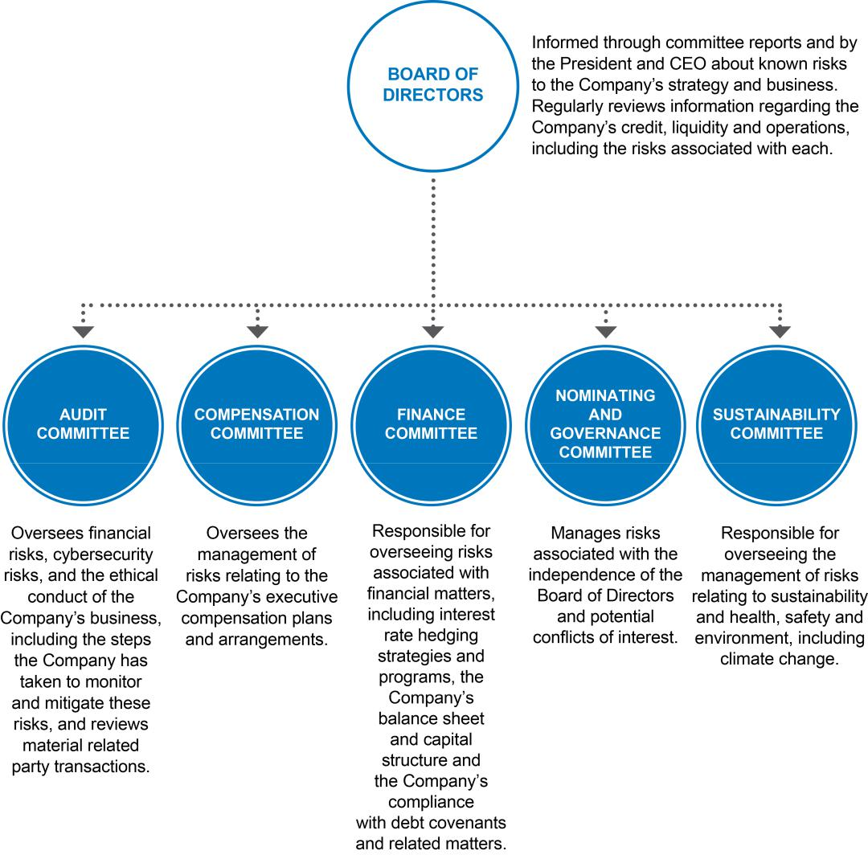

CALIFORNIA RESOURCES CORPORATION 19

2024 PROXY STATEMENT

Board of Directors and Corporate Governance

Compensation Committee Interlocks and Insider Participation

No member of our Compensation Committee is now, or at any time since the beginning of 2023 has been, employed by or served as an officer of CRC or any of its subsidiaries or had any business relationship requiring disclosure with CRC or any of its subsidiaries. None of our executive officers is now, or at any time has been, since the beginning of 2023, a member of the compensation committee or board of directors of another entity one of whose executive officers has been a member of our Board of Directors or Compensation Committee.

Communications with Directors

Our Board of Directors welcomes communications from our stockholders and other interested parties. Communications to our Board of

Directors, to any committee of our Board, or to any director in particular, should be sent to:

Board of Directors, committee name or director’s name, as appropriate

California Resources Corporation
Attention: Corporate Secretary
1 World Trade Center, Suite 1500

Long Beach, California 90831

We will forward all correspondence directly to the committee or individual director, as appropriate. Our independent directors approved our process for collecting and organizing stockholder communications to the Board of Directors.

If any stockholder or third party has a complaint or concern regarding accounting, internal controls over financial reporting or audit matters at CRC, they should send their complaint in writing to Ms. Veltmann, the Chair of the Audit Committee, at the address listed above.

Availability of Corporate Governance Documents

We are committed to good corporate governance. In furtherance thereof, the Board of Directors has adopted governance documents to guide the operation and direction of the Board and its committees, which include Corporate Governance Guidelines, a Business Ethics Policy (which applies to all directors and employees, including the Chief Executive Officer, Chief Financial Officer and Principal Accounting Officer) and charters for the Audit, Compensation, Finance, Nominating and Governance and Sustainability Committees. Each of these documents is available on our website (www.crc.com), and stockholders may obtain a printed copy, free of charge, by sending a written request to California Resources Corporation, Attention: Corporate Secretary, 1 World Trade Center, Suite 1500, Long Beach, California 90831. We will also promptly post on our website any material amendments to these documents and any waivers from the Business Ethics Policy for our directors and principal executive, financial and accounting officers.

Certain Relationships and Related Transactions

Policies and Procedures

Our Board of Directors adopted written policies regarding related party transactions. We review all relationships and transactions in which we and our directors and executive officers or their immediate family members are participants to determine whether such persons have a direct or indirect material interest. Our Corporate Secretary’s office implements procedures to obtain information from the directors and executive officers with respect to related party transactions. The Audit Committee reviews and discusses with management and the independent registered public accounting firm any material related party transactions as defined by, and required to be disclosed under, the rules of the Securities and Exchange Commission (“SEC”) and the NYSE. Agreements that embody transactions that are material in amount or significance are filed with the SEC as required.

CALIFORNIA RESOURCES CORPORATION 20

2024 PROXY STATEMENT

Board of Directors and Corporate Governance

Our Business Ethics and Corporate Policies prohibit significant conflicts of interest. Any waivers of these policies require approval by the compliance officer, or in the case of conflicts of our executive officers or directors, the Board of Directors. Under our Business Ethics and Corporate Policies, conflicts of interest generally are deemed to occur when private or family interests do not appear impartial, interfere or compete with the interests of our Company.

We have multiple processes for reporting conflicts of interests and related party transactions. Under our Business Ethics and Corporate Policies, all of our directors and employees are required to report any known or apparent conflict of interest, or potential conflict of interest, to their supervisors, the compliance officer, a member of the corporate compliance committee, our legal counsel, human resources, or the Board of Directors, as appropriate. As part of any review of any conflict of interest, potential conflict of interest or related party transaction, the following factors are generally considered:

- the nature of the related person’s interest in the transaction;

- the material terms of the transaction;

- the importance of the transaction to the related person;

- the importance of the transaction to us;

- whether the transaction would impair the judgment of a director or executive officer to act or their ability to act in our best interest;

- whether the transaction might affect a director’s independence under NYSE standards; and

- any other matters deemed appropriate with respect to the particular transaction.

We also have other policies and procedures to prevent conflicts of interest and related person transactions. For example, the charter of our Nominating and Governance Committee requires that the committee members assess the independence of the non-management directors at least annually, including a requirement that it determine whether any such directors have a material relationship with us, either directly or indirectly, as defined therein and as further described above under “Director Independence Determinations.”

Related Party Transactions

There are no transactions or relationships with related persons since the beginning of our most recently completed fiscal year that are required to be disclosed.

CALIFORNIA RESOURCES CORPORATION 21

4

2024 PROXY STATEMENT

Environment, Social and Governance Goals

Environment, Social and Governance Goals

ENVIRONMENT

Carbon Management

CRC is committed to the transition in the energy sector. CRC adopted a Full-Scope 2045 Net Zero goal for Scope 1, 2 and 3 GHG emissions. This goal places CRC among a select few industry peers to include Scope 3 GHG emissions in their Net Zero goal. In addition, CRC’s 2045 goal targets a timeframe five years sooner than many other companies’ Net Zero goals and aligns CRC with the State of California’s 2045 net zero ambitions and is sooner than the 2050 goal set out by the Paris Agreement.

Sustainability Goals

In addition to our carbon management goal, CRC continues to advance our 2030 goals relating to water sustainability, methane reductions, and integrating renewables in our operations in order to reduce our Scope 1 and 2 GHG emissions. Finally, in addition to our carbon management goal and other sustainability goals, CRC continues to have internal targets for oil spill prevention rate and asset retirement obligation reductions.

SOCIAL

We view our workforce as an asset and the Board provides oversight over significant aspects of our human capital. Safety is a key value at CRC. As a result, CRC has adopted a 2024 Incident and Injury Rate internal target and a Diversity, Equity and Inclusion-related objective.

GOVERNANCE

The full Board, in addition to its committees, is responsible for overseeing our sustainability strategy, risk management and goals, including those related to carbon management, environmental stewardship, worker safety, and diversity, equity and inclusion in our oil and gas operations as well as our carbon management business. The Sustainability Committee assists the Board in fulfilling its oversight responsibilities relating to sustainability and climate-related matters pertaining to the Company’s business, strategy, operations, performance or reputation and is responsible for reviewing and discussing the status of ESG goals, risks, and regulations with management.

Compensation

We are proud to note that CRC’s ESG goals continue to be directly tied to the performance-based compensation of our employees, including executives and senior managers, further highlighting our standing commitment and dedication to a cleaner and more sustainable future for California. In fact, the Board has further emphasized the importance of achieving our ESG goals by tying 30% of our management team’s annual incentive related to company performance to ESG related metrics.

CALIFORNIA RESOURCES CORPORATION 22

2024 PROXY STATEMENT

Audit Committee Report

Audit Committee Report

The Audit Committee of the Board of Directors of California Resources Corporation assists the Board in its oversight of corporate governance by overseeing the quality and integrity of the accounting, auditing, and financial reporting practices of the Company. The Audit Committee approves the appointment and services of the independent registered public accounting firm, and monitors (1) the integrity of the financial statements of CRC; (2) the independent registered public accounting firm’s qualifications, independence and performance; (3) the effectiveness and performance of CRC’s internal audit function; (4) CRC’s system of disclosure controls and procedures, internal control structure over financial reporting and compliance with ethical standards; and (5) the compliance by CRC with legal and regulatory requirements related to financial statements.

The Board of Directors has determined that each of the members of the Audit Committee satisfies the standards of independence established under the SEC’s rules and regulations and listing standards of the NYSE. The Board of Directors has further determined that each of the members of the Audit Committee is financially literate and that Ms. Veltmann is an “audit committee financial expert” as defined by the rules and regulations of the SEC.

In connection with our financial statements for the year ended December 31, 2023, the Audit Committee has:

- reviewed and discussed with management the audited financial statements contained in CRC’s Annual Report on Form 10-K for the fiscal year ended December 31, 2023;

- discussed with CRC’s independent registered public accounting firm, KPMG LLP, the matters required to be discussed by applicable requirements of the Public Company Accounting Oversight Board and the Securities Exchange Commission;

- received the written disclosures from KPMG LLP as required by applicable requirements of the Public Company Accounting Oversight Board regarding the independent accountant’s communications with the Audit Committee concerning independence;

- discussed with KPMG LLP its independence from CRC and members of its management;

- considered any non-audit services in assessing auditor independence;

- had executive sessions with KPMG LLP to provide them with the opportunity to discuss any other matters that they desired to raise without management present; and

- had executive sessions with Netherland, Sewell & Associates, Inc., CRC’s independent reserves audit firm, to discuss the oil and gas reserves determination process and related public disclosures, and to provide them with the opportunity to discuss any other matters that they desired to raise without management present.

Based on the review and discussions with CRC’s management, independent registered public accounting firm and independent reserves audit firm, as set forth above, the Audit Committee recommended to CRC’s Board of Directors that the audited consolidated financial statements be included in our Annual Report on Form 10-K for the fiscal year ended December 31, 2023, for filing with the SEC.

Audit Committee,

Alejandra (Ale) Veltmann, Chair

Julio M. Quintana
William B. Roby

March 15, 2024

CALIFORNIA RESOURCES CORPORATION 23

2024 PROXY STATEMENT

Compensation Discussion and Analysis

Compensation Discussion and Analysis

This Compensation Discussion and Analysis (“CD&A”) provides a description of the elements and key features of our compensation program, as well as context and rationale for decisions made with respect to the compensation for our “named executive officers” or “NEOs” for the year ended December 31, 2023, who are identified below:

Name | Position as of December 31, 2023
Francisco J. Leon | President and Chief Executive Officer
Manuela ("Nelly") Molina | Executive Vice President and Chief Financial Officer
Jay A. Bys | Executive Vice President and Chief Commercial Officer
Chris D. Gould | Executive Vice President and Chief Sustainability Officer
Michael L. Preston | Executive Vice President, Chief Strategy Officer and General Counsel
Mark A. (Mac) McFarland | Former President and Chief Executive Officer
Shawn M. Kerns | Former Executive Vice President and Chief Operating Officer

In accordance with SEC rules, our NEOs were determined as of December 31, 2023 and are listed above with the titles that they held as of that date. Mr. Leon became our President and Chief Executive Officer, replacing Mr. McFarland, effective at the 2023 Annual Meeting in April 2023. Ms. Molina joined as Executive Vice President and Chief Financial Officer in May 2023. Mr. McFarland remains a non-employee director and Mr. Kerns retired in July 2023.

Table of Contents

Compensation Discussion and Analysis |  |  |  |  |  |  |  |  |  |  |  |  |  |  |  |  |  |  |  |  |  | 24 | Compensation Committee Report |  |  |  |  |  |  |  |  |  |  |  |  |  |  |  | 43
 | Compensation Objectives and Process |  |  |  |  |  |  |  |  |  |  |  |  |  |  |  |  |  |  |  |  | 25 | Executive Compensation Tables |  |  |  |  |  |  |  |  |  |  |  |  |  |  |  | 44
 |  |  | Executive Compensation Objectives |  |  |  |  |  |  |  |  |  |  |  |  |  |  |  |  |  |  | 25 |  |  |  |  |  |  |  |  |  |  |  |  |  |  |  |  | 44
 |  |  | Compensation Program Best Practices |  |  |  |  |  |  |  |  |  |  |  |  |  |  |  |  |  |  | 25 |  | Summary Compensation Table |  |  |  |  |  |  |  |  |  |  |  |  |  |  | 44
 |  |  | Role of Compensation Committee |  |  |  |  |  |  |  |  |  |  |  |  |  |  |  |  |  |  | 26 |  | Grants of Plan-Based Awards |  |  |  |  |  |  |  |  |  |  |  |  |  |  | 46
 |  |  | Role of Management |  |  |  |  |  |  |  |  |  |  |  |  |  |  |  |  |  |  | 26 |  | Narrative Disclosure to Summary Compensation Table and Grants of |  |  |  |  |  |  |  |  |  |  |  |  |  |  | 47
 |  |  | Role of Independent Compensation Consultants |  |  |  |  |  |  |  |  |  |  |  |  |  |  |  |  |  |  | 26 |  | Plan-Based Awards Table
 |  |  | Use of Compensation Data |  |  |  |  |  |  |  |  |  |  |  |  |  |  |  |  |  |  | 26 |  | Outstanding Equity Awards at December 31, 2023 |  |  |  |  |  |  |  |  |  |  |  |  |  |  | 48
 |  |  | Stockholder Outreach |  |  |  |  |  |  |  |  |  |  |  |  |  |  |  |  |  |  | 27 |  | Option Exercises and Stock Vested in 2023 |  |  |  |  |  |  |  |  |  |  |  |  |  |  | 49
 | Stockholder Approval of Executive Compensation |  |  |  |  |  |  |  |  |  |  |  |  |  |  |  |  |  |  |  |  | 27 |  | 2023 Nonqualified Deferred Compensation Table |  |  |  |  |  |  |  |  |  |  |  |  |  |  | 49
 | 2023 Compensation Program |  |  |  |  |  |  |  |  |  |  |  |  |  |  |  |  |  |  |  |  | 27 |  | Potential Payments upon Termination or Change in Control |  |  |  |  |  |  |  |  |  |  |  |  |  |  | 50
 |  | Benefits |  |  |  |  |  |  |  |  |  |  |  |  |  |  |  |  |  |  |  | 39
 |  | 2024 Compensation Program Actions |  |  |  |  |  |  |  |  |  |  |  |  |  |  |  |  |  |  |  | 41 |  | CEO Pay Ratio |  |  |  |  |  |  |  |  |  |  |  |  |  |  | 56
 | Other Compensation Matters |  |  |  |  |  |  |  |  |  |  |  |  |  |  |  |  |  |  |  |  | 41 |  | Pay Versus Performance Disclosures |  |  |  |  |  |  |  |  |  |  |  |  |  |  | 57
 |  |  | Stock Ownership Guidelines |  |  |  |  |  |  |  |  |  |  |  |  |  |  |  |  |  |  | 41 | Director Compensation |  |  |  |  |  |  |  |  |  |  |  |  |  |  |  | 61
 |  |  | Clawback Policies |  |  |  |  |  |  |  |  |  |  |  |  |  |  |  |  |  |  | 41 |  |  |  |  |  |  |  |  |  |  |  |  |  |  |  |  | 61
 |  |  | Anti-Hedging and Anti-Pledging Policy |  |  |  |  |  |  |  |  |  |  |  |  |  |  |  |  |  |  | 41 |  | Program Objectives |  |  |  |  |  |  |  |  |  |  |  |  |  |  | 61
 |  |  | Compensation Risk Management |  |  |  |  |  |  |  |  |  |  |  |  |  |  |  |  |  |  | 42 |  | Program Elements |  |  |  |  |  |  |  |  |  |  |  |  |  |  | 61
 |  |  | Tax Considerations |  |  |  |  |  |  |  |  |  |  |  |  |  |  |  |  |  |  | 42 |  | 2023 Compensation of Directors |  |  |  |  |  |  |  |  |  |  |  |  |  |  | 62

CALIFORNIA RESOURCES CORPORATION 24

2024 PROXY STATEMENT

Compensation Discussion and Analysis

Compensation Objectives and Process

The purpose of our executive compensation program is to allow us to attract, retain, motivate and reward high-performing executives to maximize returns to our stockholders.

Executive Compensation Objectives

Our executive compensation objectives are to:

- Motivate our executives to take actions that are aligned with our short- and long-term strategic objectives, appropriately balancing risk versus potential reward.

- Provide a high percentage of senior executives’ pay based on performance to ensure the highest level of accountability to stockholders.

- Offer an opportunity for performance-based pay to provide above market compensation when our performance exceeds our goals balanced by the risk of below market compensation when it does not.

- Align executive and stockholder interests by having robust stock ownership guidelines, creating the most direct alignment of executive and stockholder interests.

Compensation Program Best Practices

Our executive compensation program is designed to incorporate compensation and governance best practices and is overseen by our Compensation Committee. Our short-term and long-term incentive plans are primarily performance-based and are intended to align with the short- and long-term best interests of stockholders. The Compensation Committee has engaged in best practices to further align executive pay with Company performance and to ensure good governance in the following ways:

CALIFORNIA RESOURCES CORPORATION 25

2024 PROXY STATEMENT

Compensation Discussion and Analysis

Role of Compensation Committee

Our executive compensation program is overseen by our Compensation Committee, with input from our management and outside compensation consultants. In its oversight role, the Compensation Committee is responsible for making compensation decisions involving our CEO and other executive officers and evaluating performance for compensatory purposes.

Role of Management

Members of our executive management team, including our President and CEO and our Vice President of Compensation and Benefits, provided input to the Compensation Committee with respect to executive compensation, key job responsibilities, achievement of performance objectives and compensation program design. We believe these individuals provide helpful support to the Compensation Committee in these areas given their understanding of our business and personnel, compensation programs and competitive environment. The Compensation Committee is not obligated to accept management’s recommendations with respect to executive compensation matters and meets in executive session to discuss such matters outside of the presence of our management. During 2023, the Compensation Committee held one executive session.

Role of Independent Compensation Consultants

The Compensation Committee retained Lyons Benenson & Company Inc. (“LB&Co”), after considering all factors relevant to LB&Co’s independence from our management and members of our Compensation Committee and determining that it was independent and without conflicts of interest under the Securities and Exchange Commission rules and the NYSE Listed Company Manual standards. LB&Co advised the Compensation Committee beginning immediately following our emergence from bankruptcy in 2020.

Use of Compensation Data

During 2023, our Compensation Committee analyzed the comparative total compensation of our executive officers. To facilitate this analysis, LB&Co provided the Compensation Committee with comparative Peer Group compensation data that included base salaries, annual incentive opportunities, and long-term incentive opportunities. This information reflected recent publicly available information and other market data for our selected peer companies listed below, which are within the same Global Industry Classification Standard (GICS) Sub-Industry classification and are of similar size and/or have similar geographic operating locations as the Company. We believe that it provided our Compensation Committee with a sufficient basis to analyze the comparative total compensation of our executive officers.

We increased our Compensation Peer Group to 18 companies in 2023 from 15 companies in 2022 as a result of several mergers within our 2022 Peer Group. In addition, for 2023, Continental Resources, Inc. was

CALIFORNIA RESOURCES CORPORATION 26

2024 PROXY STATEMENT

Compensation Discussion and Analysis

removed following its take-private acquisition. The following companies were added based on their alignment from both business and size perspectives: Comstock Resources, Inc., Crescent Energy Company, Permian Resources Corporation, and Whitecap Resources Inc.

 | 2023 Compensation Peer Group Companies
Antero Resources Corporation | Callon Petroleum Company | Chord Energy Corporation
CNX Resources Corporation | Comstock Resources, Inc. | Coterra Energy Inc.
Crescent Energy Company | Denbury Inc. | Diamondback Energy, Inc.
Marathon Oil Corporation | Matador Resources Company | Murphy Oil Corporation
PDC Energy, Inc. | Permian Resources Corporation | Range Resources Corporation
SM Energy Company | Southwestern Energy Company | Whitecap Resources Inc.

Stockholder Outreach

We value feedback regarding our governance and executive compensation practices and reached out to shareholders holding a substantial majority of our shares in 2023 to solicit any feedback on our governance and compensation programs. We sought to understand, in particular, any stockholder suggestions regarding our compensation program to ensure that we share this feedback with the Compensation Committee and consider those concerns in designing our compensation programs going forward. Stockholders who participated in our engagement efforts in 2023 were invited to meet with members of our senior management and, in some cases, the Chair of our Board.

Feedback from stockholders who engaged was positive regarding the changes we made with our 2023 compensation program, particularly with the majority of the program comprised of performance-based incentives. Stockholders offered suggestions regarding the structure of short and long-term incentives and metrics the Company should consider, including absolute total shareholder return ("TSR") modified by TSR relative to an index like the XOP index. Stockholders also expressed their preference for rigorous quantitative, rather than qualitative incentive goals. Feedback gathered at these meetings was shared with Board and specifically taken into consideration by the Compensation Committee in the formulation of the Company’s 2024 compensation program, as discussed in the 2024 Compensation Program Actions section below.

We intend to continue engaging with stockholders in 2024 to solicit feedback to ensure that our governance and executive compensation practices align with stockholders’ expectations.

Stockholder Approval of Executive Compensation

Our stockholder advisory vote in 2023 on our 2022 executive compensation program resulted in a greater than 99% approval of such compensation by stockholders.

In developing our executive compensation programs, the Compensation Committee considers the results of the advisory vote on executive compensation, feedback gathered from shareholder outreach meetings and many other factors, including the Compensation Committee's assessment of the interaction of our compensation programs with our corporate business objectives, evaluations of our programs by LB&Co, and review of data relating to pay practices of our compensation peer group. However, no specific changes were made to our 2023 executive compensation program due to the last positive stockholder approval vote we received in 2023.

2023 Compensation Program

The 2023 compensation program is a market competitive compensation structure the Compensation Committee designed with LB&Co. consisting of base salaries, annual incentives and long-term incentives to motivate and retain our executives and align our executives’ compensation with shareholder interests in a meaningful way.

CALIFORNIA RESOURCES CORPORATION 27

2024 PROXY STATEMENT

Compensation Discussion and Analysis

Base Salaries

The Compensation Committee made the following changes to the base salaries of the NEOs during 2023 based on the scope of job responsibilities, internal alignment and position relative to peer group compensation data.

 |  | Base Salary
Name | Base Salary | Effective Date
Francisco J. Leon | $500,000 | January 2021
 | $750,000 | March 2023
Manuela ("Nelly") Molina | $550,000 | May 2023
Jay A. Bys | $500,000 | May 2021
 | $540,000 | March 2023
Chris D. Gould | $475,000 | June 2021
 | $543,000 | March 2023
 | $600,000 | July 2023
Michael L. Preston | $500,000 | January 2021
 | $560,000 | March 2023
 | $610,000 | July 2023
Shawn M. Kerns | $500,000 | January 2021
 | $540,000 | March 2023
Mark A. (Mac) McFarland | $850,000 | January 2021

Annual Incentive Program ("AIP")

AnnuaI Incentive Targets

The following are the 2023 annual incentive targets approved by the Compensation Committee in February 2023 based on the scope of job responsibilities, internal alignment and peer group compensation data:

 | 2023 Annual Incentive Target
Name | (as a % of Bonus Eligible Salary)
Francisco J. Leon | 120%
Manuela ("Nelly") Molina | 100%
Jay A. Bys | 100%
Chris D. Gould | 100%
Michael L. Preston | 100%
Mark A. (Mac) McFarland | 120%
Shawn M. Kerns | 100%

Payouts under the AIP can range from 0% to 200% of the annual incentive target for an individual. Payout of 80% of the annual incentive target amount is based on the AIP Scorecard metrics and 20% is based on the Committee’s assessment of an NEO’s individual performance. While targets were initially set for Messrs. Kerns and McFarland, they did not receive AIP payouts since they were no longer employees at the end of 2023.

CALIFORNIA RESOURCES CORPORATION 28

2024 PROXY STATEMENT

Compensation Discussion and Analysis

AIP Scorecard Metrics

In February 2023, the Compensation Committee established the scorecard for the 2023 AIP to incentivize the AIP participants to undertake actions and invest capital to achieve sustainable long-term value for CRC. The construct of the AIP recognized the material impact that fluctuations in commodity prices have on CRC’s financial measures including adjusted EBITDAX and free cash flow. As such, while any AIP program cannot eliminate the impact of such fluctuations, the AIP scorecard includes metrics related to capital efficiency and controllable costs which are not impacted by commodity prices. Further, the importance of ESG-related metrics was highlighted by weighting that portion of the AIP scorecard opportunity at 30%.

The Compensation Committee has adopted a policy whereby management’s ability to achieve a maximum payout under the AIP should be due to the achievement of extraordinary results, whether via financial performance or the other non-financial metrics incorporated into the AIP, with a goal to lessen the impact of commodity price volatility on AIP payouts.
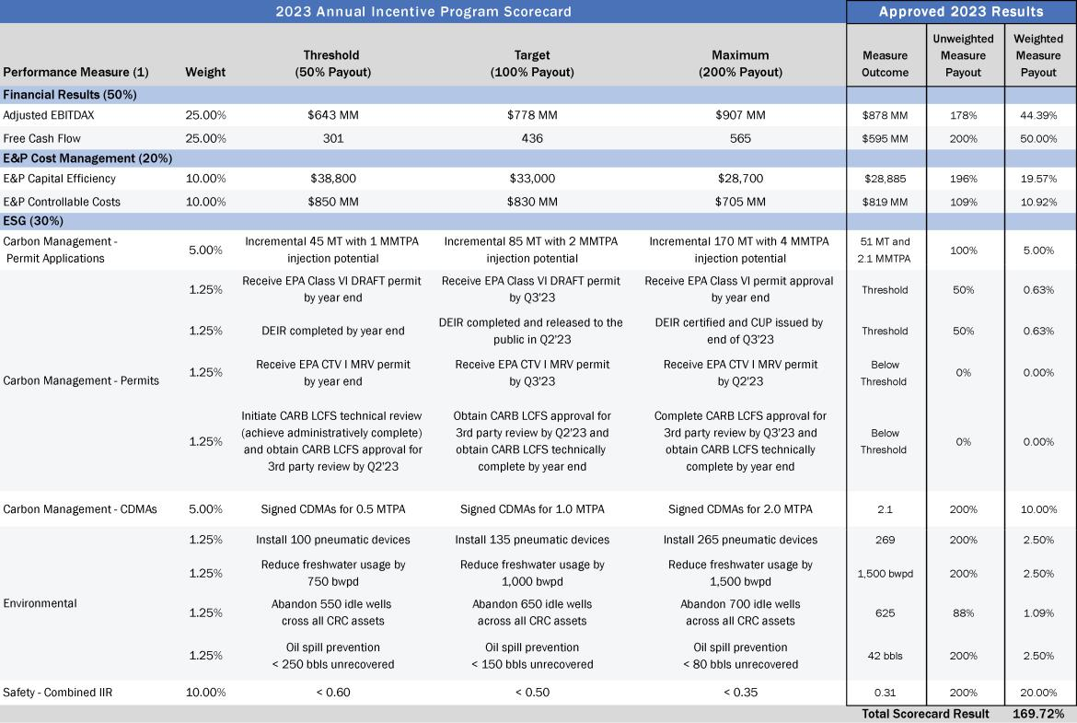

- Descriptions of the performance measures are as follows:

CALIFORNIA RESOURCES CORPORATION 29

 |  | 2024 PROXY STATEMENT
 |  | Compensation Discussion and Analysis
 | Performance Measure | Description
 | Adjusted EBITDAX | Adjusted EBITDAX is earnings before interest expense; income taxes; depreciation, depletion and amortization; exploration
 |  | expense. Also excludes other unusual, infrequent and out-of-period items; and other non-cash items. Other non-cash items
 |  | are, for example, unrealized gains/losses on our commodity derivative contracts, and accretion expense. Differences between
 |  | the payout on cash incentive awards (LTIP and AIP) as compared to the amount included in the 2023 budget are also
 |  | excluded.
 |  | Target level was set based on the approved 2023 management plan.
 | Free Cash Flow | Free Cash Flow is calculated as Adjusted EBITDAX +/-working capital changes for the period and minus cash paid for
 |  | interest, asset retirement obligations and capital investments. AIP adjusted FCF is not reduced by income tax payments.
 |  | Target level was set based on the approved 2023 management plan.
 | E&P―Capital Efficiency | E&P Capital Efficiency is the ratio of total 2023 E&P capital expenditures divided by 30-day peak initial production (“IP”) over a
 |  | 6 month period of new wells added during the year from drilling, workover, and exploration capital. Includes facility and
 |  | corporate capital. Excludes capital for carbon management business, LBU Prep & Abandon & Carry Out wells.
 |  | Target level was based on approved 2023 management plan budgeted capital.
 | E&P―Controllable Costs, | E&P Controllable Costs, Non-Energy Cost Savings includes operating costs, general and administrative expenses (G&A) and
 | Non-Energy Cost Savings | capital excluding certain non-controllable costs including purchased natural gas and electricity, noncash stock-based
 | Non-Energy Cost Savings | compensation expense. Excludes carbon management activities.
 |  | Target level was based approved 2023 management plan.
 | Carbon Management― | Submission of permit applications for Carbon TerraVault storage to make progress toward our Full Scope 2045 Net Zero goal.
 | Permit Applications
 | Carbon Management― | Completion of reviews and approval of permits for Carbon TerraVault storage.
 | Permits
 | Carbon Management― | Signed Carbon Disposal Management Agreements.
 | CDMAs
 | Environmental― | Install pneumatic devices to make progress toward methane reduction targets.
 | Pneumatic devices
 | Environmental― | Reduce freshwater usage to meet our environmental stewardship commitments.
 | Freshwater Usage
 | Environmental― | Abandon idle wells to meet our ARO commitments.
 | ARO
 | Environmental― | Net number of unrecovered barrels of reportable spill of crude oil or condensate.
 | Spill Prevention Rate
 | Safety― | Combined Injury and Illness Incident Rate of employees and contractors to promote the health and safety of our workers. The
 | Combined IIR | threshold for maximum payout was increased to 0.35 from 0.4 in prior year.

Individual NEO Payout Considerations

The Compensation Committee considered the contributions of the management team and assessed the overall performance to be exceptional. The Compensation Committee considered the contributions of each NEO and determined payouts ranging from 125% to 175% for the individual portions of the AIP were appropriate for the NEOs’ contributions to the Company’s overall performance in 2023.

Highlights of the 2023 performance achieved and considered for Mr. Leon included:

- Successful transition into President and CEO role starting at 2023 Annual Meeting in April 2023

- Good execution of 2023 objectives, beating market expectations on EBITDA, Free Cash Flow and E&P operational and Safety metrics

CALIFORNIA RESOURCES CORPORATION 30

2024 PROXY STATEMENT

Compensation Discussion and Analysis

- Returned approximately $225 million to stockholders through the Share Repurchase Plan, debt repurchases and dividends

- Advanced Carbon TerraVault's lead receiving the first ever California Class VI draft permit and adding permits for 51 MMT of storage capacity

- Executed on 100-day plans including achievement of $65 million of annual cost savings through business transformation and adding 1 Tcfe of natural gas inventory

- Implemented organizational design with leadership changes across the organization including a new Chief Financial Officer from outside the Company and Head of Operations

- Developed a strategy to execute the Aera Energy merger

- Strong stock performance with a 25% increase in 2023 and outperformed the XOP Index despite California's regulatory headwinds

In addition to their contributions to the strong financial results, the following performance highlights were considered by the Compensation Committee in determining the individual portion of the AIP for the following NEOs:

For Ms. Molina –

- Prudently allocated capital to manage low decline production in a year with no drilling permits received from California regulators and operating only one drilling rig

- Executed a robust investor relations program that helped communicate a constructive CRC story that generated more interest from existing and new investors

- Increased RBL commitments by $60 million for a total RBL facility of $640 million with improved terms which added flexibility

- Supported the business transformation exercise helping to identify over $15 million of annual contractor cost savings

- Supports community affairs efforts in preparation for the first Class VI permit's public consultation period

For Mr. Bys –

- Worked with internal stakeholders and the Board to establish clear and objective go-forward crude hedge plan

- Led the development of multiple secondary path-to-market / margin capabilities at key production areas

- Achieved very favorable marketing margins at a time when other producers were losing money or shutting in fields

- Continued to expand the CDMA pipeline remaining well ahead of all other California market participants

- Developed the conceptual framework and supporting commercial contracts for carbon sequestration, as well as behind the fence electricity and natural gas sales

CALIFORNIA RESOURCES CORPORATION 31

2024 PROXY STATEMENT

Compensation Discussion and Analysis

- Executed a letter of intent on California's possibly first long-haul carbon line

- Opportunistically locked in 2024 and 2025 Resource Adequacy capacity revenues at very favorable levels For Mr. Gould –
- CTV I Draft EPA and Kern County permits noticed to the public, first in California and second nationally

- Submitted additional 2 MPTA of storage permits, securing more than 5 MTPA of storage as the foundation for CTV business CO2 injection permits

- Executed CDMA/MOUs, advancing to nearly half of the near term goal

- Selected by the Department of Energy for grant projects for Direct Air Capture, carbon storage, geothermal and water

- Advocated local communities to support carbon management

- Positioned CTV as a national leader in carbon management by participating in media, industry, investor, public policy, and technical forums

- Formalized CTV organization structure, made key hires, and implemented management model

- Effectively engaged with regulators and stakeholders relating to injection gradients, permitting and CEQA litigation

- Developed multiple Carbon Disposal Management Agreements

- Supported Class VI permit application

- Enhanced engagement with regulators, legislators and administrators regarding CRC's alignment with California's energy transition objectives

- Effectively advocated with respect to proposed legislation impacting E&P and carbon capture and sequestration businesses

- Engaged with new leadership in building trades regarding E&P and carbon capture and sequestration businesses

- Implemented business transformation process improvements and organization changes to reduce costs and increase efficiency

- Successfully implemented new land and maintenance systems, upgraded marketing systems and enhanced cyber security across the Company

CALIFORNIA RESOURCES CORPORATION 32

2024 PROXY STATEMENT

Compensation Discussion and Analysis

AIP Payouts
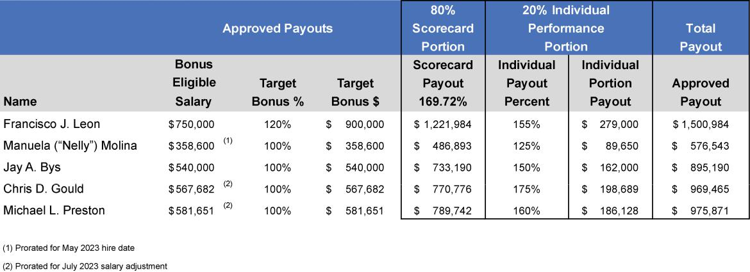

Long-Term Incentive Grants

Our 2023 Compensation Program included the resumption of long-term incentive grants, which were not provided to our NEOs in 2022. In February 2023, the Compensation Committee approved the structure and amounts for the 2023 long-term incentive awards, which were comprised of Restricted Stock Unit ("RSU") awards and Performance Stock Unit ("PSU") awards.

2023 Full and Partial Grants

The 2023 awards included regular full annual grants which are designed to vest over a three-year period. We also granted one-time partial two-year grants which vest over a two-year period. The one-time partial two-year grants, which had grant date values that were equal to two-thirds of the regular annual grant date values, were provided to address retention concerns and provide continuity of vesting for 2024 and 2025 and beyond, as illustrated in the table below. The Compensation Committee provided the one-time awards to address specific retention concerns during the 2023 year and does not intend for the partial two-year awards to be a regular part of future year compensation programs.
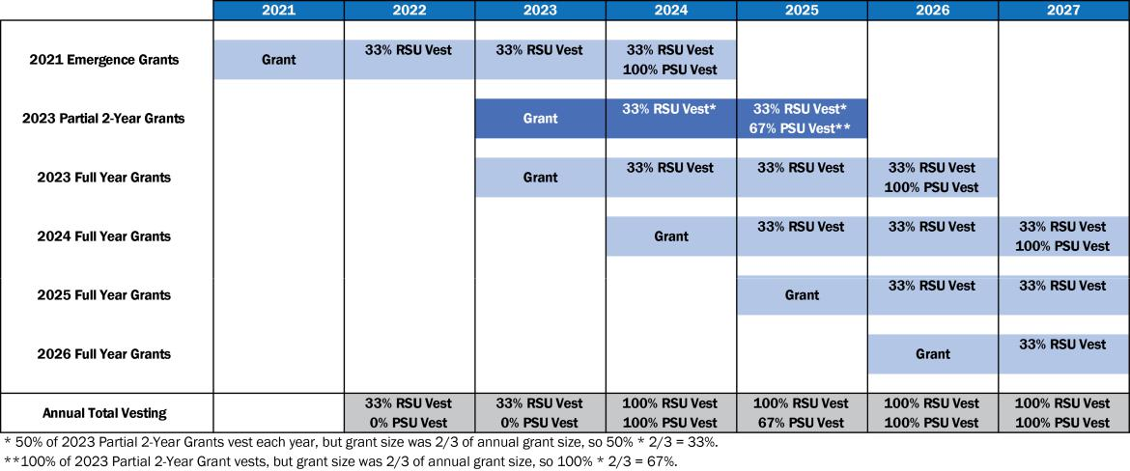

CALIFORNIA RESOURCES CORPORATION 33

2024 PROXY STATEMENT

Compensation Discussion and Analysis

The grant target values for both awards were split between 40% RSUs and 60% PSUs, reflecting our majority performance-based philosophy and consistent with stockholder feedback we received that long-term incentives should be majority performance-based.
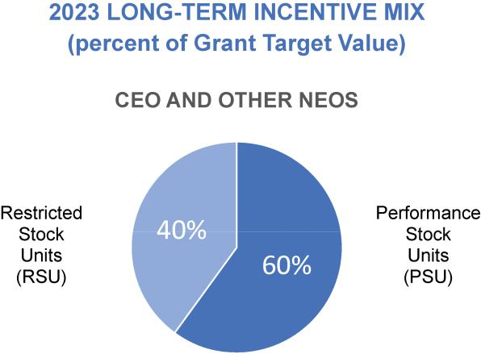

CALIFORNIA RESOURCES CORPORATION 34

2024 PROXY STATEMENT

Compensation Discussion and Analysis

2023 Long-Term Incentive Grants
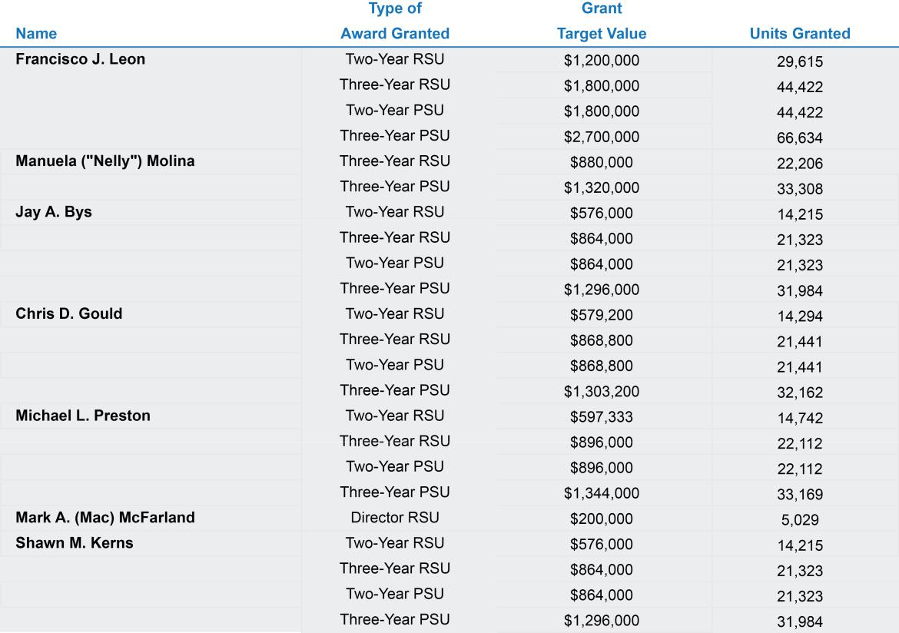

2023 Restricted Stock Unit Awards

The 2023 Restricted Stock Unit awards ("2023 RSU Awards") are stock-based and stock-settled long-term incentive awards primarily intended to promote retention and enhance alignment with stockholder interests through development of ownership in the Company with time-vested payouts. The 2023 RSU Awards generally vest on the anniversary dates of the grant date. The delivery of vested shares occurs immediately after each applicable vesting date. Dividend equivalents are accumulated and paid at the time shares are delivered.

2023 Performance Stock Unit Awards

The 2023 Performance Stock Unit awards ("2023 PSU Awards") are stock-based and stock-settled long-term incentive with performance measures based on the Company's cumulative Total Shareholder Return ("TSR") and the Company's TSR relative the TSR of the companies included in the XOP index.

The 2023 PSU Awards generally vest on the third anniversary of the grant date for the three-year awards and on the second anniversary of the grant date for the two-year award. Payouts can range from 0% to 200% of the target PSUs awarded, based on the performance level attained during the performance period according to the payout matrices below. The performance periods run from January 1, 2023 through December 31 of the year prior to the vesting date. Delivery of earned shares occurs after the applicable vesting date following the Compensation Committee's certification of the performance level achieved. Dividend equivalents are accumulated and paid on earned shares at the time shares are delivered.

CALIFORNIA RESOURCES CORPORATION 35

2024 PROXY STATEMENT

Compensation Discussion and Analysis
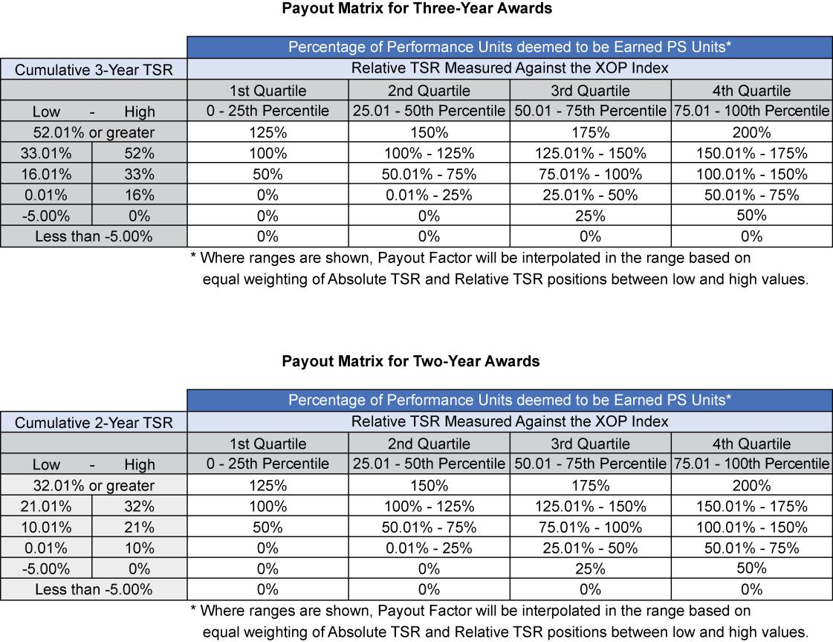

Please see the table below titled “Outstanding Equity Awards at December 31, 2023” for a description of the outstanding equity-based awards that were held by our NEOs at the end of 2023, and the table below titled “Option Exercises and Stock Vested in 2023” for a description of the NEO equity-based awards that vested during the 2023 year.

Cash Retention Bonus Agreements

In February 2023, at the time we announced that Mr. McFarland would step down as President and Chief Executive Officer and Mr. Leon would become President and CEO at our 2023 Annual Meeting and that we were searching for a new Chief Financial Officer, the Compensation Committee determined that it would be in the best interests of stockholders and the Company to enter into individual Retention Bonus Agreements with Messrs. Bys, Gould, Kerns, and Preston in order ensure stability among the senior management team during the period of uncertainty that comes with a change in leadership.

The individual Retention Bonus Agreements provide for a total cash bonus opportunity of one times the NEO's annual base salary at the time of grant. The bonus vests in three installments - the first installment equal to 20% of the total bonus opportunity vested six months after the grant date, the second installment equal to 20% vested 12 months after the grant date and the third installment equal to 60% vests 18 months after the grant date. Vested portions of the retention bonus will become immediately payable following the vesting date. During the retention period, if the NEO is terminated by the Company without cause or due to the NEO's death or disability, any remaining unvested bonus award will immediately become vested and will be paid to the NEO.

CALIFORNIA RESOURCES CORPORATION 36

2024 PROXY STATEMENT

Compensation Discussion and Analysis

Linkage Between Pay and Performance

The 2023 compensation program was designed to link the majority of pay realized by our executives to the performance against the AIP scorecard metrics and stock-based long-term incentives designed to enhance the performance of CRC and the returns to our stockholders.

The pay mix at target values for our CEO and other NEOs under the 2023 Compensation Program was substantially performance-based, with 92% and 80%, respectively, of total compensation considered at-risk for our CEO and other NEOs.
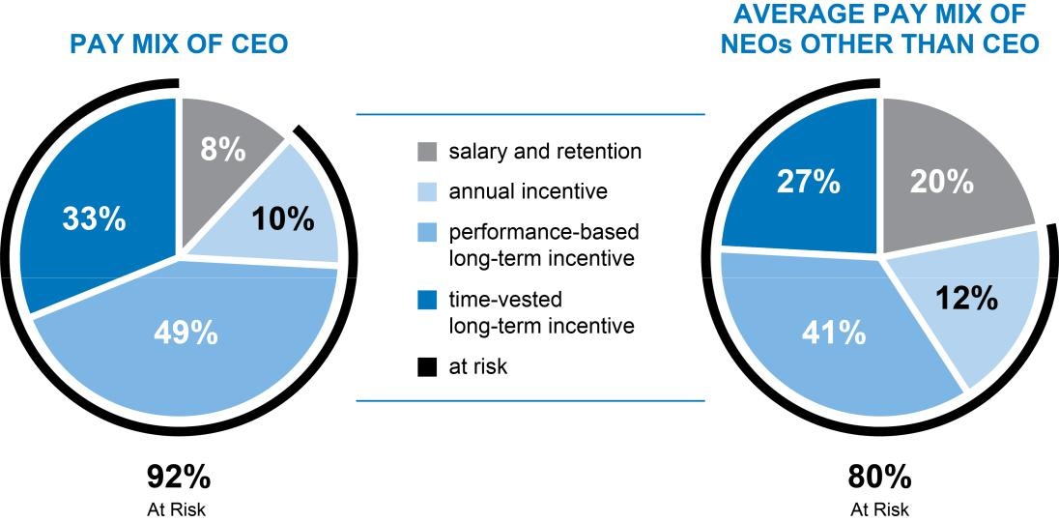

CALIFORNIA RESOURCES CORPORATION 37

2024 PROXY STATEMENT

Compensation Discussion and Analysis

Employment Agreements

In 2021, the Company entered into various employment agreements with our then CEO, Mr. McFarland, and other NEOs, as summarized below. In 2023, the Company entered into new employment agreements with our new CEO, Mr. Leon, our new CFO, Ms. Molina, and Mr. Gould. The Compensation Committee believes it is the best interests of stockholders to have agreements in place to help retain the CEO and other NEOs. These agreements also protect Company interests and ensure that covered executives can execute their duties in the best interests of stockholders without personal bias by providing change in control protections in the event a transaction that is in the best interests of stockholders would result in their termination of their employment.

2023 CEO Employment Agreement

On February 23, 2023, the Company entered into a new employment agreement with Mr. Leon (the “2023 CEO Employment Agreement”) in connection with his anticipated promotion to the position of President and Chief Executive Officer, which superseded the employment agreement previously maintained by the Company and Mr. Leon, dated June 8, 2021, for his position of Executive Vice-President and Chief Financial Officer of the Company. The 2023 CEO Employment Agreement initially governed his role as the Company’s Executive Vice-President and Chief Financial Officer but automatically began covering his new role as President and Chief Executive Officer in connection with his promotion on the date of the Company’s 2023 Annual Meeting of Stockholders. The 2023 CEO Employment Agreement provides for an initial two-year term beginning on February 23, 2023 (the “Effective Date”) and will automatically renew for an additional one-year term on each anniversary of the Effective Date unless the Company or Mr. Leon provides 90 days’ written notice to the other that no such automatic renewal shall occur. The 2023 CEO Employment Agreement provides that Mr. Leon will receive an annual base salary of $750,000. Mr. Leon will also be eligible to receive: (i) an annual cash bonus with a target value equal to 120% of his annual base salary; (ii) participation in those benefit plans and programs of the Company available to similarly situated executives; and (iii) at the same time as other executive officers of the Company receive 2023 annual equity award grants, annual long-term incentive awards (to be comprised 60% of performance stock units and 40% of restricted stock units) under the Company’s 2021 Long Term Incentive Plan (as amended, the "LTIP") with a target grant value of 600% of his base salary as in effect on the applicable grant date. The performance stock unit awards will vest over a three-year cliff vesting period beginning on the date of grant, and the restricted stock units will vest in three equal installments over a three-year vesting period beginning on the date of grant. In addition to his annual 2023 LTIP awards described above, Mr. Leon will also receive two separate awards pursuant to the LTIP in 2023: (i) an award of restricted stock units with a grant date target value of $1,200,000 and (ii) an award of performance units with a grant date target value of $1,800,000, each award of which will vest over a two-year vesting period. The 2023 CEO Employment Agreement also contains provisions that could provide severance payments and benefits to Mr. Leon in qualifying situations. Those terms and an estimate of the payments that he could receive in connection with certain termination events are detailed further below within the section titled "Potential Payments Upon Termination or Change in Control."

Other NEOs

On June 8, 2021, the Company entered into employment agreements with each of Messrs. Bys, Kerns and Preston (each a “2021 Employment Agreement”) that was initially effective through the 2023 year. Each 2021 Employment Agreement provided for an initial one-year term and will automatically renew for an additional one-year term on each anniversary unless the Company or the executive provides 90 days’ written notice to the other that no such automatic renewal shall occur. However, either the Company or the executive may terminate the employment relationship for any or no reason at any time during the initial one-year term or any renewal term. Pursuant to each 2021 Employment Agreement, each executive will receive an annualized base salary of $500,000, will be covered under the Company’s directors and officers liability insurance and will be eligible (i) to receive an annual cash bonus with a target value of 100% of his base salary, (ii) to participate in those benefit plans and programs of the Company available to similarly situated executives and (iii) commencing in 2023, to receive annual long-term incentive awards under the LTIP with a grant target value of not less than 220% of his base salary as in effect on the applicable grant date. The 2021 Employment Agreements also contain provisions that could provide severance payments and benefits to the NEOs in qualifying situations. Those terms and an estimate of the payments that the NEO could receive in connection with certain termination events are detailed further below in the section titled "Potential Payments upon Termination or Change in Control".

CALIFORNIA RESOURCES CORPORATION 38

2024 PROXY STATEMENT

Compensation Discussion and Analysis

On May 8, 2023, the Company entered into an employment agreement (the "2023 CFO Employment Agreement") with Manuela ("Nelly") Molina, the new CFO. The 2023 CFO Employment Agreement provides for an initial two-year term beginning on May 8, 2023 (the "Effective Date") and will automatically renew for an additional one-year term on each anniversary of the Effective Date unless the Company or Ms. Molina provides 90 days’ written notice to the other that no such automatic renewal shall occur. Pursuant to the Employment Agreement, Ms. Molina will receive an annual base salary of $550,000. She will also be eligible to receive: (i) an annual cash bonus with a target value equal to 100% of her annual base salary (prorated for calendar year 2023); (ii) participation in those benefit plans and programs of the Company available to similarly situated executives; and (iii) annual long-term incentive awards (expected to be comprised 60% of performance stock units and 40% of restricted stock units) under the Company’s 2021 Long Term Incentive Plan (as amended, the “LTIP”) with a target grant value of 400% of Ms. Molina’s base salary as in effect on the applicable grant date. The performance stock unit awards are expected to vest over a three-year cliff vesting period beginning on the date of grant, and the restricted stock units are expected to vest in three equal installments over a three-year vesting period beginning on the date of grant. Additionally, Ms. Molina will receive a cash sign-on bonus of $150,000, subject to all applicable tax withholdings. The 2023 CFO Employment Agreement also contains provisions that could provide severance payments and benefits to Ms. Molina in qualifying situations. Those terms and an estimate of the payments that she could receive in connection with certain termination events are detailed further below within the section titled "Potential Payments Upon Termination or Change in Control."

On July 27, 2023, the Company entered into an amended and restated employment agreement (the "2023 CSO Employment Agreement") with Chris D. Gould, our Chief Sustainability Officer, which superseded the employment agreement previously maintained by the Company and Mr. Gould, dated June 14, 2021. The 2023 CSO Employment Agreement provides for an initial two-year term beginning on the Effective Date and will automatically renew for an additional one-year term on each anniversary of the Effective Date unless the Company or Mr. Gould provides 90 days’ written notice to the other that no such automatic renewal shall occur. Pursuant to the Employment Agreement, Mr. Gould will receive an annual base salary of $ 600,000. He will also be eligible to receive: (i) an annual cash bonus with a target value equal to 100% of his annual base salary (prorated for calendar year 2023); (ii) participation in those benefit plans and programs of the Company available to similarly situated executives; and (iii) annual long-term incentive awards (expected to be comprised 60% of performance stock units and 40% of restricted stock units) under the Company’s 2021 Long Term Incentive Plan (as amended, the “LTIP”) with a target grant value of 400% of Mr. Gould’s base salary as in effect on the applicable grant date. The performance stock unit awards are expected to vest over a three-year cliff vesting period beginning on the date of grant, and the restricted stock units are expected to vest in three equal installments over a three-year vesting period beginning on the date of grant. The 2023 CSO Employment Agreement also contains provisions that could provide severance payments and benefits to Mr. Gould in qualifying situations. Those terms and an estimate of the payments that he could receive in connection with certain termination events are detailed further below within the section titled "Potential Payments Upon Termination or Change in Control."

Benefits

In addition to the components of the executive compensation program described above, we provided the following programs to our NEOs during the 2023 year.

Qualified Defined Contribution Plan – All of our employees, including our NEOs, were eligible to participate in a tax-qualified, defined contribution plan. The defined contribution plan provided for periodic cash contributions by us based on annual employee cash compensation and employee-elected deferrals. Employees were permitted to contribute into the plan a percentage of their annual salary and bonus up to the annual limit set by the Internal Revenue Service (“IRS”). Employees were able to direct their account balances to a variety of investments.

Nonqualified Defined Contribution Plans – All employees, including our NEOs, whose participation in our qualified defined contribution plan was limited by applicable tax laws were eligible to participate in our supplemental savings plan (the “SSP”), a nonqualified defined contribution plan, which provided additional retirement benefits outside of those limitations.

CALIFORNIA RESOURCES CORPORATION 39

2024 PROXY STATEMENT

Compensation Discussion and Analysis

Annual allocations for each participant were generally intended to restore the amounts that would have been contributed to our qualified defined contribution plan but for certain tax law limitations, and certain employer allocations were subject to a vesting schedule that required the completion of three years of service. Vested account balances will be payable following separation from service.

Interest on SSP account balances was allocated monthly to each participant’s account based on the yield on five-year U.S. Treasury Constant Maturities plus 2% converted to a monthly allocation factor.

In addition, we sponsored a supplemental retirement plan (the “SRP II”), which was established for purposes of the assumption by us of certain liabilities under the Occidental Petroleum Corporation Supplemental Retirement Plan II, including those for Messrs. Leon, Kerns and Preston. All account balances under the SRP II were fully vested at all times and are credited with interest on a monthly basis based on the yield on five-year U.S. Treasury Constant Maturities plus 2% converted to a monthly allocation factor. No additional allocations were made under the SRP II other than the crediting of interest.

In order to provide greater financial planning flexibility to participants while not increasing costs under the plan, the SRP II allowed in-service distribution of a participant’s account at a specified age, but not earlier than age 60, as elected by the participant when initially participating in the plan. After a participant receives a specified age distribution, future allocations under the SRP II and earnings on those allocations are to be distributed in the first 70 days of each following year.

Nonqualified Deferred Compensation Plan – Certain management and other highly compensated employees (including each of our NEOs) were eligible to participate in our nonqualified deferred compensation plan (the “DCP”). Under the DCP, participants were able to elect to defer a portion of their base salary and annual bonus for a given year. For the year of deferral, we allocated an additional amount to a participant’s account equal to the sum of 6% (which is immediately vested) and 2% (which is subject to a vesting schedule that required the completion of three years of service) of the compensation deferred by the participant under the DCP to restore amounts that were not contributed to the qualified and nonqualified defined contribution plans due to such deferral of compensation under the DCP. Deferred amounts earned interest based on the yield on five-year U.S. Treasury Constant Maturities based on a monthly frequency plus 2%, converted to a monthly allocation factor. Vested account balances will be payable following separation from service, or upon attainment of a specified age elected by the participant.

Tax Preparation and Financial Planning – Our executives, including each of the NEOs, were eligible to receive reimbursement, up to certain annual limits, for income tax preparation, financial planning and investment advice, including legal advice related to tax and financial matters.

Insurance – We offered a variety of health coverage options to all employees. NEOs participated in these plans on the same terms as other employees. In addition, for executives, including the NEOs, we paid for an annual comprehensive physical examination. We provided all employees with life insurance equal to twice the employee’s base salary.

Employee Stock Purchase Plan – We adopted the California Resources Corporation Employee Stock Purchase Plan (the “ESPP”), effective in July 2022, which was approved by shareholders in May 2022 at the 2022 Annual Meeting. The ESPP provides our employees (including our NEOs) the ability to purchase shares of our common stock at a price equal to 85% of the closing price of a share of our common stock as of either the first day of each offering period or the last day of each offering period, whichever amount is less.

The maximum number of shares of our common stock authorized to be issued pursuant to the ESPP is 1.25 million, subject to adjustment pursuant to the terms of the ESPP. In addition, participants in the ESPP will be subject to certain limits on the number of shares that can be purchased in any given year and during any given offering period (a calendar quarter) under the ESPP.

CALIFORNIA RESOURCES CORPORATION 40

2024 PROXY STATEMENT

Compensation Discussion and Analysis

2024 Compensation Program Actions

Base Salaries

The Compensation Committee has approved base salary adjustments for the NEOs in 2024 based on updated peer market data and changes in internal alignment and responsibilities.

Annual Incentive Program

In February 2024, the Compensation Committee approved the scorecard metrics for the 2024 Annual Incentive Program. In addition to metrics related to financial performance and cost management, 30% of the 2024 scorecard weighting relates to ESG-related carbon management, environmental stewardship, and worker safety goals.

Long-Term Incentive Grants

The Compensation Committee continued granting long-term incentive awards to the NEOs in February 2024, consisting of 40% time-based restricted stock units and 60% performance stock units with payouts subject to absolute TSR and relative TSR goals compared to the XOP Index, as supported by feedback from our stockholder outreach.

Other Compensation Matters

Stock Ownership Guidelines

We have minimum stock ownership guidelines for senior executives. The target direct and indirect ownership level for the CEO is six times annual base salary, and for the other NEOs, is three times annual base salary. Executives are expected to reach their guideline ownership levels within five years of assuming their senior executive role. Due to the cancellation of the Company’s stock upon emergence from bankruptcy in October 2020, executives at emergence will have five years from the emergence date to attain the minimum stock holdings.

Clawback Policies

Under the Company’s Incentive-Based Compensation Recoupment Policy, which was adopted in 2023 to ensure compliance with new clawback recovery rules, in the event the Company is required to restate its financial statements, the Company requires in certain circumstances, and to the extent permitted or required by applicable law, regulation or exchange rules, the reimbursement of incentive-based compensation received by a covered employee, including our NEOs, that is in excess of the incentive-based compensation that would have been received based on the restated amounts. Such incentive-based compensation generally includes any cash, equity, equity-based or other award that is granted, earned or vested based wholly or in part upon the attainment of a financial reporting measure, as defined in the policy adopted in October 2023.

In addition, under the Company's Misconduct Compensation Recoupment and Clawback Policy, the Company has the right to require the reimbursement of all or a portion of generally any incentive compensation received by a covered employee, to the extent permitted by applicable law, in the event of fraud or intentional illegal conduct.

Anti-Hedging and Anti-Pledging Policy

Under the Company’s Insider Trading Policy, all directors, officers and employees are prohibited from hedging, buying or selling options, engaging in short sales, or trading prepaid variable forwards, equity swaps, exchange funds, forward-sale contracts, collars or other derivatives or monetizations on Company securities. In addition, all directors, officers and employees may not pledge or mortgage Company securities as collateral for a loan, or hold Company securities in a margin account.

CALIFORNIA RESOURCES CORPORATION 41

2024 PROXY STATEMENT

Compensation Discussion and Analysis

Compensation Risk Management

Our compensation programs are designed to motivate and reward our employees for their performance during the current year and over the long term, and for taking appropriate business risks to enhance CRC’s business performance. The Compensation Committee has analyzed CRC’s employee compensation programs and policies and believes that they are not reasonably likely to have a material adverse effect on CRC. CRC’s compensation programs do not encourage unnecessary or excessive risk-taking and any potential risk that the executive compensation program could influence behavior that would be inconsistent with the overall interests of CRC and its stockholders is mitigated by several factors:

- Target compensation mix utilizes a balance of salary, annual incentives and long-term equity compensation vesting over three years

- Transparent financial and operational metrics that are readily ascertainable from publicly-filed information

- External performance metrics, utilizing the increase in the volume-weighted average price of the Company’s shares, for the long-term performance-based incentive awards

- Forfeiture and clawback provisions for incentive compensation in the event of a restatement of our financial statements or misconduct

Tax Considerations

Section 162(m) of the Internal Revenue Code of 1986, as amended (the “Code”), limits a company’s ability to deduct compensation paid in excess of $1 million during any fiscal year to each of certain NEOs. The Compensation Committee believes it is in the best interest of the Company and our stockholders to provide compensation that is necessary to retain and motivate our executive officers, even if that is not fully deductible.

CALIFORNIA RESOURCES CORPORATION 42

2024 PROXY STATEMENT

Compensation Committee Report

Compensation Committee Report

The Compensation Committee has reviewed and discussed the Compensation Discussion and Analysis included in this proxy statement with management. Based on this review and discussion, the Compensation Committee recommended to the Board of Directors that the Compensation Discussion and Analysis be included in the Company’s proxy statement relating to the 2024 Annual Meeting of Stockholders.

Compensation Committee,

James N. Chapman, Chair

Andrew B. Bremner
Nicole Neeman Brady

March 15, 2024

CALIFORNIA RESOURCES CORPORATION 43

2024 PROXY STATEMENT

Executive Compensation Tables

Executive Compensation Tables

Summary Compensation Table ("SCT")

 |  |  |  |  |  |  |  |  |  |  |  |  |  |  |  | Change in
 |  |  |  |  |  |  |  |  |  |  |  |  |  |  |  | Pension
 |  |  |  |  |  |  |  |  |  |  |  |  |  |  |  | Value and
 |  |  |  |  |  |  |  |  |  |  |  |  |  |  |  | Nonqualified
 |  |  |  |  |  |  |  |  |  |  |  |  |  | Non-Equity |  | Deferred
 | Name and |  |  |  |  |  |  |  |  | Stock |  | Option | Incentive Plan |  | Compensation |  |  |  | All Other
 | Principal |  | Year |  |  | Salary |  | Bonus |  | Awards |  | Awards | Compensation |  |  | Earnings | Compensation |  |  |  |  | Total
 | Position |  |  |  |  | (1) |  | (2) |  | (3) |  | (3) |  | (4) |  | (5) |  |  | (6)
 | Francisco J. Leon |  |  |  |  |  |  |  |  |  |  |  |  |  |  |  |  |  |  |  |  | 10,185,66
 | Francisco J. Leon | 2023 |  | $ |  | 708,654 | $ | 279,000 | $ | 7,673,589 | $ | 0 | $ | 1,221,984 | $ | 10,234 | $ |  | 292,207 |  | $ | 8
 | President and | 2022 |  | $ |  | 500,000 | $ | 175,000 | $ | 0 | $ | 0 | $ | 483,200 | $ | 10,245 | $ |  | 244,557 |  | $ | 1,413,002
 | Chief Executive Officer | 2021 |  | $ |  | 491,154 | $ | 150,000 | $ | 3,641,638 | $ | 0 | $ | 648,000 | $ | 4,181 | $ |  | 106,925 |  | $ | 5,041,898
 | Manuela ("Nelly") Molina (7) | 2023 |  | $ |  | 349,039 | $ | 239,650 | $ | 2,298,501 | $ | 0 | $ | 486,893 | $ | 0 | $ |  | 59,474
 |  |  |  |  |  |  |  |  |  |  |  |  |  |  |  |  |  |  |  |  | $ | 3,433,557
 | Executive Vice President and
 | Chief Financial Officer
 | Jay A. Bys |  | 2023 | $ |  | 532,308 | $ | 270,000 | $ | 3,683,335 | $ | 0 | $ | 733,190 | $ | 1,517 | $ |  | 213,928
 | Jay A. Bys |  |  |  |  |  |  |  |  |  |  |  |  |  |  |  |  |  |  |  | $ | 5,434,278
 | Executive Vice President and |  | 2022 | $ |  | 500,000 | $ | 140,000 | $ | 0 | $ | 0 | $ | 483,200 | $ | 431 | $ |  | 218,688 |  | $ | 1,342,319
 | Chief Commercial Officer | 2021 |  | $ |  | 626,923 | $ | 150,000 | $ | 2,684,108 | $ | 0 | $ | 648,000 | $ | 0 | $ |  | 77,332 |  | $ | 4,186,363
 | Chris D. Gould (7) | 2023 |  | $ |  | 553,381 | $ | 307,289 | $ | 3,703,777 | $ | 0 | $ | 770,776 | $ | 954 | $ |  | 157,113
 |  |  |  |  |  |  |  |  |  |  |  |  |  |  |  |  |  |  |  |  | $ | 5,493,290
 | Executive Vice President and
 | Chief Sustainability Officer
 | Michael L. Preston |  | 2023 | $ |  | 569,038 | $ | 298,128 | $ | 3,819,735 | $ | 0 | $ | 789,742 | $ | 27,431 | $ |  | 253,195
 | Michael L. Preston |  |  |  |  |  |  |  |  |  |  |  |  |  |  |  |  |  |  |  | $ | 5,757,269
 | Executive Vice President, |  | 2022 | $ |  | 500,000 | $ | 150,000 | $ | 0 | $ | 0 | $ | 483,200 | $ | 30,044 | $ |  | 244,557 |  | $ | 1,407,801
 | Chief Strategy Officer | 2021 |  | $ |  | 495,385 | $ | 150,000 | $ | 3,641,638 | $ | 0 | $ | 648,000 | $ | 13,148 | $ |  | 107,834 |  | $ | 5,056,005
 | and General Counsel
 | Mark A. (Mac) McFarland (8) | 2023
 | Mark A. (Mac) McFarland (8) |  |  |  | $ | 294,231 | $ | 0 | $ | 203,675 | $ | 0 | $ | 0 | $ | 3,261 | $ |  | 413,530 |  | $ | 914,697
 | Former President and |  | 2022 |  | $ | 850,000 | $ | 301,920 | $ | 0 | $ | 0 | $ | 985,728 | $ | 1,180 | $ |  | 668,921 |  | $ | 2,807,749
 | Chief Executive Officer |  |  |  |  |  |  |  |  |  |  |  |  |  |  |  |  |  |  |  |  | 17,583,28
 | Chief Executive Officer |  | 2021 |  | $ | 1,122,395 | $ | 306,000 | $ | 14,132,218 | $ | 0 | $ | 1,043,022 | $ | 0 | $ |  | 979,646 |  | $ | 1
 | Shawn M. Kerns (9) | 2023 |  | $ |  | 316,308 | $ | 540,000 | $ | 3,683,335 | $ | 0 | $ | 0 | $ | 23,230
 |  |  |  |  |  |  |  |  |  |  |  |  |  |  |  |  |  | $ | 1,597,097 |  | $ | 6,159,970
 | Former Executive Vice | 2022 |  | $ |  | 500,000 | $ | 115,000 | $ | 0 | $ | 0 | $ | 483,200 | $ | 25,360 |  | $ | 244,557 |  | $ | 1,368,117
 | President and Chief Operating Officer | 2021 |  | $ |  | 494,231 | $ | 150,000 | $ | 3,641,638 | $ | 0 | $ | 648,000 | $ | 11,056 | $ |  | 107,368 |  | $ | 5,052,293

- Amounts shown for 2023 reflect a partial year for Ms. Molina and Messrs. McFarland and Kerns. Ms. Molina was hired in May 2023, replacing Mr. Leon as Chief Financial Officer. Mr. McFarland stepped down as President and Chief Executive Officer at the 2023 Annual Meeting, at which time Mr. Leon became President and CEO. Mr. McFarland continues to serve as a director. Mr. Kerns retired as part of the Company's restructuring at the end of July 2023. Amounts shown for 2021 reflect a partial year of independent contractor fees and a partial year of employment for Messrs. McFarland and Bys. Mr. McFarland had an Interim CEO Agreement with the Company under which the Company paid a fee of $175,000 per month, beginning in January 2021 and ending March 21, 2021, for his services as Interim CEO. Under the terms of the agreement, he received no cash compensation for his role as Chair of the Board while serving as Interim CEO but remained eligible to receive a director’s emergence equity grant. On March 22, 2021, the Company announced that Mr. McFarland had been named President and CEO, dropping the interim title, in addition to his role as Chair of the Board. On April 15, 2021, the Company announced that Ms. Tiffany (TJ) Thom Cepak had been named Chair of the Board, thereby replacing Mr. McFarland in that role. Mr. Bys had a consulting agreement with the Company under which the Company paid a fee of $75,000 per month, beginning January 1, 2021, for his consulting services. The agreement terminated upon his appointment as an officer of the Company, effective May 1, 2021.

- The amounts shown for 2023 for Messrs. Bys, Gould and Preston include 20% of the Retention Bonus Awards granted in February 2023 which were paid in August 2023. The remainder of those Retention Bonus Awards will be paid in 2024. The amount shown for 2023 for Ms. Molina includes a $150,000 sign-on bonus which is subject to repayment if Ms. Molina terminates employment before the second anniversary of her employment date. The amounts shown for all years include the individual performance portion of the AIP bonus payouts.

- See the Grants of Plan-Based Awards Table below for detail regarding the 2023 awards. As required by the SEC rules, the amounts shown represent the grant date fair value of the awards granted in that year as computed in accordance with U.S. generally accepted accounting principles (GAAP) and Financial Accounting Standards Board (FASB) Accounting Standards Codification (ASC) Topic 718, as more fully described in Note 9 in our Annual Report. Awards reported in the Stock Awards column reflect the value of both time-vested RSUs and performance-earned PSUs (including the director grants that Mr. McFarland was eligible to receive in 2023 and 2021). Depending on the market price of CRC stock on the award certification date, the final payout value could be significantly higher or lower that the amount shown in the table. For PSUs, there was a possibility of no payout depending on the outcome of the performance criteria. There were no stock awards granted to the NEOs in 2022 and no option awards granted in any year.

CALIFORNIA RESOURCES CORPORATION 44

2024 PROXY STATEMENT

Executive Compensation Tables

- The amounts shown are the scorecard portion of the payouts under the AIP, which are based on Company performance. The 2021 amount for Mr. McFarland reflects a reduction of $278,898 from the amount approved by the Compensation Committee to reflect the difference between his interim CEO agreement monthly fee and his employment agreement salary for the period from January 1, 2021 through March 21, 2021.

- The amounts shown are the portion of each executive’s interest credited on nonqualified deferred compensation plan balances that was in excess of 120% of the long-term applicable federal rate, compounded monthly, as prescribed under Section 1274(d) of the Code.

- The following table shows “All Other Compensation” amounts for 2023.

All Other Compensation

 |  |  | Mr. |  |  |  |  | Ms. |  |  | Mr. |  |  | Mr. |  |  | Mr. |  |  | Mr. |  |  | Mr.
 |  |  | Leon |  |  |  |  | Molina |  |  | Bys |  |  | Gould |  |  | Preston |  |  | McFarland |  |  | Kerns
Qualified Plan (a) | $ |  | 23,700 | $ |  |  |  | 33,000 | $ |  | 33,000 | $ |  | 27,000 | $ |  | 21,646 | $ |  | 26,400 | $ |  | 26,400
Supplemental Plan (b) |  |  | 140,220 |  |  |  |  | 26,474 |  |  | 84,158 |  |  | 92,277 |  |  | 103,262 |  |  | 48,750 |  |  | 25,449
Director Fees (c) |  |  | - |  |  |  |  | - |  |  | - |  |  | - |  |  | - |  |  | 105,353 |  |  | -
Dividend Equivalents (d) |  |  | 128,287 |  |  |  |  | - |  |  | 96,770 |  |  | 27,836 |  |  | 128,287 |  |  | 139,547 |  |  | 62,620
Accrued Vacation Payout (e) |  |  | - |  |  |  |  | - |  |  | - |  |  | - |  |  | - |  |  | 93,480 |  |  | 93,462
Severance (f) |  |  | - |  |  |  |  | - |  |  | - |  |  | - |  |  | - |  |  | - |  |  | 1,389,166
Personal Benefits (g) |  |  | - |  |  |  |  | - |  |  | - |  |  | 10,000 |  |  | - |  |  | - |  |  | -
Total |  | $ | 292,207 |  |  |  | $ | 59,474 | $ |  | 213,928 | $ |  | 157,113 | $ |  | 253,195 | $ |  | 413,530 | $ |  | 1,597,097

  - The amount shown reflects the Company matching and profit-sharing retirement contributions to the qualified defined contribution savings plan–the California Resources Corporation Savings Plan (the “Qualified Plan”).

  - The amount shown is the Company contributions to the nonqualified defined contribution plan–the California Resources Corporation Supplemental Savings Plan (the “Supplemental Plan”), which restores amounts limited by the IRS to the Qualified Plan.

  - Reflects the director fees paid to Mr. McFarland after he stepped down as President and Chief Executive Officer at the 2023 Annual meeting and remained as a non-employee director.

  - Reflects value of dividend equivalents credited during 2023 on unvested RSU and unvested PSU awards which have been earned for awards where dividend equivalents were not factored into the grant date fair value of the award.

  - Reflects payouts of unused accrued vacation following termination of employment.

  - Reflects severance payments for Mr. Kerns which were payable under the terms of his employment agreement following his retirement on July 31, 2023 as part of the Company's restructuring.

  - Reflects financial counseling benefits for Mr. Gould.

- Ms. Molina and Mr. Gould were not NEOs in 2021 or 2022. Compensation paid for years in which the executive was not an NEO are not disclosed in the SCT.

- Mr. McFarland stepped down as President and CEO at the 2023 Annual Meeting and was replaced by Mr. Leon.

- As a result of restructuring during 2023, Mr. Kerns retired, effective July 31, 2023. Under the terms of his employment agreement, Mr. Kerns was eligible for certain severance benefits, including 18 months of base salary, one times his annual target bonus and continued medical coverage at active contribution rates for 18 months.

CALIFORNIA RESOURCES CORPORATION 45

2024 PROXY STATEMENT

Executive Compensation Tables

Grants of Plan-Based Awards

The table below summarizes the plan-based awards granted in 2023 to our NEOs, which included AIP awards (Annual Incentive), Restricted Stock Unit awards (RSU) and Performance Stock Unit awards (PSU).

 |  |  |  |  |  |  |  |  |  |  |  |  |  |  | All Other
 |  |  |  |  |  |  |  |  |  |  |  |  |  |  | Stock
 |  |  |  |  |  |  |  |  |  |  |  |  |  |  | Awards:
 |  |  |  |  |  |  |  |  |  |  |  |  |  |  | Number of |  |  |  | Grant Date
 |  |  | Estimated Future Payouts |  |  |  |  |  |  | Estimated Future Payouts |  |  |  |  | Shares of |  |  |  | Fair Value
 |  |  | Under Non-Equity Incentive |  |  |  |  |  |  |  | Under Equity Incentive |  |  |  | Stock |  |  |  | of Stock
 |  |  |  |  | Plan Awards |  |  |  |  |  | Plan Awards |  |  |  | or Units |  |  |  | Awards
Name / | Grant |  | Threshold |  | Target |  | Maximum |  |  | Threshold | Target | Maximum
Type of Grant | Date |  | ($)(1) |  | ($) |  | ($) |  |  | (# Shares)(2) | (# Shares) | (# Shares) |  |  | (# Shares) |  |  |  | ($)
Francisco J. Leon
Annual Incentive | $ |  | 7,200 | $ | 720,000 | $ | 1,440,000
RSU(3) | 2/23/2023 |  |  |  |  |  |  |  |  |  |  |  | 44,422 |  |  | $ |  |  | 1,759,555
RSU(4) | 2/23/2023 |  |  |  |  |  |  |  |  |  |  |  | 29,615 |  |  | $ |  |  | 1,173,050
PSU(5) | 2/23/2023 |  |  |  |  |  |  | 7 |  |  | 66,634 | 133,268 |  |  |  | $ |  |  | 3,016,521
PSU(6) | 2/23/2023 |  |  |  |  |  |  | 4 |  |  | 44,422 | 88,844 |  |  |  | $ |  |  | 1,724,462
Manuela ("Nelly") Molina
Annual Incentive |  | $ | 2,869 | $ | 286,880 | $ | 573,760
RSU(7) | 5/8/2023 |  |  |  |  |  |  |  |  |  |  |  | 22,206 |  |  | $ |  |  | 881,578
PSU(8) | 5/8/2023 |  |  |  |  |  |  | 3 |  |  | 33,308 | 66,616 |  |  |  | $ |  |  | 1,416,922
Jay A. Bys
Annual Incentive |  | $ | 4,320 | $ | 432,000 | $ | 864,000
RSU(3) | 2/23/2023 |  |  |  |  |  |  |  |  |  |  |  | 21,323 |  |  | $ |  |  | 844,604
RSU(4) | 2/23/2023 |  |  |  |  |  |  |  |  |  |  |  | 14,215 |  |  | $ |  |  | 563,056
PSU(5) | 2/23/2023 |  |  |  |  |  |  |  |  | 3 | 31,984 | 63,968 |  |  |  | $ |  |  | 1,447,916
PSU(6) | 2/23/2023 |  |  |  |  |  |  |  |  | 2 | 21,323 | 42,646 |  |  |  | $ |  |  | 827,759
Chris D. Gould
Annual Incentive |  | $ | 4,541 | $ | 454,146 | $ | 908,292
RSU(3) | 2/23/2023 |  |  |  |  |  |  |  |  |  |  |  | 21,441 |  |  | $ |  |  | 849,278
RSU(4) | 2/23/2023 |  |  |  |  |  |  |  |  |  |  |  | 14,294 |  |  | $ |  |  | 566,185
PSU(5) | 2/23/2023 |  |  |  |  |  |  |  |  | 3 | 32,162 | 64,324 |  |  |  | $ |  |  | 1,455,974
PSU(6) | 2/23/2023 |  |  |  |  |  |  |  |  | 2 | 21,441 | 42,882 |  |  |  | $ |  |  | 832,340
Michael L. Preston
Annual Incentive |  | $ | 4,653 | $ | 465,321 | $ | 930,642
RSU(3) | 2/23/2023 |  |  |  |  |  |  |  |  |  |  |  | 22,112 |  |  | $ |  |  | 875,856
RSU(4) | 2/23/2023 |  |  |  |  |  |  |  |  |  |  |  | 14,742 |  |  | $ |  |  | 583,931
PSU(5) | 2/23/2023 |  |  |  |  |  |  |  |  | 3 | 33,169 | 66,338 |  |  |  | $ |  |  | 1,501,561
PSU(6) | 2/23/2023 |  |  |  |  |  |  |  |  | 2 | 22,112 | 44,224 |  |  |  | $ |  |  | 858,388
Mark A. (Mac) McFarland
Annual Incentive(9)
RSU(10) | 4/28/2023 |  |  |  |  |  |  |  |  |  |  |  |  |  | 5,029 | $ |  |  | 203,675
Shawn M. Kerns
Annual Incentive(9) |  | $ | 4,320 | $ | 432,000 | $ | 864,000
RSU(3) | 2/23/2023 |  |  |  |  |  |  |  |  |  |  |  |  |  | 21,323 |  |  | $ | 844,604
RSU(4) | 2/23/2023 |  |  |  |  |  |  |  |  |  |  |  |  |  | 14,215 |  |  | $ | 563,056
PSU(5) | 2/23/2023 |  |  |  |  |  |  |  |  | 3 | 31,984 | 63,968 |  |  |  |  |  | $ | 1,447,916
PSU(6) | 2/23/2023 |  |  |  |  |  |  |  |  | 2 | 21,323 | 42,646 |  |  |  |  |  | $ | 827,759

- The “Threshold” amounts are shown at 1% of target, calculated based on threshold payout of the lowest weighted performance metric under the award. Actual payments could have ranged from 0% to 200%.

- The “Threshold” amounts are shown at 0.01% of target, calculated based on the lowest possible nonzero payout under the award. Actual payments can range from 0% to 200%.

- The amounts shown represent the estimated grant date fair value of the units granted as computed in accordance with FASB ASC Topic 718, as more fully described in Note 9 Stock-Based Compensation to CRC’s Consolidated Financial Statements in the Form 10-K for the year ended December 31, 2023. The units vest one-third each

on February 22, 2024, February 22, 2025 and February 22, 2026.

- The amounts shown represent the estimated grant date fair value of the units granted as computed in accordance with FASB ASC Topic 718, as more fully described in Note 9 Stock-Based Compensation to CRC’s Consolidated Financial Statements in the Form 10-K for the year ended December 31, 2023. The units vest one-half each on February 22, 2024 and February 22, 2025.

- The amounts shown represent the estimated grant date fair value of the units granted as computed in accordance with FASB ASC Topic 718, as more fully described in Note 9 Stock-Based Compensation to CRC’s Consolidated Financial Statements in the Form 10-K for the year ended December 31, 2023. The maximum payouts under the awards were: Leon - $7,287,094, Bys - $3,497,770, Gould - $3,517,236, Preston - $3,627,362, Kerns - $3,497,770. Payouts under the PSU award can range from 0% to 200% of target number of units based on our cumulative TSR and TSR relative to the companies in the XOP Index during the three-year performance period from January 1, 2023 through December 31, 2025. The threshold amount is shown at 0.01% of target, calculated based on threshold payout under the performance metric for the award. Linear interpolation applies between the thresholds in the payout matrix shown in the "Compensation Discussion and Analysis" section above. The PSU awards vest on February 22, 2026. Vested shares are delivered immediately following certification of the performance result by the Compensation Committee following the vesting date.

- The amounts shown represent the estimated grant date fair value of the units granted as computed in accordance with FASB ASC Topic 718, as more fully described in Note 9 Stock-Based Compensation to CRC’s Consolidated Financial Statements in the Form 10-K for the year ended December 31, 2023. The maximum payouts under the awards were: Leon - $4,857,990, Bys - $2,331,883, Gould - $2,344,788, Preston - $2,418,168, Kerns - $2,331,883. Payouts under the Performance Stock Unit award can range from 0%

CALIFORNIA RESOURCES CORPORATION 46

2024 PROXY STATEMENT

Executive Compensation Tables

to 200% of target number of units based on our cumulative TSR and TSR relative to the companies in the XOP Index during the two-year performance period from January 1, 2023 through December 31, 2024. The threshold amount is shown at 0.01% of target, calculated based on threshold payout under the performance metric for the award. Linear interpolation applies between the thresholds in the payout matrix shown in the "Compensation Discussion and Analysis" section above. The PSU awards vest on February 22, 2025. Vested shares are delivered immediately following certification of the performance result by the Compensation Committee following the vesting date.

- The amount shown represents the estimated grant date fair value of the units granted as computed in accordance with FASB ASC Topic 718, as more fully described in Note 9 Stock-Based Compensation to CRC’s Consolidated Financial Statements in the Form 10-K for the year ended December 31, 2023. The units vest one-third each on May 8, 2024, May 8, 2025 and May 8, 2026.

- The amount shown represents the estimated grant date fair value of the units granted as computed in accordance with FASB ASC Topic 718, as more fully described in Note 9 Stock-Based Compensation to CRC’s Consolidated Financial Statements in the Form 10-K for the year ended December 31, 2023. The maximum payout under the award was $3,642,563. Payout under the Performance Stock Unit award can range from 0% to 200% of target number of units based on our cumulative TSR and TSR relative to the companies in the XOP Index during the three-year performance period from January 1, 2023 through December 31, 2025. The threshold amount is shown at 0.01% of target, calculated based on threshold payout under the performance metric for the award. Linear interpolation applies between the thresholds in the payout matrix shown in the "Compensation Discussion and Analysis" section above. The PSU awards vest on May 8, 2026. Vested shares are delivered immediately following certification of the performance result by the Compensation Committee following the vesting date.

- Messrs. McFarland and Kerns forfeited their 2023 Annual Incentive when they separated from employment.

- The amount shown represents the estimated grant date fair value of the units granted as computed in accordance with FASB ASC Topic 718, as more fully described in Note 9 Stock-Based Compensation to CRC’s Consolidated Financial Statements in the Form 10-K for the year ended December 31, 2023. The units vest on April 28, 2024, but are not delivered to Mr. McFarland until six months after he ends his board service.

Narrative Disclosure to Summary Compensation Table and Grants of Plan-Based Awards Table

Employment Agreements

We have entered into an employment agreement with each of our NEOs. For more information, see the “Employment Agreements” section in the “Compensation Discussion and Analysis” section above.

Long-Term Incentives

There were no long-term incentive grants in 2022. During 2021, our NEOs received emergence grants allocated between RSUs and PSUs which generally vested over three years. Since all of the NEO's prior Company equity awards were cancelled upon our emergence from bankruptcy in 2020, the NEOs have not received payouts of long-term incentives since 2020, other than Mr. Gould, who received payouts of his 2021 two-year awards in 2023. During 2023, our NEOs received long-term incentive grants allocated between RSUs and PSUs. The 2023 RSUs and PSUs consisted of regular three-year grants and one-time two-year grants to reestablish ongoing annual long-term incentive payouts beginning in 2024 for our NEOs. While RSUs and PSUs generally vest (and performance under the PSUs is measured) over a three- or two-year period and payment is made following vesting, please see the description of each NEO’s employment agreement in the “Employment Agreements” section of the “Compensation Discussion and Analysis” section above and the “Potential Payments upon Termination or Change in Control” section below for a description of certain circumstances pursuant to which vesting and payout can occur earlier.

Annual Incentives

Our NEOs were eligible to participate in the AIP for the 2023 calendar year. Payouts under the AIP are based on a combination of company performance against goals for pre-established performance metrics, and our Compensation Committee’s assessment of each NEO’s individual performance, as described in the "Compensation Discussion and Analysis" section above.

CALIFORNIA RESOURCES CORPORATION 47

2024 PROXY STATEMENT

Executive Compensation Tables

Outstanding Equity Awards at December 31, 2023

The following table summarizes the outstanding equity awards for our NEOs as of December 31, 2023.

 |  |  |  |  | Stock Awards
 |  |  |  |  |  |  |  | Equity
 |  |  |  |  |  |  | Incentive
 |  |  |  |  |  |  |  | Plan
 |  |  |  |  |  | Equity | Awards:
 |  |  |  |  |  | Incentive | Market or
 |  |  | Number |  |  | Plan |  | Payout
 |  |  | of |  |  | Awards: | Value of
 |  |  | Shares |  | Market | Number of | Unearned
 |  |  | or Units |  | Value of | Unearned |  | Shares,
 |  |  | of Stock |  | Shares or | Shares, Units | Units or
 |  |  | That |  | Units That | or Other | Other Rights
 |  |  | Have Not |  | Have Not | Rights That | That Have
Name / Type | Grant |  | Vested |  | Vested | Have Not | Not Vested
of Grant | Date | (#) |  |  | ($)(1) | Vested (#) | ($ |  | )(1)
Francisco J. Leon
RSU(2) | 1/25/2021 | 27,707 |  | $ | 1,515,019
PSU(3) | 1/25/2021 | 83,124 |  | $ | 4,545,220
RSU(4) | 2/23/2023 |  | 44,422 | $ | 2,428,995
RSU(5) | 2/23/2023 |  | 29,615 | $ | 1,619,348
PSU(6) | 2/23/2023 |  |  |  |  | 66,634 | $ |  | 3,643,547
PSU(7) | 2/23/2023 |  |  |  |  | 44,422 | $ |  | 2,428,995
Manuela ("Nelly") Molina
RSU(8) | 5/8/2023 |  | 22,206 | $ | 1,214,224
PSU(9) | 5/8/2023 |  |  |  |  | 33,308 | $ |  | 1,821,281
Jay A. Bys
RSU(2) | 5/12/2021 |  | 22,294 | $ | 1,219,036
PSU(3) | 5/12/2021 |  | 61,309 | $ | 3,352,376
RSU(4) | 2/23/2023 |  | 21,323 | $ | 1,165,942
RSU(5) | 2/23/2023 |  | 14,215 | $ | 777,276
PSU(6) | 2/23/2023 |  |  |  |  | 31,984 | $ |  | 1,748,885
PSU(7) | 2/23/2023 |  |  |  |  | 21,323 | $ |  | 1,165,942
Chris D. Gould
RSU(4) | 2/23/2023 |  | 21,441 | $ | 1,172,394
RSU(5) | 2/23/2023 |  | 14,294 | $ | 781,596
PSU(6) | 2/23/2023 |  |  |  |  | 32,162 | $ |  | 1,758,618
PSU(7) | 2/23/2023 |  |  |  |  | 21,441 | $ |  | 1,172,394
Michael L. Preston
RSU(2) | 1/25/2021 |  | 27,707 | $ | 1,515,019
PSU(3) | 1/25/2021 |  | 83,124 | $ | 4,545,220
RSU(4) | 2/23/2023 |  | 22,112 | $ | 1,209,084
RSU(5) | 2/23/2023 |  | 14,742 | $ | 806,093
PSU(6) | 2/23/2023 |  |  |  |  | 33,169 | $ |  | 1,813,681
PSU(7) | 2/23/2023 |  |  |  |  | 22,112 | $ |  | 1,209,084
Mark A. (Mac) McFarland
RSU(10) | 1/25/2021 |  | 20,444 | $ | 1,117,878
RSU(11) | 4/28/2023 |  | 5,029 | $ | 274,986
Shawn M. Kerns
PSU(6) | 2/23/2023 |  |  |  |  | 4,850 | $ |  | 265,198
PSU(7) | 2/23/2023 |  |  |  |  | 4,976 | $ |  | 272,088

- The amount shown represents the product of the number of units in the column immediately to the left and the closing price on December 31, 2023, of our common stock as reported in the NYSE Composite Transactions, which was $54.68 per share.

- These units vest on January 25, 2024, and settlement of vested units will occur immediately thereafter.

- Payout of this PSU award is subject to the achievement of specified 60-day VWAP thresholds over a three-year period from January 25, 2021 to January 24, 2024. As of December 31, 2022, the 60-day VWAP had reached the performance level to earn a 100% payout. This award is not reported in the Equity Incentive Plan Awards column because the performance condition for earning a payout of 100% of the units has been met, although vesting and settlement will not occur until January 25, 2024, subject to certain conditions as provided in the award agreements.

- One-third of these units vest on each of February 23, 2024, February 23, 2025, and February 23, 2026, and settlement of vested units will occur immediately thereafter.

- One-half of these units vest on each of February 23, 2024 and February 23, 2025, and settlement of vested units will occur immediately thereafter.

- Payout of this PSU award is subject to the achievement of specified cumulative TSR and TSR relative to the companies in the XOP Index over a three-year period from January 1, 2023 to December 31, 2025. The units cliff vest on February 23, 2026. The number of shares is shown at target performance.

- Payout of this PSU award is subject to the achievement of specified cumulative TSR and TSR relative to the companies in the XOP Index over a two-year period from January 1, 2023 to December 31, 2024. The units cliff vest on February 23, 2025. The number of shares is shown at target performance.

- One-third of these units vest on each of May 8, 2024, May 8, 2025, and May 8, 2026, and settlement of vested units will occur immediately thereafter. The number of shares is shown at target performance.

- Payout of this PSU award is subject to the achievement of specified cumulative TSR and TSR relative to the companies in the XOP Index over a three-year period from January 1, 2023 to December 31, 2025. The units cliff vest on May 8, 2026. The number of shares is shown at target performance.

CALIFORNIA RESOURCES CORPORATION 48

2024 PROXY STATEMENT

Executive Compensation Tables

- These units vest on January 25, 2024, although settlement of vested units will not occur until six months after the end of Mr. McFarland's Board service.

- These units vest on April 28, 2024, although settlement of vested units will not occur until six months after the end of Mr. McFarland's Board service.

Option Exercises and Stock Vested in 2023

The second tranche of the RSUs granted in 2021 vested during 2023, although vested shares will not be delivered until 2024 under the terms of the awards, except for Mr. Gould, as noted below. As such, none of the NEOs, other than Mr. Gould, have been issued any shares under the 2021 awards and have not realized any value with respect to those vested RSUs. Mr. Kerns received vested shares from the RSUs granted in 2023, which prorated and vested upon his separation in 2023. At the time shares are delivered under the stock awards, shares are cancelled and the Company pays cash for required tax withholding, reducing the potential stock dilution from shares issued for stock awards. There are no outstanding option awards to be exercised.

 |  |  | Stock Awards
 | Number of |  |  | Value Realized
 | Shares
Name | Acquired on |  |  | on Vesting
Name | Vesting (#)(1) |  | ($ |  | )(2)
Francisco J. Leon |  | 27,708 | $ |  | 1,303,384
Manuela ("Nelly") Molina |  | 0 | $ |  | 0
Jay A. Bys |  | 22,294 | $ |  | 1,048,710
Chris D. Gould |  | 49,267 | $ |  | 2,081,038
Michael L. Preston |  | 27,708 | $ |  | 1,303,384
Mark A. (Mac) McFarland |  | 416,180 |  | $ | 16,598,535
Shawn M. Kerns |  | 57,985 |  | $ | 2,918,662

- The second tranche of RSUs granted on January 25, 2021, to Messrs. McFarland, Leon, Kerns and Preston and on May 12, 2021, to Mr. Bys vested on January 25, 2023; the second tranche of RSUs and all of the earned PSUs granted to Mr. Gould on June 14, 2021, vested on June 14, 2023; the second tranche of RSUs granted to Mr. McFarland on March 22, 2021, vested on March 22, 2023. Under the terms of the awards, the vested shares will not be delivered to the NEOs until 2024, except for the vested shares for Mr. Gould, which were delivered to him following vesting in 2023.

- These amounts were calculated as the number of vesting RSUs times the closing stock price of our common stock as reported in the NYSE Composite Transactions on the respective vesting dates. The vested RSUs will not be delivered to the NEOs, except for Mr. Gould as noted in Footnote (1) above, until 2024. Includes the cash value of RSUs canceled to pay certain tax liabilities on RSUs which vested during 2023. The number of RSUs canceled were: Mr. McFarland – 3,797; Mr. Leon 1,506; Messrs. Kerns and Preston – 1,507 each; and Mr. Bys – 1,109. The remaining amounts of vested RSUs that will be settled in 2024 are reflected below within the 2023 Nonqualified Deferred Compensation Table.

2023 Nonqualified Deferred Compensation Table

The following table sets forth for 2023 the contributions, earnings, withdrawals and balances under the SSP, SRP II and the DCP in which the NEOs participated. Messrs. Leon, Kerns and Preston were fully vested in their respective aggregate balances shown below, which include amounts CRC assumed from our former parent Occidental Petroleum Corporation’s plans. Ms. Molina will be fully vested in her SSP balance following the third anniversary of her employment in 2026. Messrs. Bys and Gould will be fully vested in their SSP balances following their third anniversary of employment in 2024. Mr. McFarland forfeited the unvested portion of his SSP balance when he stepped down as CEO at the 2023 Annual Meeting. For additional information

CALIFORNIA RESOURCES CORPORATION 49

2024 PROXY STATEMENT

Executive Compensation Tables

relating to these plans, see “Nonqualified Defined Contribution Plans” and “Nonqualified Deferred Compensation Plan” above.

 |  |  |  |  |  |  |  |  |  | Aggregate
 |  |  | Executive |  |  | Company |  | Aggregate |  | Withdrawals/ |  | Aggregate
 |  | Contributions |  |  | Contributions |  |  | Earnings |  | Distributions |  | Balance
 |  | 2023 |  |  |  | in 2023 |  | in 2023 |  | in 2023 |  | at 12/31/2023
Name | Plan | ($ |  | )(1) |  | ($)(2) |  | ($)(3) |  | ($) |  | ($)(4)(5)
Francisco J. Leon | SSP | $ |  | 0 | $ | 140,220 | $ | 41,809 | $ | 0 | $ | 870,997
 | SRP II | $ |  | 0 | $ | 0 | $ | 10,421 | $ | 0 | $ | 178,170
 | RSU |  |  |  |  |  | $ | 61,084 |  |  | $ | 2,946,657
Manuela ("Nelly") Molina | SSP | $ |  | 0 | $ | 26,474 | $ | 0 | $ | 0 | $ | 26,474
Jay A. Bys | SSP | $ |  | 0 | $ | 84,158 | $ | 7,800 | $ | 0 | $ | 232,331
 | RSU |  |  |  |  |  | $ | 43,163 |  |  | $ | 2,082,180
Chris D. Gould | SSP | $ |  | 0 | $ | 92,277 | $ | 5,225 | $ | 0 | $ | 187,368
Michael L. Preston | SSP | $ |  | 0 | $ | 103,262 | $ | 70,351 | $ | 0 | $ | 1,322,354
 | SRP II | $ |  | 0 | $ | 0 | $ | 69,761 | $ | 0 | $ | 1,192,669
 | RSU |  |  |  |  |  | $ | 61,082 |  |  | $ | 2,946,600
Mark A. (Mac) McFarland | SSP | $ |  | 0 | $ | 48,750 | $ | 16,747 | $ | 0 | $ | 363,319
 | PSU |  |  |  |  |  | $ | 271,673 |  |  | $ | 17,248,883
 | RSU |  |  |  |  |  | $ | 235,900 |  |  | $ | 11,379,793
Shawn M. Kerns | SSP | $ |  | 0 | $ | 25,449 | $ | 58,878 | $ | 0 | $ | 1,046,874
 | SRP II | $ |  | 0 | $ | 0 | $ | 27,975 | $ | 0 | $ | 478,279
 | DCP | $ |  | 0 | $ | 0 | $ | 31,810 | $ | 0 | $ | 543,845
 | PSU |  |  |  |  |  | $ | 47,058 |  |  | $ | 4,389,853
 | RSU |  |  |  |  |  | $ | 75,375 |  |  | $ | 4,279,939

- No employee contributions are permitted in the SSP or SRP II. None of the NEOs elected to defer compensation under the DCP for 2023.

- Amounts represent Company contributions to the SSP and are reported under “All Other Compensation” in the Summary Compensation Table for 2023.

- The amounts reported in this column include aggregate interest as provided in the SSP, SRP II, and DCP plans that accrued during 2023. Included in these amounts are excess earnings which are reported under the “Change in Pension Value and Nonqualified Deferred Compensation Earnings” column in the Summary Compensation Table for 2023 because they were above-market earnings as follows: Mr. Leon - $10,234; Mr. Bys – $1,517; Mr. Gould - $954; Mr. Preston - $27,431; Mr. McFarland - $3,261; Mr. Kerns - $23,230. The amounts reported in this column for RSUs and PSUs represent dividend equivalents which accumulated during the year on vested PSUs and RSUs which did not factor in dividends in the grant date fair value at grant. The accumulated dividend equivalents are paid when the shares are delivered.

- The amounts reported in this column reflect the total balance of the NEO’s accounts in the plans as of December 31, 2023. The total amount previously reported in the Summary Compensation Table for each of the NEOs was as follows: Mr. Leon – $499,976; Ms. Molina - $26,474; Mr. Bys – $224,973; Mr. Gould – $93,231; Mr. Preston – $751,372; Mr. McFarland - $346,886; Mr. Kerns - $773,836.

- Under the terms of the RSU and PSU awards granted in 2021, the vested RSUs will not be delivered to the NEOs until 2024, therefore they are considered deferred compensation arrangements. Messrs. McFarland and Kerns vested in their PSU and RSU awards granted in 2021 under the terms of their employment agreements, but the vested PSUs and RSUs will not be delivered until 2024.

Potential Payments upon Termination or Change in Control

Summary

Payments and other benefits payable to NEOs in various termination circumstances and a change in control were subject to certain policies, plans and employment agreements. Following is a summary of the material terms of these arrangements.

CEO

The 2023 CEO Employment Agreement also provides for certain severance payments and benefits to be provided to Mr. Leon upon his termination of employment by the Company without “Cause” (including a termination of employment at the expiration of the term because the Company elected not to renew the 2023 CEO Employment Agreement) or the executive’s resignation for “Good Reason,” death or “Disability” (each quoted term as defined in the 2023 CEO Employment Agreement). Upon Mr. Leon’s termination of employment for any reason, the 2023 CEO Employment Agreement provides that the Company shall pay all unpaid base salary, any unreimbursed business expenses incurred prior to the date on which the employment terminates (as applicable, the “Termination Date”), and all benefits to which he is entitled under the terms of any applicable benefit plan (collectively, the "Accrued Benefits"). Upon Mr. Leon’s termination of employment by the Company without Cause (including a termination of employment at the expiration of the term because the Company elected not to renew the 2023 CEO Employment Agreement), or by Mr. Leon for Good Reason, Mr. Leon will receive payment of any earned but unpaid annual bonus for the calendar year preceding the

CALIFORNIA RESOURCES CORPORATION 50

2024 PROXY STATEMENT

Executive Compensation Tables

calendar year in which the Termination Date occurs and, so long as Mr. Leon executes a release of claims in favor of the Company and its affiliates and abides by the restrictive covenants within the 2023 CEO Employment Agreement, Mr. Leon shall receive severance payments, generally payable in monthly installments following the Termination Date consisting of: (i) cash payments equal to a predetermined multiple of annual base salary plus target annual bonus awards for the year in which the termination occurs (the multiple being two (2.0) times, increased to two and one-half (2.5) times if such termination of employment occurs within the one (1)-year period following a qualifying Change in Control (such term as defined in the 2023 CEO Employment Agreement); (ii) a pro-rata annual bonus for the calendar year in which the Termination Date occurs, based on actual performance levels earned for the applicable calendar year, (iii) reimbursement for the difference between the amount Mr. Leon pays to effect continued coverage (including coverage for his spouse and eligible dependents) under the Company’s group health plans pursuant to the Consolidated Omnibus Budget Reconciliation Act of 1985, as amended, and Mr. Leon’s contribution amount that similarly situated executives of the Company pay for the same or similar coverage under such group health plans, during the portion, if any, of the 24-month period for following the Termination Date that Mr. Leon elects to continue coverage, and (iv) full vesting of the restricted stock units and performance stock units previously granted to Mr. Leon during the 2021 calendar year under the LTIP and his original employment agreement. If Mr. Leon’s employment is terminated due to death or Disability, then he will receive (i) the Accrued Benefits, (ii) payment of any earned but unpaid annual bonus for the calendar year preceding the calendar year in which the termination of employment occurs, and (iii) a pro-rata portion of the annual bonus for the calendar year in which the Termination Date occurs, based on actual performance for such calendar year and payable at the time such bonuses are paid to similarly situated executives of the Company.

CFO

The 2023 CFO Employment Agreement also provides for certain severance payments and benefits to be provided to Ms. Molina upon her termination of employment by the Company without “Cause” (including a termination of employment at the expiration of the term because the Company elected not to renew the 2023 CFO Employment Agreement) or her resignation for “Good Reason,” death or “Disability” (each quoted term as defined in the 2023 CFO Employment Agreement). Upon Ms. Molina’s termination of employment for any reason, her 2023 CFO Employment Agreement provides that the Company shall pay her all unpaid base salary, any unreimbursed business expenses incurred prior to the date on which the employment terminates (as applicable, the “Termination Date”) and all benefits to which she is entitled under the terms of any applicable benefit plan. Upon Ms. Molina’s termination of employment by the Company without Cause (including a termination of employment at the expiration of the term because the Company elected not to renew the 2023 CFO Employment Agreement), or by her for Good Reason, she will receive payment of any earned but unpaid annual bonus for the calendar year preceding the calendar year in which the Termination Date occurs and, so long as Ms. Molina executes a release of claims in favor of the Company and its affiliates and abides by the restrictive covenants within the 2023 CFO Employment Agreement, she shall receive severance payments, generally payable in monthly installments following the Termination Date consisting of: (i) cash payments equal to a predetermined multiple of annual base salary plus target annual bonus awards for the year in which the termination occurs (the multiple being one and one-half (1.5) times for Ms. Molina, increased to two (2) times for her if such termination of employment occurs within the one (1)-year period following a qualifying Change in Control (such term as defined in the 2023 CFO Employment Agreement)); (ii) a pro-rata annual bonus for the calendar year in which the Termination Date occurs, based on actual performance levels earned for the applicable calendar year and payable at the time such bonuses are paid to similarly situated executives of the Company; and (iii) reimbursement for the difference between the amount Ms. Molina pays to effect continued coverage (including coverage for her spouse and eligible dependents) under the Company’s group health plans pursuant to the Consolidated Omnibus Budget Reconciliation Act of 1985, as amended, and her contribution amount that similarly situated executives of the Company pay for the same or similar coverage under such group health plans, during the portion, if any, of the 18-month period for Ms. Molina following the Termination Date (or 24-month period in the event of a termination during the one (1)-year period following a qualifying Change in Control for Ms. Molina) that she elects to continue coverage. If Ms. Molina’s employment is terminated due to death or Disability, then she will receive (i) payment of any earned but unpaid annual bonus for the calendar year preceding the calendar year in which the termination of employment occurs and (ii) a pro-rata portion of the annual bonus for the calendar year in which the

CALIFORNIA RESOURCES CORPORATION 51

2024 PROXY STATEMENT

Executive Compensation Tables

Termination Date occurs, based on actual performance for such calendar year and payable at the time such bonuses are paid to similarly situated executives of the Company.

CSO

The 2023 CSO Employment Agreement also provides for certain severance payments and benefits to be provided to Mr. Gould upon his termination of employment by the Company without “Cause” (including a termination of employment at the expiration of the term because the Company elected not to renew the 2023 CSO Employment Agreement) or his resignation for “Good Reason,” death or “Disability” (each quoted term as defined in the 2023 CSO Employment Agreement). Upon Mr. Gould’s termination of employment for any reason, his 2023 CSO Employment Agreement provides that the Company shall pay him all unpaid base salary, any unreimbursed business expenses incurred prior to the date on which the employment terminates (as applicable, the “Termination Date”) and all benefits to which he is entitled under the terms of any applicable benefit plan. Upon Mr. Gould’s termination of employment by the Company without Cause (including a termination of employment at the expiration of the term because the Company elected not to renew the 2023 CSO Employment Agreement), or by him for Good Reason, he will receive payment of any earned but unpaid annual bonus for the calendar year preceding the calendar year in which the Termination Date occurs and, so long as Mr. Gould executes a release of claims in favor of the Company and its affiliates and abides by the restrictive covenants within the 2023 CSO Employment Agreement, he shall receive severance payments, generally payable in monthly installments following the Termination Date consisting of: (i) cash payments equal to a predetermined multiple of annual base salary plus target annual bonus awards for the year in which the termination occurs (the multiple being one and one-half (1.5) times for Mr. Gould, increased to two (2) times for him if such termination of employment occurs within the one (1)-year period following a qualifying Change in Control (such term as defined in the 2023 CSO Employment Agreement)); (ii) a pro-rata annual bonus for the calendar year in which the Termination Date occurs, based on actual performance levels earned for the applicable calendar year and payable at the time such bonuses are paid to similarly situated executives of the Company; and (iii) reimbursement for the difference between the amount Mr. Gould pays to effect continued coverage (including coverage for his spouse and eligible dependents) under the Company’s group health plans pursuant to the Consolidated Omnibus Budget Reconciliation Act of 1985, as amended, and his contribution amount that similarly situated executives of the Company pay for the same or similar coverage under such group health plans, during the portion, if any, of the 18-month period for Mr. Gould following the Termination Date (or 24-month period in the event of a termination during the one (1)-year period following a qualifying Change in Control for Mr. Gould) that he elects to continue coverage. If Mr. Gould’s employment is terminated due to death or Disability, then he will receive (i) payment of any earned but unpaid annual bonus for the calendar year preceding the calendar year in which the termination of employment occurs and (ii) a pro-rata portion of the annual bonus for the calendar year in which the Termination Date occurs, based on actual performance for such calendar year and payable at the time such bonuses are paid to similarly situated executives of the Company.

Other NEOs

Under the terms of the 2021 Employment Agreements, if the NEO's employment was terminated by the Company without "Cause or by the NEO with Good Reason," as defined in the employment agreement, the NEO is eligible for (i) 18 – 30 months of base salary, (ii) 1- to 2.5-times the target annual incentive, depending on the employee’s position and the nature of the termination, and (iii) reimbursement for up to 24 months of the difference between the amount paid by the NEO for Company-provided continued health care and the employee contribution amount paid by similarly situated active employees. In connection with a termination under such circumstances, the employment agreements also provide for full vesting of 100% of the RSU awards granted during 2021 and 100% of the PSU awards granted during 2021 will vest and remain outstanding and may become earned until the earlier of the date that is six months after the date of termination of employment or the last day of the applicable performance period. If an NEO’s employment is terminated due to his death or disability, then he will receive under the terms of his employment agreement (i) payment of any earned but unpaid annual bonus for the calendar year preceding the calendar year in which the termination of employment occurs and (ii) a pro-rata portion of the annual bonus for the calendar year in which the termination of employment occurs, based on actual performance for such calendar year and payable at the time such bonuses are paid to similarly situated executives of the Company.

CALIFORNIA RESOURCES CORPORATION 52

2024 PROXY STATEMENT

Executive Compensation Tables

Under the terms of the agreements evidencing the RSUs granted to the NEOs in 2021, (a) if the NEO’s employment is terminated after the first anniversary of the date of grant of the award due to disability, then a prorated portion of the number of units scheduled to vest as of the next anniversary of the date of grant will immediately vest as of the date of termination, (b) if the NEO’s employment is terminated after the first anniversary of the date of grant of the award due to the NEO’s death, then 100% of the unvested units will immediately vest as of the date of death, and (c) if the NEO’s employment is terminated on or within 12 months after a qualifying “Change in Control” (such quoted term as defined in the LTIP, but excluding any event that would otherwise constitute a Change in Control and that relates to any acquisition of securities of the Company by a stockholder that owns 20% or more of our outstanding stock or outstanding voting securities as of the date of grant of the award) due to disability or death, then 100% of the unvested units will immediately vest as of the date of such termination.

Under the terms of the agreements evidencing the PSUs granted to the NEOs in 2021, (a) if the NEO’s employment is terminated after the first anniversary of the date of grant of the award due to disability, then a prorated portion of the number of units subject to such award will become vested (but not less than the number of units earned based on satisfaction of the performance metric) and shall remain outstanding and eligible to become earned based on satisfaction of the applicable performance goal, (b) if the NEO’s employment is terminated after the first anniversary of the date of grant of the award due to the NEO’s death or voluntary termination of employment without “Good Reason” (such quoted term as defined in the award agreement), then 100% of the unvested units that have become earned units based on satisfaction of the performance metric will immediately vest as of the date of such termination of employment, and (c) if the NEO’s employment is terminated on or within 12 months after a qualifying “Change in Control” (as described in the preceding paragraph) due to disability or death, then a prorated portion of the number of units subject to such award will become vested (but not less than the number of units earned based on satisfaction of the performance metric) and shall remain outstanding and eligible to become earned based on satisfaction of the applicable performance goal (as such performance goal may be adjusted in connection with such qualifying Change in Control).

Under the terms of the agreements evidencing the RSUs granted to the NEOs in 2023, (a) if the NEO’s employment is terminated without Cause, for Good Reason or due to disability, then a prorated portion of the number of units scheduled to vest as of the next anniversary of the date of grant will immediately vest as of the date of termination, (b) if the NEO’s employment is terminated due to the NEO’s death, then 100% of the unvested units will immediately vest as of the date of death, and (c) if the NEO’s employment is terminated on or within 12 months after a qualifying “Change in Control” (such quoted term as defined in the LTIP, but excluding any event that would otherwise constitute a Change in Control and that relates to any acquisition of securities of the Company by a stockholder that owns 20% or more of our outstanding stock or outstanding voting securities as of the date of grant of the award) without Cause, for Good Reason, or due to disability or death, then 100% of the unvested units will immediately vest as of the date of such termination.

Under the terms of the agreements evidencing the PSUs granted to the NEOs in 2023, (a) if the NEO’s employment is terminated (whether or not in connection with a qualifying “Change in Control”) without Cause, for Good Reason, or due to death or disability, then a prorated portion of the number of units subject to such award will become vested and shall remain outstanding and eligible to become earned based on satisfaction of the applicable performance goal, or (b) if the NEO’s employment is terminated due to the NEO’s voluntary termination of employment without “Good Reason” (such quoted term as defined in the award agreement), then all of the PSUs will terminate automatically and be forfeited as of the date of such termination of employment.

Under the terms of their 2023 Retention Bonus Agreements, the NEOs will become eligible for payment of the remaining unvested portion of their retention bonus amounts if the Company terminates their employment without Cause (as defined in the Company's Notice and Severance Pay Plan for purposes of Option C) or the NEO dies or becomes disabled.

Mr. McFarland's termination on April 28, 2023 was a termination "without Good Reason," as defined in the employment and PSU and RSU award agreements. Per the terms of his employment agreement, he received

CALIFORNIA RESOURCES CORPORATION 53

2024 PROXY STATEMENT

Executive Compensation Tables

no severance or benefits as a result of his termination. Under the terms defined in his employment agreement, he 100% vested in his PSUs (which were previously fully earned) and forfeited his unvested RSUs granted in 2021.

Mr. Kerns' termination on July 31, 2023 was a termination "without Cause or by the NEO with Good Reason," as defined in the employment and PSU and RSU award agreements. Per the terms of his employment agreement, he received (i) 18 months of base salary, (ii) 1-times his target annual incentive and reimbursement for up to 18 months of the difference between the amount he paid for Company-provided continued health care and the amount paid by similarly situated active employees. Under the terms defined in the employment agreement, he 100% vested in his PSUs (which were previously fully earned) and RSUs granted in 2021. Under the terms of the PSUs and RSUs granted to him in 2023, he vested in prorated portions of those awards and the prorated PSUs will remain outstanding and eligible to become earned based on satisfaction of the applicable performance goal. He also received the unpaid portion of the Cash Retention Bonus awarded to him in 2023, in accordance with the terms of that award.

Except as described in this summary and below under “Potential Payments,” we did not have any other agreements or plans in effect at the end of 2023 that would have required us to provide compensation to our NEOs in the event of a termination of employment or a change in control.

Potential Payments

In the discussion that follows, payments and other benefits that would have been payable upon various terminations and change in control situations are set out as if the conditions for payments had occurred and the terminations took place on December 31, 2023, and reflect the terms of applicable agreements then in effect. All of our NEOs had employment agreements which provide for certain payments in the event of termination. The amounts set forth below are estimates of the amounts that would have been paid to each NEO upon his termination. The disclosures below do not take into consideration any requirements under Section 409A of the Code, which could have affected, among other things, the timing of payments and distributions.

The following payments and benefits, which are potentially available on a non-discriminatory basis to all full-time salaried employees when their employment terminates, are not included in the amounts shown below:

- Life insurance proceeds equal to two times base salary, payable on death as was available to all eligible employees.

- Payout of unused accrued vacation.

CALIFORNIA RESOURCES CORPORATION 54

2024 PROXY STATEMENT

Executive Compensation Tables

The following is a summary of the payments and benefits each of our active NEOs would have been entitled to receive if the event specified occurred as of December 31, 2023.

 |  | Termination
 |  | Without Cause or |  | Termination |  |  |  |  |  |  |  |  | Change in |  | Change in
 |  | Termination by |  | by Executive |  |  |  |  | Termination |  | Termination |  | Control |  | Control with
Benefits and Payments |  | Executive with |  | Without |  | Termination |  |  | Due to |  | Due to |  | without |  | Termination
Upon Termination |  | Good Reason |  | Good Reason |  | for Cause |  |  | Death |  | Disability |  | Termination |  | as Result
Francisco J. Leon
Annual Bonus(1) | $ | 1,500,984 | $ | 0 | $ |  | 0 | $ | 1,500,984 | $ | 1,500,984 | $ | 0 | $ | 1,500,984
Severance(2) | $ | 3,300,000 | $ | 0 | $ |  | 0 | $ | 0 | $ | 0 | $ | 0 | $ | 4,125,000
Equity Awards(3) | $ | 9,650,551 | $ | 4,545,220 | $ |  | 0 | $ | 12,316,270 | $ | 9,550,933 | $ | 0 | $ | 12,316,270
Medical Benefits(4) | $ | 52,221 | $ | 0 | $ |  | 0 | $ | 0 | $ | 0 | $ | 0 | $ | 52,221
Manuela ("Nelly") Molina
Annual Bonus(1) | $ | 576,543 | $ | 0 | $ |  | 0 | $ | 576,543 | $ | 576,543 | $ | 0 | $ | 576,543
Severance(2) | $ | 1,650,000 | $ | 0 | $ |  | 0 | $ | 0 | $ | 0 | $ | 0 | $ | 2,200,000
Equity Awards(3) | $ | 711,005 | $ | 0 | $ |  | 0 | $ | 1,661,556 | $ | 711,005 | $ | 0 | $ | 1,661,556
Medical Benefits(4) | $ | 39,166 | $ | 0 | $ |  | 0 | $ | 0 | $ | 0 | $ | 0 | $ | 52,221
Jay A. Bys
Annual Bonus(1) | $ | 540,000 | $ | 0 | $ |  | 0 | $ | 895,190 | $ | 895,190 | $ | 0 | $ | 540,000
Severance(2) | $ | 810,000 | $ | 0 | $ |  | 0 | $ | 0 | $ | 0 | $ | 0 | $ | 1,080,000
Retention Bonus(5) | $ | 432,000 | $ | 0 | $ |  | 0 | $ | 432,000 | $ | 432,000 | $ | 0 | $ | 432,000
Equity Awards(3) | $ | 6,294,769 | $ | 3,352,376 | $ |  | 0 | $ | 7,574,326 | $ | 6,214,613 | $ | 0 | $ | 7,574,326
Medical Benefits(4) | $ | 39,166 | $ | 0 | $ |  | 0 | $ | 0 | $ | 0 | $ | 0 | $ | 52,221
Chris D. Gould
Annual Bonus(1) | $ | 969,495 | $ | 0 | $ |  | 0 | $ | 969,495 | $ | 969,495 | $ | 0 | $ | 969,495
Severance(2) | $ | 1,800,000 | $ | 0 | $ |  | 0 | $ | 0 | $ | 0 | $ | 0 | $ | 1,800,000
Retention Bonus(5) | $ | 434,400 | $ | 0 | $ |  | 0 | $ | 434,400 | $ | 434,400 | $ | 0 | $ | 434,400
Equity Awards(3) | $ | 1,732,919 | $ | 0 | $ |  | 0 | $ | 3,019,567 | $ | 1,732,919 | $ | 0 | $ | 3,019,567
Medical Benefits(4) | $ | 39,166 | $ | 0 | $ |  | 0 | $ | 0 | $ | 0 | $ | 0 | $ | 52,221
Michael L. Preston
Annual Bonus(1) | $ | 610,000 | $ | 0 | $ |  | 0 | $ | 975,871 | $ | 975,871 | $ | 0 | $ | 610,000
Severance(2) | $ | 915,000 | $ | 0 | $ |  | 0 | $ | 0 | $ | 0 | $ | 0 | $ | 1,220,000
Retention Bonus(5) | $ | 448,000 | $ | 0 | $ |  | 0 | $ | 448,000 | $ | 448,000 | $ | 0 | $ | 448,000
Equity Awards(3) | $ | 7,847,413 | $ | 4,545,220 | $ |  | 0 | $ | 9,174,348 | $ | 7,747,795 | $ | 0 | $ | 9,174,348
Medical Benefits(4) | $ | 39,166 | $ | 0 | $ |  | 0 | $ | 0 | $ | 0 | $ | 0 | $ | 52,221

- Under the terms of their employment agreements, Messrs. Bys and Preston will receive one times his annual target bonus in the events of termination without cause or termination by the executive with good reason. In the event of a qualifying change in control with such a termination within one year as a result, Messrs. Bys and Preston will receive 1.5 times their annual target bonus. In the event of termination due to death or disability, Messrs. Bys and Preston would receive a prorated bonus for the current year, based on actual performance results achieved. Amounts shown for death or disability are the AIP award that would have been payable, based on the amounts that were approved by the Compensation Committee as disclosed in the Summary Compensation Table. Mr. Leon’s, Ms. Molina's, and Mr. Gould's 2023 Agreement provides prorate payout of their current year bonus for the year of termination based on actual performance achieved.

- Mr. Leon’s 2023 Agreement provides for 24 months of severance payments equal to his annual base salary plus target annual bonus in the event of a termination without cause or a by the executive with good reason (increased to 30 months in the event of such a termination that occurs in connection with a qualifying change in control).Under the terms of their employment agreements, Messrs. Bys and Preston will receive 18 months of severance in the events of termination without cause or termination by the executive with good reason, including such termination after a change in control. Ms. Molina's and Mr. Gould's 2023 Agreements provide for 18 months of severance equal to their annual base salary plus target annual bonus in the event of a termination without cause or a by the executive with good reason (increased to 24 months in the event of such a termination that occurs in connection with a qualifying change in control).

- Under the terms of their employment agreements, the NEOs will receive full immediate vesting of their 2021 emergence RSUs and PSUs in the events of termination without cause or termination by the executive with good reason, including such a termination after a change in control, and the vested PSUs shall remain eligible to be earned for up to six months following such a termination. If a NEO’s death or disability occurred on December 31, 2023 in connection with a qualifying change in control on such date, then 100% of the 2021 RSUs would vest and, based upon the level of satisfaction of the performance criteria as of December 31, 2023, all of the NEOs would become vested in 100% of their 2021 PSUs. The amounts included above relating to the 2021 PSUs reflect immediate vesting at the performance level attained as of December 31, 2023, which was 100% for all of the NEOs. Mr. Leon’s 2023 Agreement states that in the event of termination without cause or termination by the executive with good reason, his emergence PSUs would remain eligible to be earned through the remaining performance period, although 100% of his emergence PSUs were already earned as of the effective date of the 2023 Agreement. Under the terms of the 2023 RSU and PSU awards, in the events of termination without cause or termination by the executive with good reason, including such a termination after a change in control for the 2023 PSUs, the unvested 2023 RSUs and 2023 PSUs would vest on a prorata basis and the 2023 PSUs would remain outstanding and subject to the performance criteria for the remainder of the performance period specified in the award. In the event of the employees death or termination within 12 months of a change in control, all of the unvested 2023 RSUs would immediately vest. The amounts in this row are based on the closing price on December 31, 2023 of our common stock as reported in the NYSE Composite Transactions, which was $54.68.

- Under the terms of their employment agreements, the NEOs will be eligible to continue coverage under the Company’s group health plans for up to 18 months (24 months for Mr. Leon or in the case of a change in control for the other NEOs) in the events of termination without cause or termination by the executive with good reason, including such a termination after or a change in control with termination as a result. The NEO’s contribution for coverage would be the same as active employees. The amount shown above is the current cost, net of required employee contributions, for full coverage under the Company’s highest cost health plans based upon the cost of such coverage as in effect as of December 31, 2023.

CALIFORNIA RESOURCES CORPORATION 55

2024 PROXY STATEMENT

Executive Compensation Tables

- Under the terms of their 2023 Retention Bonus Agreements, the NEOs will become eligible for payment of the remaining unvested portion of their retention bonus amounts if the Company terminates their employment without Cause (as defined in the Company's Notice and Severance Pay Plan for purposes of Option C) or the NEO dies or becomes disabled.

CEO Pay Ratio

As required by Section 953(b) of the Dodd-Frank Wall Street Reform and Consumer Protection Act, and Item 402(u) of Regulation S-K, we are providing the following information about the relationship of the median of the annual total compensation of our employees and the annual total compensation of our CEO.

For 2023, our last completed fiscal year:

- The median of the annual total compensation of all employees of our company (other than our CEO) was $184,505.

- The annual total compensation of our CEO, as reported in the Summary Compensation Table above, was $11,100,365.

- Based on this information, for 2023 the ratio of the annual total compensation of our CEO to the median of the annual total compensation of all employees was reasonably estimated to be 60 to 1.

To identify the median of the annual total compensation of all our employees, as well as to determine the annual total compensation of our median employee and our CEO, we took the following steps:

- We determined that, as of December 31, 2023 (which is the date we chose to identify our median employee), our employee population consisted of approximately 970 individuals with all of these individuals located in the United States (as reported in Part I, Items 1 & 2 Business and Properties, in our Annual Report on Form 10-K filed with the Securities and Exchange Commission on February 28, 2024 (our “Annual Report”)). This population consisted of our full-time, part-time, and temporary employees, as we do not have seasonal workers.

- We used the total compensation reflected in our payroll records as reported to the Internal Revenue Service on Form W-2 for 2023 as a consistently applied compensation measure to identify our median employee. We did not make any assumptions, adjustments, or estimates with respect to the W-2 wages, and we did not annualize the compensation for any employees that were not employed by us for all of 2023. We believe the use of W-2 wages, as applicable, is the most appropriate compensation measure since it includes the total taxable compensation received by our employees in 2023.

- We identified our median employee by consistently applying this compensation measure to all of our employees included in our analysis. Since all of our employees, including our CEO, are located in the United States, we did not make any cost of living adjustments in identifying the median employee.

- After we identified our median employee, we combined all of the elements of such employee’s compensation for the 2023 year in accordance with the requirements of Item 402(c)(2)(x) of Regulation S-K, resulting in annual total compensation of $184,505.

- With respect to the annual total compensation of our CEO, we used the aggregate amounts reported in the “Total” column of our 2023 Summary Compensation Table for Mr. McFarland, who served as our CEO through the 2023 Annual Meeting and for Mr. Leon, who served as our CEO for the remainder of the year after our 2023 Annual Meeting, included above and incorporated by reference under Item 11 of Part III of our Annual Report. The total 2023 compensation for Mr. Leon includes one-time two-year one-term incentive grants – which we would not expect to be included in CEO total compensation in future years.

This pay ratio is calculated in a manner consistent with SEC rules. Because the SEC rules for identifying the median compensated employee and calculating the pay ratio based on that employee’s annual total compensation allow companies to adopt a variety of methodologies, to apply certain exclusions, and to make reasonable estimates and assumptions that reflect their compensation practices, the pay ratio reported by other companies – including companies in our peer group – may not be comparable to the pay ratio reported above. Other companies may have different employment and compensation practices, different geographic

CALIFORNIA RESOURCES CORPORATION 56

2024 PROXY STATEMENT

Executive Compensation Tables

breadth, perform different types of work, and may utilize different methodologies, exclusions, estimates and assumptions in calculating their own pay ratios.

This information is being provided for compliance purposes. Neither the Compensation Committee nor management of the Company used the pay ratio measure in making compensation decisions.

Pay Versus Performance Disclosures

As required by Item 402(v) of Regulation S-K, we are providing the following information regarding the relationship between executive compensation and the Company’s financial performance for applicable years. The following table summarizes compensation values reported in the Summary Compensation Table for our principal executive officer (“PEO”) and the average for our other NEOs, as compared to “compensation actually paid” and the Company's financial performance for the years ended December 31, 2023, 2022, 2021 and 2020. In determining the “compensation actually paid” to our NEOs, we are required to make various adjustments to amounts that have been previously reported in the Summary Compensation Table in previous years, as the SEC’s valuation methods for this section differ from those required in the Summary Compensation Table. “Compensation actually paid” includes payments made to executives during the applicable year such as salary, performance bonus, and various benefits. However, the SEC’s valuation methods for this section emphasize the changes in fair value of equity awards under applicable financial accounting standards, and as such, references to “compensation actually paid” below reflects the change in equity award values on the applicable calculation dates and does not necessarily reflect what our NEOs received year-to-year.

 | Summary Compensation |  | Average Summary | Average Compensation | Value of Initial Fixed $100
 | Summary Compensation |  | Average Summary | Average Compensation | Investment Based On: |  | Net Income
 | Table Total for PEO(1) | Compensation Actually | Compensation Table | Actually Paid to Non-PEO |  |  | Net Income | Free Cash Flow
 |  | Paid to PEO(2) | Total for Non-PEO | NEOs(2) |  | Peer Group | (Loss) | Free Cash Flow
 |  | Paid to PEO(2) | Total for Non-PEO | NEOs(2) |  | Peer Group | (Loss) | (millions)
Year |  |  | NEOs(1) |  | TSR | TSR(3) | (millions) | (millions)
(a) | (b) | (c) | (d) | (e) | (f) | (g) | (h) | (i)
2023⁽⁴⁾ | $914,697 | $(2,675,996)
2023⁽⁵⁾ | $10,185,668 | $13,968,755 | $5,255,617 | $5,995,797 | $381.98 | $518.83 | $564 | $595
2022 | $2,807,749 | $3,368,621 | $1,382,810 | $1,448,173 | $296.45 | $498.98 | $524 | $360
2021 | $17,583,281 | $30,872,890 | $4,834,140 | $8,066,445 | $285.97 | $346.08 | $625 | $458
2020⁽⁶⁾ | $47,529 | $47,529 | $4,549,943 | $3,264,927 | $157.27 | $136.65 | $(125) | n/a
2020⁽⁷⁾ | $21,520,647 | $16,120,640

- The PEO and the non-PEO NEOs for each year are as follows:

  - 2023: PEOs – Mark A. McFarland ("PEO 1" below) and Francisco J. Leon ("PEO 2" below); Non-PEOs – Manuela ("Nelly") Molina, Jay A. Bys, Chris D. Gould, Michael L. Preston, Shawn M. Kerns
  - 2022 and 2021: PEO – Mark A. McFarland; Non-PEOs – Francisco J. Leon, Jay A. Bys, Shawn M. Kerns, Michael L. Preston
  - 2020: PEOs – Mark A. McFarland ("PEO 1" below) and Todd A. Stevens ("PEO 2" below); Non-PEOs – Francisco J. Leon, Marshall D. Smith, Charles F. Weiss, Shawn M. Kerns, Darren Williams

CALIFORNIA RESOURCES CORPORATION 57

2024 PROXY STATEMENT

Executive Compensation Tables

- The following tables reconcile the Summary Compensation Table totals to the Compensation Actually Paid totals:

 |  |  | 2023
 |  |  | PEO 1 |  |  |  |  | PEO 2
PEO Summary Compensation Table Totals | $ |  | 914,697 |  |  |  | $ | 10,185,668
Add (Subtract):
Fair value of equity awards granted during the year from the Summary Compensation Table |  |  | (203,675 ) |  |  |  |  | (7,673,589 )
Fair value at year end of equity awards granted during the year |  |  | 274,986 |  |  |  |  | 10,120,885
Change in fair value of equity awards granted in prior years that were unvested as of
the end of the year |  |  | 228,359 |  |  |  |  | 1,237,982
Change in fair value of equity awards granted in prior years that vested during the year |  |  | (181,005 |  | ) |  |  | 97,809
Equity awards granted in prior years that were forfeited during the year |  |  | (3,709,358 |  | ) |  |  | —
Total Equity Award Related Adjustments |  |  | (3,590,693 |  | ) |  |  | 3,783,087
Compensation Actually Paid Totals |  | $ | (2,675,996 |  | ) |  | $ | 13,968,755
 |  |  |  |  |  |  |  | 2023
Non-PEO NEOs Summary Compensation Table Totals |  |  | $ |  |  |  |  | 5,255,617
Add (Subtract):
Fair value of equity awards granted during the year from the Summary Compensation Table |  |  |  |  |  |  |  | (3,437,737 )
Fair value at year end of equity awards granted during the year |  |  |  |  |  |  |  | 3,308,421
Change in fair value of equity awards granted in prior years that were unvested as of
the end of the year |  |  |  |  |  |  |  | 652,481
Change in fair value of equity awards granted in prior years that vested during the year |  |  |  |  |  |  |  | 218,408
Equity awards granted in prior years that were forfeited during the year |  |  |  |  |  |  |  | (1,394 | )
Total Equity Award Related Adjustments |  |  |  |  |  |  |  | 740,180
Compensation Actually Paid Totals |  |  |  | $ |  |  |  | 5,995,797

- Peer Group TSR for the peer group of prior years (other than 2020, which as noted herein was the year that we emerged from bankruptcy and only partial year financials can be used) is the same peer group used for Item 201(e) of Reg S-K as shown in our Annual Reports. For the 2023 year, that peer group consisted of Antero Resources Corporation; Berry Corporation; Callon Petroleum Company; Chord Energy Corporation (the combination of Oasis Petroleum Inc. and Whiting Petroleum Corporation which merged in 2022); Comstock Resources Inc.; Coterra Energy Inc.; Crescent Energy Company; Denbury Inc.; Kosmos Energy Ltd.; Magnolia Oil & Gas Corp; Matador Resources Company; Murphy Oil Corporation; PDC Energy, Inc.; Range Resources Corporation; SM Energy Company; Southwestern Energy Company; Talos Energy Inc.; and Vermilion Energy Inc. Before-Tax Free Cash Flow is a non-GAAP measure described above in the AIP Scorecard Metrics section of the Compensation Discussion and Analysis section above. See also Annex A for a reconciliation to the nearest GAAP measure.

- Information shown for PEO McFarland, who was PEO through April 28, 2023.

- Information shown for PEO Leon, who was PEO beginning April 28, 2023.

- Information shown for PEO McFarland, who became PEO on December 31, 2020.

- Information shown for PEO Stevens, who was PEO until December 31, 2020.

Discussion of Relationship Between Compensation Actually Paid and Performance Measures

The relationship between compensation actually paid and the Company’s financial performance over the three-year period shown in the table above is described as follows.

PEO

From 2022 to 2023, compensation actually paid to the PEO increased by $7,924,138 or 235%. Over this same period, the Company's TSR increased by 28.9%, net income increased by 7.6% and free cash-flow increased by 65%. The key factors that drove the increase in compensation actually paid to our PEO were the timing of equity award grants and the increase in TSR from the equity award grant date early in 2023. The PEO received equity award grants in 2023, but did receive any equity award grants in 2022.

From 2021 to 2022, compensation actually paid to the PEO decreased by $27,504,269 or (89%). Over this same period, the Company’s TSR increased by 3.7%, net income decreased by 16.2%, and before-tax free cash flow decreased by 21.4%. The key factor that drove the decrease in compensation actually paid to our PEO was due to the timing of equity award grants. The PEO received an equity award in 2021 following the Company’s emergence from bankruptcy whereas a similar grant was not made in 2022.

From 2020 to 2021, compensation actually paid to the PEO increased by $30,825,361 or 648.6%. Over this same period, the Company’s TSR increased by 81.8% and net income increased by over 600%. The key

CALIFORNIA RESOURCES CORPORATION 58

2024 PROXY STATEMENT

Executive Compensation Tables

factors that drove the changes in compensation actually paid were the transition to a new PEO on December 31, 2020, the timing of the equity award grants in 2021 following the Company’s emergence from bankruptcy and the positive stock price performance for the Company in 2021 which impacted the PEO equity award values as shown in the table.

Since a substantial majority of the compensation paid to the PEO during 2021 - 2023 was equity-based, the compensation actually paid is directly linked to increases or decreases in the Company’s stock price.

Non-PEOs

From 2022 to 2023, compensation actually paid to the Non-PEOs increased by $4,547,624 or 314%. Over this same period, the Company's TSR increased by 28.9%, net income increased by 7.6% and freed cash-flow increased by 65%. The key factors that drove the increase in compensation actually paid to our Non-PEOs were the timing of equity award grants and the increase in TSR from the equity award grant date early in 2023. The Non-PEOs received equity award grants in 2023, but did receive any equity award grants in 2022.

From 2021 to 2022, compensation actually paid to the Non-PEOs decreased by $6,618,272 or 82%. Over this same period, the Company’s TSR increased by 3.7%, net income decreased by 16.2%, and before-tax free cash flow decreased by 21.4%. The key factor that drove the decline in compensation actually paid in 2022 from the prior period was the timing of equity award grants. The non-PEOs did not receive equity awards in 2022; however, equity awards were granted in 2021 following the Company’s emergence from bankruptcy on October 27, 2020.

From 2020 to 2021, compensation actually paid to the Non-PEOs increased by $4,801,518 or 147%. Over this same period, the Company’s TSR increased by 81.8%, net income increased by over 600%. The key factors that drove the changes in compensation paid were the equity grants in 2021 following the Company’s emergence from bankruptcy and the positive stock price performance for the Company in 2021, which impacted the Non-PEO equity award values as shown in the table.

Since a majority of the compensation paid to the non-PEOs during 2021 - 2023 was equity-based, the compensation actually paid is directly linked to increases or decreases in the Company’s stock price.

Company TSR versus Peer Group TSR

Our peer group changed from 2022 to 2023. We added Civitas Resources, Inc. which is a newly formed company with similar market capitalization and operations. We also added Permian Resources Corporation to our peer group due to its similar market capitalization and operations. We removed Denbury Inc. and PDC Energy, Inc. from our peer group after they were acquired in 2023. We also removed Coterra Energy, Inc., which had a much larger market capitalization.

The relationship of our TSR to the two peer groups as of December 31 for each year presented in the table below:

Year | Our TSR | 2023 Peer Group TSR | 2022 Peer Group TSR
2023 | $381.98 | $518.83 | $368.66
2022 | $296.45 | $498.98 | $365.51
2021 | $285.97 | $346.08 | $256.53
2020 | $157.27 | $136.65 | $118.70

CALIFORNIA RESOURCES CORPORATION 59

2024 PROXY STATEMENT

Executive Compensation Tables

Disclosure of Most Important Performance Measures for Fiscal Year 2023

The following unranked performance measures for fiscal year 2023 were the most important performance measures the Company used to link executive compensation actually paid to our PEO and Non-PEOs during the last fiscal year to company performance.

Most Important Performance Measures

Free Cash Flow (as described in the Compensation Discussion and Analysis section above)

Adjusted EBITDAX (as described in the Compensation Discussion and Analysis section above)

E&P Capital Efficiency (as described in the Compensation Discussion and Analysis section above)

E&P Controllable Costs (as described in the Compensation Discussion and Analysis section above)

Carbon Emissions Permits (as described in the Compensation Discussion and Analysis section above)

CALIFORNIA RESOURCES CORPORATION 60

2024 PROXY STATEMENT

Director Compensation

Director Compensation

Program Objectives

Our director compensation program is designed to be consistent with the market practices of our peer companies in order to be able to recruit and retain directors.

Program Elements

In December 2020, the Board adopted a new outside director compensation program, based on a review of the director compensation programs of our peer companies provided by LB&Co and recommendation of the Compensation Committee. In 2023, the Compensation Committee did not recommend any changes to the director compensation program and the Board did not adopt any changes. The elements of the program are as follows:

- An annual cash retainer of $125,000 ($200,000 for the Independent Chairperson) paid on a quarterly basis in advance.

- An annual equity grant of restricted stock units (“RSUs”), granted at the Annual Meeting of Shareholders each year with a grant value of $200,000 ($325,000 for the Independent Chairperson), which vest on the first anniversary of the grant date. Vested shares are not delivered to the director until six months after the end of Board service.

- Board Leadership annual fees as follows, paid on a quarterly basis in advance:

  - Committee chairperson (Audit, Sustainability, Finance, Special Committees) – $31,000

  - Committee chairperson (Compensation, Nominating and Governance) – $22,000

  - Committee member (Audit, Sustainability, Finance, Special Committees) – $16,000

  - Committee member (Compensation, Nominating and Governance) – $11,000

CALIFORNIA RESOURCES CORPORATION 61

2024 PROXY STATEMENT

Director Compensation

2023 Compensation of Directors

The following table sets forth the total compensation for 2023 for each of the non-employee directors who served in 2023, other than Messrs. Leon and McFarland, who are included in the Summary Compensation Table due to their concurrent roles as directors and President and CEO at various times during 2023:

 |  | Fees Earned |  |  |  | Other
 |  | or Paid in |  | Stock Awards |  | Compensation
Name |  | Cash |  | (1) |  | (2) |  | Total
Andrew B. Bremner | $ | 178,805 | $ | 203,675 | $ | — | $ | 382,480
Douglas E. Brooks (3) | $ | 51,327 | $ | — | $ | 27,723 | $ | 79,050
Tiffany (TJ) Thom Cepak | $ | 210,805 | $ | 330,966 | $ | 55,386 | $ | 597,157
James N. Chapman | $ | 192,407 | $ | 203,675 | $ | 37,863 | $ | 433,945
Nicole Neeman Brady | $ | 152,000 | $ | 203,675 | $ | — | $ | 355,675
Julio M. Quintana | $ | 163,000 | $ | 203,675 | $ | 37,863 | $ | 404,538
William B. Roby | $ | 179,429 | $ | 203,675 | $ | 37,863 | $ | 420,967
Alejandra (Ale) Veltmann | $ | 167,000 | $ | 203,675 | $ | — | $ | 370,675

- The Stock Awards amounts represent the grant date fair value attributable to restricted stock unit awards granted in 2023. The award values shown are based on the closing price of CRC common stock on the date of the grant multiplied by the number of restricted stock units granted. The number of restricted stock units granted was calculated based on the grant value of the award divided by the 10-day volume-weighted average price of CRC common stock from the day preceding the date of the grant. The vested shares will not be delivered to the director until six months after the end of Board service. The following table provides the grant date fair values of the RSU grants made during 2023:

 | Grant | RSUs |  | Stock Price |  | Grant Date
Name | Date | Granted |  | on Grant Date |  | Fair Value
Andrew B. Bremner | 4/28/2024 | 5,029 | $ | 40.50 | $ | 203,675
Tiffany (TJ) Thom Cepak | 4/28/2024 | 8,172 | $ | 40.50 | $ | 330,966
James N. Chapman | 4/28/2024 | 5,029 | $ | 40.50 | $ | 203,675
Nicole Neeman Brady | 4/28/2024 | 5,029 | $ | 40.50 | $ | 203,675
Julio M. Quintana | 4/28/2024 | 5,029 | $ | 40.50 | $ | 203,675
William B. Roby | 4/28/2024 | 5,029 | $ | 40.50 | $ | 203,675
Alejandra (Ale) Veltmann | 4/28/2024 | 5,029 | $ | 40.50 | $ | 203,675

The number of outstanding unvested RSUs as of December 31, 2023, for each of the directors were: Mr. Bremner, Mss. Neeman Brady and Veltmann – 5,029 each; Messrs. Chapman, Quintana, and Roby – 15,932 each; Ms. Cepak – 24,121.

- The amounts shown as Other Compensation represent dividend equivalents accrued on unvested and vested restricted stock units that were not factored into the grant date fair value reported in the “Stock Awards” column above since the Company was not paying dividends at the time of the grants prior to November 2021. Accrued dividend equivalents are paid to the directors in cash within 60 days of when the underlying RSUs vest. Dividend equivalents on vested RSUs are paid to the directors in cash within 60 days of the dividend payment date. The dividend equivalents paid during the year on vested RSUs that did not factor in dividend equivalents in the grant date fair value were: Brooks - $24,642; Cepak - $35,500; Chapman - $25,243; Quintana - $25,243; Roby - $25,243.

- Mr. Brooks ended his Board service following the Company's 2023 Annual Meeting of Stockholders. In connection with the end of his service, the Board immediately vested the remaining 10,903 of his unvested RSUs, which were then paid to him six months after the end of his Board service.

CALIFORNIA RESOURCES CORPORATION 62

2024 PROXY STATEMENT

Stock Ownership Information

Stock Ownership Information

Security Ownership of Directors, Management and Certain Beneficial Holders

The following table sets forth certain information regarding beneficial ownership of common stock as of March 15, 2024 (unless otherwise indicated) of (1) each person known by us to own beneficially more than 5% of our outstanding common stock (based on Schedule 13G or Schedule 13D filings with the SEC), (2) our NEOs (as defined herein), (3) each of our directors and director nominees, and (4) all of our executive officers and directors as a group. Unless otherwise indicated, each of the persons below has sole voting and investment power with respect to the shares beneficially owned by such person.

 | Amount of | Percent of
Name and Address of Beneficial Owner (1) | Beneficial Ownership | Class (2)
BlackRock, Inc. (3) | 10,993,936 | 16.0%
The Vanguard Group (4) | 7,756,240 | 11.3%
Solar Projects LLC (5) | 6,148,821 | 8.9%
Kimmeridge Energy Management Company, LLC (6) | 3,498,554 | 5.1%
Andrew B. Bremner | 745 | *
Tiffany (TJ) Thom Cepak | 10,000 | *
James N. Chapman | — | *
Francisco L. Leon | 90,734 | *
Mark A. (Mac) McFarland | 500 | *
Nicole Neeman Brady | — | *
Julio M. Quintana | — | *
William B. Roby | 9,181 | *
Alejandra (Ale) Veltmann | — | *
Jay A. Bys | 75,505 | *
Chris D. Gould | 44,547 | *
Shawn M. Kerns (7) | 107,418 | *
Manuela ("Nelly") Molina | — | *
Michael L. Preston | 83,854 | *
Executive officers and directors as a group (consisting
of 15 persons) | 434,751 | *

* Less than 1%.

- Unless otherwise noted below, the address for each beneficial owner is c/o California Resources Corporation, 1 World Trade Center, Suite 1500, Long Beach, California 90831.

- Except as otherwise noted below, based on total shares outstanding of 68,761,684 as of March 15, 2024.

- Based on Amendment No. 4 to Schedule 13G filed with the SEC on January 22, 2024 by BlackRock, Inc. (“BlackRock”). BlackRock has sole voting power with respect to 10,837,806 shares of common stock, and sole dispositive power with respect to 10,993,936 shares of common stock. BlackRock’s address is 50 Hudson Yards, New York, NY 10001.

- Based on Amendment No. 4 to Schedule 13G filed with the SEC on February 13, 2024 by The Vanguard Group (“Vanguard”). Vanguard has shared voting power with respect to 49,767 shares of common stock, sole dispositive power with respect to 7,652,417 shares of common stock, and shared dispositive power with respect to 103,823 shares of common stock. Vanguard’s address is 100 Vanguard Blvd., Malvern, PA 19355.

- Based on Amendment No. 5 to Schedule 13G filed with the SEC on February 9, 2024 by Solar Projects LLC (“Solar”) and certain other reporting persons. Solar has an aggregate beneficial ownership of 6,148,821 shares of common stock, or 8.96% of the class, and has shared voting and dispositive powers with respect to 6,148,821 shares of common stock. Solar’s sole member, Solar Trust No. 2 (“Solar Trust”), may be deemed to beneficially own the 6,148,821 shares of common stock beneficially owned by Solar, and has shared voting and dispositive powers with respect to 6,148,821 shares of common stock. Comeg Trust LLC (“Comeg LLC”), has an aggregate beneficial ownership of 91,044 shares of common stock or less than 1% of the class, and has shared voting and dispositive powers with respect to 91,044 shares of common stock. Comeg Trust, as the controlling member of Comeg LLC, may be deemed to beneficially own the 91,044 shares beneficially owned by Comeg LLC and has shared voting and dispositive powers with respect to 91,044 shares of common stock. David Scott Gimbel, as manager of Solar and Comeg LLC and the trustee of Solar Trust and Comeg Trust, has an aggregate beneficial ownership of 6,246,865 shares of common stock or 9.10% of the class, and has sole voting and dispositive powers with respect to 7,000 shares of common stock and shared voting and dispositive powers with respect to 6,239,865 shares of common stock. The address of Solar and Solar Trust is 1201 North Market Street, Suite 1002, Wilmington DE 19801.The address of Comeg LLC and Comeg Trust is 20 Montchanin, Suite 100, Greenville, Delaware 19807. The address of Mr. Gimbel is 323 Pablo Rd, Ponte Vedra Beach, Florida 32082.

CALIFORNIA RESOURCES CORPORATION 63

2024 PROXY STATEMENT

Stock Ownership Information

- Based on Schedule 13G filed with the SEC on January 31, 2024 by Kimmeridge Energy Management Company, LLC (“Kimmeridge”). Kimmeridge has sole voting and dispositive powers with respect to 3,498,554 shares of common stock. Kimmeridge’s address is 15 Little West 12th Street, 5th Floor, New York, NY 10014.

- Mr. Kerns retired effective July 31, 2023. The amount reported is based on a Form 4 filed by Mr. Kerns on February 27, 2023, the settlement of certain outstanding equity awards and the forfeiture of certain shares to pay taxes on settled shares.

CALIFORNIA RESOURCES CORPORATION 64

2024 PROXY STATEMENT

Proposals Requiring Your Vote

Proposals Requiring Your Vote

Proposal 1: Election of Directors

In 2024, Mr. Kendall and eight of our incumbent directors have been nominated by the Board of Directors for reelection through the 2025 annual meeting. Mr. Quintana will not stand for re-election at the Annual Meeting. Accordingly, his term as a member of the Board will expire at the Annual Meeting. The Board expresses its gratitude to Mr. Quintana for his many contributions during his service on the Board.

A brief statement about the background and qualifications of each nominee is given above under “Our Board of Directors and Director Nominees.” If any nominee for whom you have voted becomes unable to serve, your proxy may be voted for another person designated by our Board, or our Board of Directors may determine to reduce the size of the Board of Directors.

THE BOARD OF DIRECTORS RECOMMENDS STOCKHOLDERS VOTE

“FOR” EACH OF THE DIRECTOR NOMINEES IDENTIFIED ABOVE.

Proposal 2: Ratification of the Appointment of the Independent Registered Public Accounting Firm

The Audit Committee appointed, and the Board of Directors ratified the appointment of, KPMG LLP, independent registered public accounting firm, to audit our financial statements as of and for the year ending December 31, 2024. The submission of this matter for ratification by stockholders is not legally required, but the Board of Directors believes the submission provides an opportunity for stockholders through their vote to communicate with the Board of Directors about an important aspect of corporate governance. The Board of Directors recommends that stockholders vote for the ratification of this appointment. Notwithstanding the selection, the Board of Directors, in its discretion, may direct the appointment of a new independent registered public accounting firm at any time during the year if the Board believes that the change would be in the best interests of CRC and its stockholders. If the stockholders vote against ratification, the Board of Directors will reconsider its selection.

KPMG LLP has served as our independent registered public accounting firm and audited our financial statements beginning with the year ended December 31, 2014.

The table below sets forth the aggregate fees incurred for professional services rendered by KPMG LLP for the years ended December 31, 2023 and 2022:

 |  |  | 2023 |  |  | 2022
Audit Fees (1) | $ |  | 2,115,000 | $ |  | 2,135,000
Audit-Related Fees (2) |  |  | 95,997 |  |  | 110,000
Total | $ |  | 2,210,997 | $ |  | 2,245,000

- Audit Fees represent the aggregate fees for professional services provided in connection with the annual audit of our financial statements included in Form 10-K and reviews of our quarterly financial statements. Audit Fees also includes professional services related to consents and comfort letters.

- Audit-Related Fees are for audits of our benefit plans and a financial system assessment. KPMG did not render any advisory services in 2023 or with respect to financial accounting matters or tax compliance, tax advice and tax planning.

The Audit Committee must give prior approval to any management request for any amount or type of service (audit, audit-related and tax services or, to the extent permitted by law, non-audit services) our independent registered accounting firm provides to us. The Audit Committee has established policies and procedures

CALIFORNIA RESOURCES CORPORATION 65

2024 PROXY STATEMENT

Proposals Requiring Your Vote

regarding pre-approval of all services provided by the independent registered public accounting firm. The Audit Committee pre-approved all services provided to CRC by our independent registered accounting firm in 2023 and 2022.

A representative of KPMG LLP is expected to be present at the Annual Meeting and will be offered the opportunity to make a statement if such representative desires to do so and will be available to respond to appropriate questions from stockholders.

THE BOARD OF DIRECTORS RECOMMENDS THAT STOCKHOLDERS VOTE “FOR” PROPOSAL 2 TO RATIFY THE APPOINTMENT OF THE INDEPENDENT REGISTERED PUBLIC ACCOUNTING FIRM, KPMG LLP, FOR 2024.

Proposal 3: Advisory Vote to Approve Named Executive Officer Compensation

Section 14A of the Securities Exchange Act of 1934, as amended, requires us to provide our stockholders with an advisory (nonbinding) vote on the compensation paid to our named executive officers (sometimes referred to as the “say-on-pay” proposal) as disclosed pursuant to Item 402 of Regulation S-K, including the Compensation Discussion and Analysis, accompanying compensation tables and narrative discussion set forth in this proxy statement. Accordingly, you may vote on the following resolution at our Annual Meeting:

“RESOLVED, that the compensation paid to the Company’s named executive officers as disclosed pursuant to Item 402 of Regulation S-K, including the Compensation Discussion and Analysis, accompanying compensation tables and narrative discussion, is hereby approved.”

This vote is nonbinding. The Board of Directors and the Compensation Committee, which is comprised of independent directors, expect to take into account the outcome of the vote when considering future executive compensation decisions to the extent they can determine the cause or causes of any significant negative voting results.

The Company last held a “say-on-frequency” vote in 2021, at which point our stockholders voted for, and the Board determined to hold, annual say-on-pay votes.

As described above in detail under the “Compensation Discussion and Analysis” section of this proxy statement, our 2023 Compensation Program significantly aligns our executive compensation with our shareholder interests. Our compensation program includes a mix of short-and long-term awards that are primarily performance-based, with the significant majority provided as time- and performance-based equity awards. This advisory, nonbinding say-on-pay vote does not cover director compensation, which is also disclosed in the accompanying compensation tables.

THE BOARD OF DIRECTORS RECOMMENDS THAT STOCKHOLDERS VOTE “FOR”

PROPOSAL 3 ON THE ADVISORY VOTE TO APPROVE

NAMED EXECUTIVE OFFICER COMPENSATION.

CALIFORNIA RESOURCES CORPORATION 66

2024 PROXY STATEMENT

General Information

General Information

Voting Procedures

Record Date

At the close of business on March 15, 2024, the “Record Date” for the determination of stockholders entitled to receive notice of and to vote at the Annual Meeting, there were 68,761,684 shares of common stock outstanding, each share of which is entitled to one vote. Common stock is the only class of our outstanding securities entitled to receive notice of and to vote at the Annual Meeting. There are no cumulative voting rights associated with the Company’s common stock.

Appointment of Proxy Holders

Our Board of Directors asks you to appoint Francisco Leon and Tiffany (TJ) Thom Cepak as your proxy holder (“Proxy Holder”) to vote your shares at the Annual Meeting. You make this appointment by using one of the voting methods described below.

Quorum and Discretionary Authority

The presence at the Annual Meeting of a majority of shares of our common stock issued and outstanding and entitled to vote, present at the Annual Meeting or by proxy, is necessary to constitute a quorum in order to transact business at the Annual Meeting. Your shares are counted as present at the Annual Meeting if you attend the Annual Meeting and vote at the Annual Meeting or if you properly return a proxy by Internet, telephone or mail. Abstentions will be counted as present for purposes of determining whether a quorum is present at the Annual Meeting.

The Chair of the Annual Meeting or, if directed by the Chair of the Annual Meeting, a majority of the shares so represented, may adjourn the Annual Meeting from time to time, whether or not there is a quorum represented, and the Proxy Holder will vote the proxies they have been authorized to vote at the Annual Meeting in favor of such an adjournment. In the event a quorum is present at the Annual Meeting but sufficient votes to approve any of the items proposed by our Board of Directors have not been received, the Chair of the meeting or the Proxy Holder may propose one or more adjournments of the Annual Meeting to permit further solicitation of proxies. A stockholder vote may be taken on one or more of the proposals in this proxy statement prior to such adjournment if sufficient proxies have been received and it is otherwise appropriate.

Our Board of Directors does not know of any other matters that are to be presented for action at the Annual Meeting. However, if other matters properly come before the Annual Meeting, the proxies solicited by the Board of Directors will provide the Proxy Holder with the authority to vote on those matters and nominees in accordance with such person’s discretion. Where a stockholder has appropriately specified how a proxy is to be voted, it will be voted by the Proxy Holder in accordance with the specification.

CALIFORNIA RESOURCES CORPORATION 67

2024 PROXY STATEMENT

General Information

How to Vote Shares Registered in Your Name

If you own shares that are registered in your own name, you are a “registered stockholder” and you may attend the Annual Meeting and vote at the Annual Meeting. You also may vote by proxy without attending the Annual Meeting in any of the following ways:

BY INTERNET | BY TELEPHONE | BY MAIL
You may submit a proxy electronically on the | If you request paper copies of the proxy | If you request paper copies of the proxy
Internet by following the instructions provided | materials by mail, you may submit a proxy | materials by mail, you may indicate your
in the Notice of Internet Availability of Proxy | by telephone using the toll-free number | vote by completing, signing and dating
Materials. Please have the Notice of Internet | listed on the proxy card. Please have your | your proxy card and returning it in the
Availability of Proxy Materials in hand when | proxy card in hand when you call. | reply envelope provided.
you log onto the website. Internet voting | Telephone voting facilities will close and no
facilities will be available 24 hours a day, 7 | longer be available after 11:59 p.m., Eastern
days a week, and will close at 11:59 p.m., | Time, on May 2, 2024.
Eastern Time, on May 2, 2024.




For stockholders who have their shares voted by duly submitting a proxy by Internet, telephone or mail, the Proxy Holders will vote all shares represented by such valid proxies in accordance with the stockholders’ instructions. If a stockholder signs and mails a proxy card, but does not indicate how the Proxy Holders should vote, the Proxy Holders will vote in accordance with the Board of Directors’ recommendations as set forth above.

If you received more than one Notice of Internet Availability of Proxy Materials, your shares are likely registered in different names or with different addresses or are in more than one account. You must separately vote the shares shown on each Notice of Internet Availability of Proxy Materials that you receive in order for all of your shares to be voted at the Annual Meeting.

How to Vote Shares Held in “Street Name”

If you hold shares through a brokerage firm, trustee, bank, other financial intermediary or nominee (known as shares held in “street name”), you will receive from that broker, trustee, bank, financial intermediary or other nominee (the “intermediary”) a voting instruction form that will explain how to direct the voting of your shares through the intermediary, which may include the ability to provide voting instructions via the Internet or by telephone.

If your shares are held in street name through a brokerage firm that is a member of the NYSE and you want to vote on any of the proposals to be submitted to a vote at the Annual Meeting (except as to Proposal 2), you MUST indicate how you wish your shares to be voted. The broker will vote shares held by you in street name in accordance with your voting instructions, as indicated on your signed voting instruction form or by the instructions you provide via the Internet or by telephone. Absent such instructions, the proxy submitted by the broker with respect to your shares will indicate that the broker is not able to cast a vote with respect to the matter, which is commonly referred to as a “broker non-vote.” Accordingly, if your shares are held in street name, it is important that you provide voting instructions to the broker or other intermediary so that your vote will be counted. Under NYSE rules, Proposal 2 is considered a “routine matter,” and thus a broker is permitted in its discretion to cast a vote on this proposal as to your shares in the event that you do not provide the broker with voting instructions.

CALIFORNIA RESOURCES CORPORATION 68

2024 PROXY STATEMENT

General Information

If you hold shares in street name and wish to vote your shares at the Annual Meeting, you must first obtain a valid proxy from the intermediary. To attend the Annual Meeting (regardless of whether you intend to vote your shares at the Annual Meeting), you should follow the instructions under “Attending the Annual Meeting” below.

If you received more than one voting instruction form, your shares are likely registered in different names or with different addresses or are in more than one account. You must separately follow the foregoing voting procedures for each voting instruction form that you receive in order for all of your shares to be voted at the Annual Meeting.

Revoking or Changing a Proxy

If you are a registered stockholder, you may revoke your proxy at any time before your shares are voted at the Annual Meeting by:

- voting again through the Internet or by telephone prior to 11:59 p.m., Eastern Time on May 2, 2024;

- requesting, completing and mailing in a new paper proxy card, as outlined in the Notice of Internet Availability of Proxy Materials;

- voting at the Annual Meeting; however, attending the Annual Meeting without completing a ballot will not revoke any previously submitted proxy; or

- submitting a written notice of revocation to the Corporate Secretary of California Resources Corporation at 1 World Trade Center, Suite 1500, Long Beach, California 90831 that is received no later than May 2, 2024.

If you are a street-name stockholder and you vote by proxy, you may change your vote by submitting new voting instructions to your broker, bank or other nominee in accordance with that entity’s procedures.

Required Vote and Method of Counting

Proposal 1. Election of Directors

Pursuant to the Company's Bylaws, a nominee will be elected to the Board of Directors if such nominee receives the highest number of votes cast "FOR" a particular position on the Board of Directors. The election of directors involves a matter on which a broker (or other nominee) does not have “discretionary” authority to vote. If you do not instruct your broker how to vote with respect to this item, your broker may not vote your shares with respect to this proposal. In such case, a broker non-vote will occur. “Withhold” votes and broker non-votes are not considered votes cast and will have no effect on the outcome of the election of directors.

Proposal 2. Ratification of the Appointment of the Independent Registered Public Accounting Firm

The affirmative vote of a majority in voting power of the shares present in person, or represented by proxy at the Annual Meeting, and entitled to vote on the matter, is required to approve Proposal 2. Proposal 2 involves a matter on which a broker (or other nominee) does have “discretionary” authority to vote. Even if you do not instruct your broker how to vote with respect to this item, your broker may vote your shares with respect to this proposal in its discretion. With respect to Proposal 2, abstentions are treated as present or represented and entitled to vote on the matter and will have the same effect as a vote “AGAINST.”

CALIFORNIA RESOURCES CORPORATION 69

2024 PROXY STATEMENT

General Information

Proposal 3. Advisory Vote to Approve Named Executive Officer Compensation

The affirmative vote of a majority in voting power of the shares present in person, or represented by proxy at the Annual Meeting, and entitled to vote on the matter, is required to approve the recommendations in Proposal 3. Such proposal involves matters on which a broker (or other nominee) does not have “discretionary” authority to vote. If you do not instruct your broker how to vote with respect to this item, your broker may not vote your shares with respect to this proposal. In such case, a broker non-vote will occur. Broker non-votes are not considered and will have no effect on the outcome of Proposal 3. Abstentions are treated as present or represented and entitled to vote on the matter and will have the same effect as a vote “AGAINST.” With respect to Proposal 3, while this vote is required by law, it will neither be binding on the Company or the Board of Directors nor will it create or imply any change in the fiduciary duties of, or impose any additional fiduciary duty on, the Company or the Board of Directors. However, the views of our stockholders are important to us, and our Compensation Committee will take into account the outcome of the vote when considering future executive compensation decisions. We urge you to read the section entitled “Compensation Discussion and Analysis,” including the compensation tables that follow, which discusses in detail how our executive compensation program implements our compensation philosophy.

Method and Cost of Soliciting and Tabulating Votes

The Board of Directors is providing these proxy materials to you in connection with the solicitation by the Board of Directors of proxies to be voted at the Annual Meeting. In addition to solicitation by mail, our officers, directors and employees may solicit proxies personally or by telephone, facsimile or electronic means. These officers, directors and employees will not receive any extra compensation for these services. In addition, we will make arrangements with brokerage houses, custodians, nominees and other fiduciaries to send proxy materials to the beneficial owners of our stock, and we will reimburse them for postage and clerical expenses. We will bear the costs of the solicitation, including the cost of the preparation, assembly, printing and, where applicable, mailing of the Notice of Internet Availability of Proxy Materials, the Notice of the 2024 Annual Meeting of Stockholders, this proxy statement, the proxy card and any additional information furnished by us to our stockholders. In addition, we have hired Okapi Partners, LLC to assist us in soliciting proxies, which it may do by telephone or in person. We will pay Okapi Partners, LLC a fee of $9,000, plus expenses.

Attending the Annual Meeting

How can I vote my shares and participate at the Annual Meeting?

This year’s Annual Meeting will be held entirely online to allow greater participation. Shareholders may participate in the Annual Meeting by visiting the following website: https://www.virtualshareholdermeeting.com/CRC2024. To participate in the Annual Meeting, you will need the 16-digit control number included on your Notice, on your proxy card or on the instructions that accompanied your proxy materials. Shares held in your name as the shareholder of record may be voted electronically during the Annual Meeting. Shares for which you are the beneficial owner but not the shareholder of record also may be voted electronically during the Annual Meeting; however, in order for stockholders whose shares were held in an account at a brokerage firm, bank or other nominee (i.e., in “street name”) as of March 15, 2024, to vote their shares at the meeting, they will need to obtain a legal proxy from the broker, bank or other nominee that holds their shares authorizing them to vote at the Annual Meeting. However, even if you plan to attend the Annual Meeting, the Company recommends that you vote your shares in advance, so that your vote will be counted if you later decide not to attend the Annual Meeting.

What will I need in order to attend the Annual Meeting?

You are entitled to attend the virtual Annual Meeting only if you were a stockholder of record as of the record date for the Annual Meeting, or March 15, 2024, or you hold a valid proxy for the Annual Meeting. You may attend the Annual Meeting, vote, and submit a question during the Annual Meeting by visiting https://www.virtualshareholdermeeting.com/CRC2024 and using your 16-digit control number to enter the meeting. If you are not a stockholder of record but hold shares as a beneficial owner in street name, you may be required to provide proof of beneficial ownership, such as your most recent account statement as of the Record Date, a copy of the voting instruction form provided by your broker, bank, trustee, or nominee, or other

CALIFORNIA RESOURCES CORPORATION 70

2024 PROXY STATEMENT

General Information

similar evidence of ownership. If you do not comply with the procedures outlined above, you will not be admitted to the virtual Annual Meeting.

Stockholders may submit questions live during the meeting on our Annual Meeting website, https://www.virtualshareholdermeeting.com/CRC2024. We plan to provide adequate time for stockholder questions to be read and answered by Company personnel during the meeting. Following the Annual Meeting, we will publish an answer to each appropriate question we received on our Investor Relations website at http://investors.crc.com as soon as practical. In submitting questions, please note that we will only address questions that are germane to the matters being voted on at our Annual Meeting.

During the Annual Meeting, we will offer live technical support for all stockholders attending the meeting. We encourage you to access the meeting prior to the start time. Please allow ample time for online check-in, which will begin at 10:45 a.m. Pacific Time. We will have technicians ready to assist if you have difficulties accessing the virtual meeting during the check-in time or during the Annual Meeting. If you encounter any difficulties accessing the virtual meeting during the check-in or course of the Annual Meeting, please call (844) 976-0738 (U.S.) or (303) 562-9301 (international).

Notice of Internet Availability of Proxy Materials

On March 22, 2024, we mailed a Notice of Internet Availability of Proxy Materials to our stockholders of record and beneficial owners who owned shares of our common stock at the close of business on March 15, 2024. The Notice of Internet Availability of Proxy Materials contained instructions on how to access the proxy materials and vote online. We have made these proxy materials available to you over the Internet or, upon your request, have delivered paper versions of these materials to you by mail, in connection with the solicitation of proxies by our Board of Directors for the Annual Meeting.

Choosing to receive your future proxy materials by e-mail will save us the cost of printing and mailing documents to you. If you choose to receive future proxy materials by e-mail, you will receive an e-mail next year with instructions containing a link to those materials and a link to the proxy voting site. Your election to receive proxy materials by e-mail will remain in effect until you terminate it.

CALIFORNIA RESOURCES CORPORATION 71

2024 PROXY STATEMENT

General Information

Stockholder Proposals and Director Nominations

Any stockholder who wishes to submit a proposal for inclusion in the proxy materials and for presentation at our 2025 annual meeting of stockholders must comply with the requirements set forth in Rule 14a-8 under the Exchange Act. In accordance with Rule 14a-8, stockholder proposals must be received by our Corporate Secretary at the address below not later than November 22, 2024.

For stockholder proposals to be considered at our 2025 annual meeting of stockholders that are not submitted for inclusion in our proxy statement, as more specifically provided in our Bylaws, in order for stockholder nominations of persons for election to the Board of Directors or a proposal of any other business to be properly brought before the 2025 annual meeting of stockholders, it must be submitted in accordance with our Bylaws and must be received at our principal executive offices no earlier than the close of business on January 3, 2025 and not later than the close of business on February 2, 2025. Any such proposal must be an appropriate subject for stockholder action under applicable law and must comply with the notice requirements set forth in Section 2.9 of our Bylaws and should be sent in writing to:

California Resources Corporation

Attention: Corporate Secretary
1 World Trade Center, Suite 1500

Long Beach, California 90831

In addition to the satisfying the requirements under our Bylaws described above, to comply with the universal proxy rules under the Exchange Act, any stockholder who intends to solicit proxies in support of director nominees other than the Board of Directors’ nominees must provide written notice that sets forth the information required by Rule 14a-19 under the Exchange Act no later than March 4, 2025.

Detailed information for submitting recommendations for director nominees is available upon written request to our Corporate Secretary at the address listed above.

Householding of Proxy Materials

The SEC’s proxy rules permit companies and intermediaries, such as brokers, banks and other nominees, to satisfy delivery requirements for proxy materials with respect to two or more stockholders sharing the same address by delivering a single set of proxy materials to those stockholders. This method of delivery, often referred to as “householding,” helps to reduce the amount of duplicative information that stockholders receive and lowers printing and mailing costs for companies.

We are householding proxy materials for stockholders of record in connection with the Annual Meeting unless otherwise notified. We have been notified that certain intermediaries may household proxy materials as well. If you hold your shares of common stock through a broker, bank or other nominee that has determined to household proxy materials, only one set of proxy materials will be delivered to multiple stockholders sharing an address unless you notify your broker, bank or other nominee to the contrary.

We will promptly deliver you a separate copy of the proxy materials for the Annual Meeting if you so request by (1) visiting http://www.proxyvote.com, (2) calling (800) 579-1639 or (3) sending an email to sendmaterial@proxyvote.com. If sending any email, please include your 16-digit control number in the subject line. You may also contact your broker, bank or other nominee to make a similar request.

Please contact us or your broker, bank or other nominee directly if you have questions or wish to receive separate copies of our proxy materials in the future. You should also contact us or your broker, bank or other nominee if you wish to request delivery of a single copy if you are currently receiving multiple copies. These options are available to you at any time.

CALIFORNIA RESOURCES CORPORATION 72

2024 PROXY STATEMENT

General Information

2023 Annual Report

Our 2023 Annual Report to Stockholders, including our Annual Report on Form 10-K for the fiscal year ended December 31, 2023, as filed with the SEC, is being furnished to our stockholders primarily via the Internet and mailed to all stockholders who have requested to receive paper copies of the proxy materials. The 2023 Annual Report to Stockholders does not constitute a part of the proxy soliciting material.

A copy of our Annual Report on Form 10-K for the fiscal year ended December 31, 2023, including the financial statements and the financial statement schedules, if any, but not including exhibits, is also available at http://www.proxyvote.com and a copy will be furnished at no charge to each person to whom a Notice of Internet Availability of Proxy Materials is delivered upon the request of such person to the following:

TELEPHONE:

(800) 579-1639

EMAIL:

sendmaterial@proxyvote.com

WEBSITE:

http://www.proxyvote.com

If sending an email, please include your 16-digit control number in the subject line.

CALIFORNIA RESOURCES CORPORATION 73

2024 PROXY STATEMENT

Annex A

Annex A

Reconciliation of Non-GAAP Measures

Adjusted EBITDAX

We define Adjusted EBITDAX as earnings before interest expense; income taxes; depreciation, depletion and amortization; exploration expense; other unusual, infrequent and out-of-period items; and other non-cash items. We believe this measure provides useful information in assessing our financial condition, results of operations and cash flows and is widely used by the industry, the investment community and our lenders. Although this is a non-GAAP measure, the amounts included in the calculation were computed in accordance with GAAP. Certain items excluded from this non-GAAP measure are significant components in understanding and assessing our financial performance, such as our cost of capital and tax structure, as well as depreciation, depletion and amortization of our assets. This measure should be read in conjunction with the information contained in our financial statements prepared in accordance with GAAP. A version of Adjusted EBITDAX is a material component of certain of our financial covenants under our Revolving Credit Facility and is provided in addition to, and not as an alternative for, income and liquidity measures calculated in accordance with GAAP.

The following tables present a reconciliation of the GAAP financial measures of net income and net cash provided by operating activities to the non-GAAP financial measure of adjusted EBITDAX and the calculation of adjusted EBITDAX for a performance metric used in our annual incentive plan (AIP), which excludes differences between the payout for cash incentive awards and the amount at target:

($ in millions) |  |  | 2023
Net income | $ |  | 524
Interest and debt expense |  |  | 56
Interest income |  |  | (21 )
Depreciation, depletion and amortization |  |  | 225
Income tax provisions |  |  | 184
Exploration expense |  |  | 3
Unusual, infrequent and other items
Non-cash derivative gain |  |  | (252 | )
Asset impairment |  |  | 3
Severance and termination costs |  |  | 10
Net gain on asset divestitures |  |  | (32 | )
Loss on early extinguishment of debt |  |  | 1
Other, net |  |  | 6
Non-cash items
Accretion expense |  |  | 46
Stock-based compensation |  |  | 27
Post-retirement medical and pension |  |  | 2
Other non-cash items
Adjusted EBITDAX |  |  | 862
Differences in cash incentive awards |  |  | 16
Adjusted EBITDAX, AIP |  | $ | 878
Net cash provided by operating activities |  |  | 653
Cash interest payments |  |  | 49
Cash interest received |  |  | (21 | )
Cash income taxes |  |  | 121
Adjustments to changes in operating assets and liabilities |  |  | 57
Adjusted EBITDAX |  |  | 862
Differences in cash incentive awards |  |  | 16
Adjusted EBITDAX, AIP |  | $ | 878

CALIFORNIA RESOURCES CORPORATION A - 1

2024 PROXY STATEMENT

Annex A

Free Cash Flow, AIP

The following table presents a reconciliation of free cash flow used as a performance metric in our AIP which is defined for this purpose as Adjusted EBITDAX, AIP plus or minus working capital changes for the period, minus cash paid for asset retirement obligations, cash paid for interest, reduced by capital investments. Free cash flow used as a performance metric is not reduced by income tax payments or increased by interest income.

($ in millions) |  |  | 2023
Adjusted EBITDAX, AIP | $ |  | 878
Working capital changes |  |  | 2
Asset retirement obligations |  |  | (51 )
Cash interest payments |  |  | (49 | )
Capital investments |  |  | (185 | )
Free Cash Flow, AIP |  | $ | 595

CALIFORNIA RESOURCES CORPORATION A - 2



®UFCW 888 UFCW FSC www.fsc.org® MIX Paper from responsible source C132107

CO2 ESG

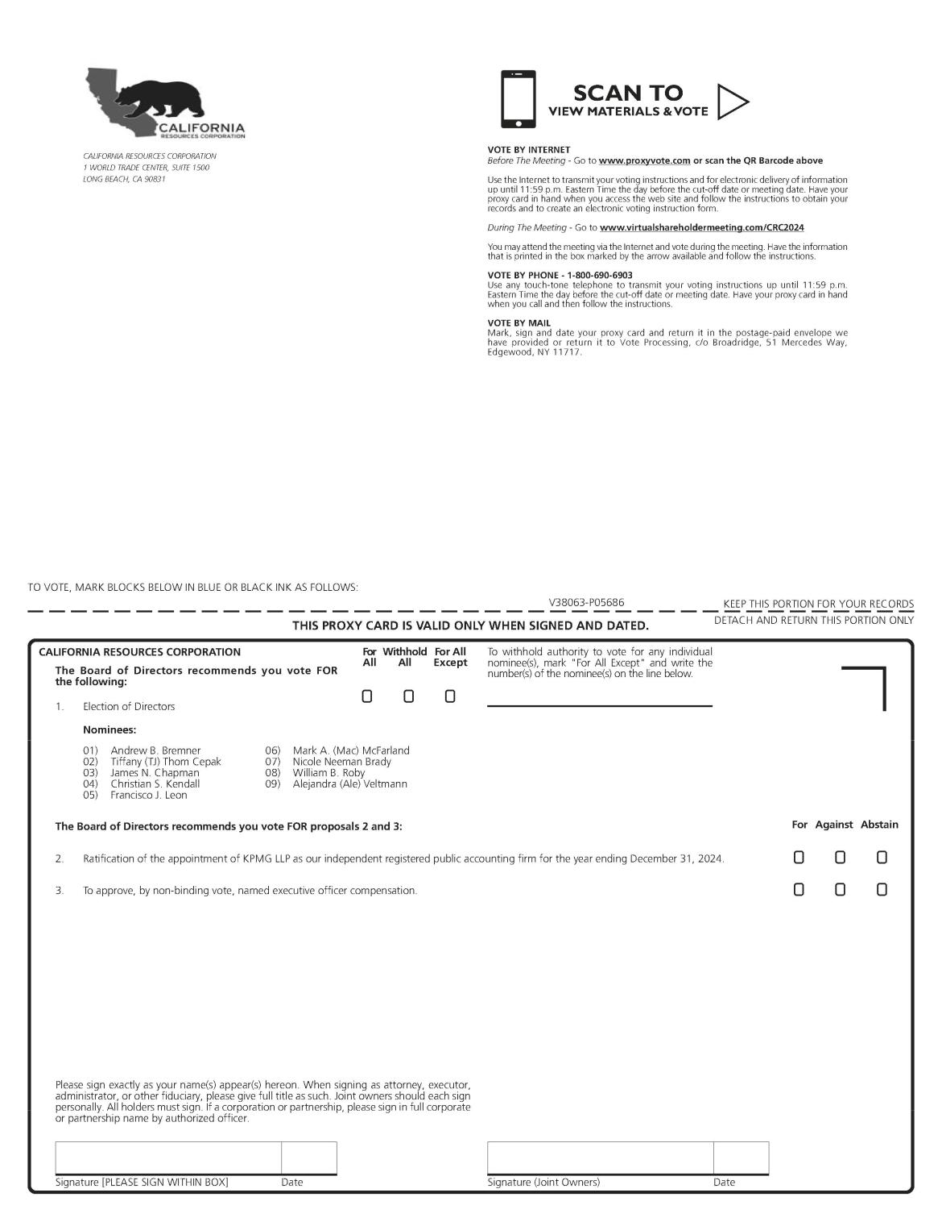CALIFORNI

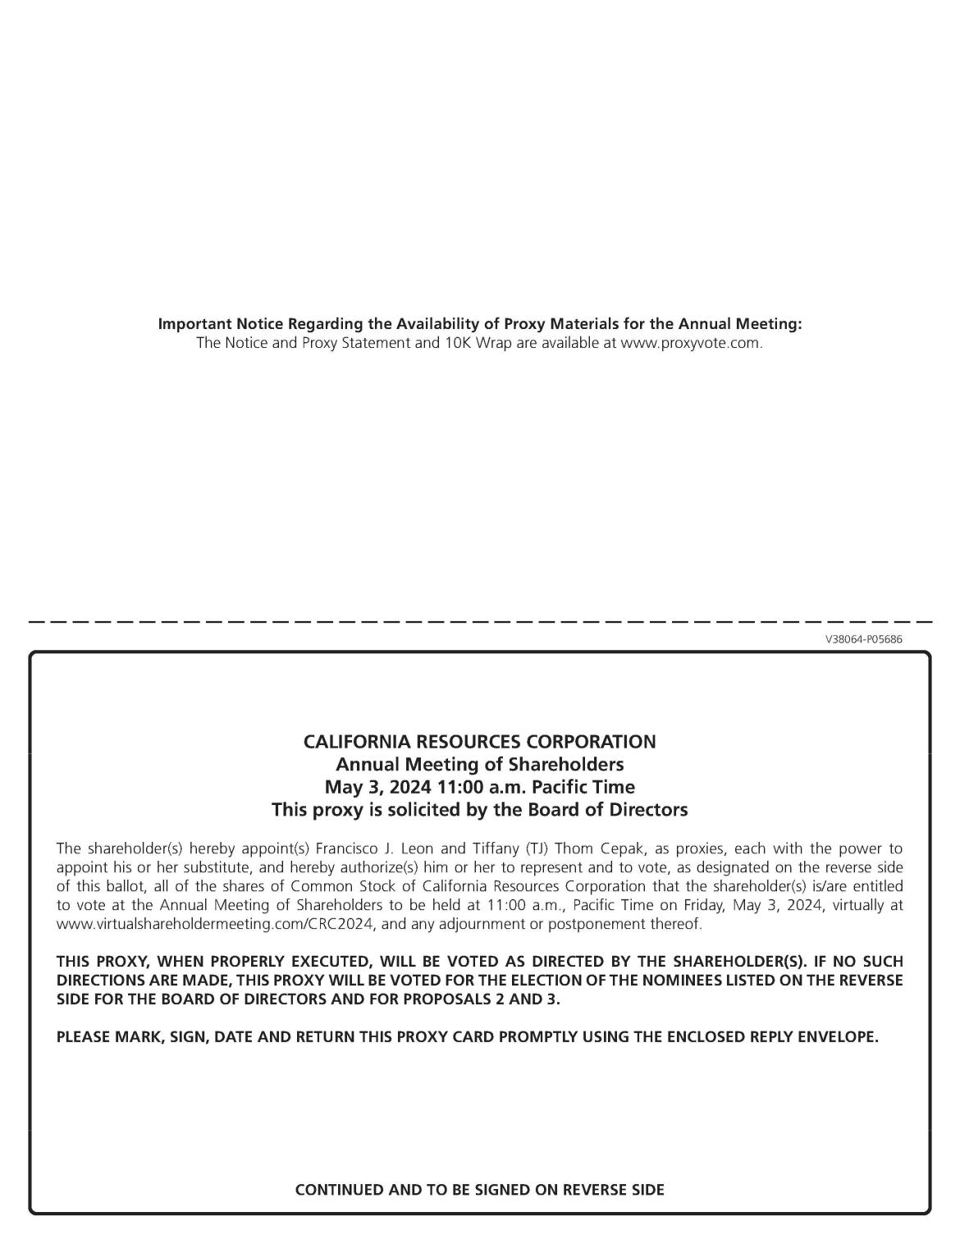

[INSERT PROXY NOTICE]

