UNITED STATES
SECURITIES AND EXCHANGE COMMISSION
Washington, D.C. 20549

SCHEDULE 14A
Proxy Statement Pursuant to Section 14(a) of
the Securities Exchange Act of 1934 (Amendment No. )

Filed by the Registrant ☒
Filed by a Party other than the Registrant ☐
Check the appropriate box:
☐ Preliminary Proxy Statement
☐ Confidential, for Use of the Commission Only (as permitted by Rule 14a-6(e)(2))
☐ Definitive Proxy Statement
☒ Definitive Additional Materials
☐ Soliciting Material under §240.14a-12

CALIFORNIA RESOURCES CORPORATION

(Name of Registrant as Specified In Its Charter)

(Name of Person(s) Filing Proxy Statement, if other than the Registrant)

Payment of Filing Fee (Check all boxes that apply):

☒ No fee required.

☐ Fee paid previously with preliminary materials.

☐ Fee computed on table in exhibit required by Item 25(b) per Exchange Act Rules 14a-6(i)(1) and
0-11.



Your Vote Counts! California Resources Corporation 2025 Annual Meeting Vote by May 1, 2025 11:59 PM ET 1 World Trade Center, Suite 1500 Long Beach, CA 90831 V66054-P27435 You invested in CALIFORNIA RESOURCES CORPORATION and it's time to vote! You have the right to vote on proposals being presented at the Annual Meeting. This is an important notice regarding the availability of proxy materials for the shareholder meeting to be held on May 2, 2025. Get informed before you vote View the Notice and Proxy Statement and 10K Wrap online OR you can receive a free paper or email copy of the material(s) by requesting prior to April 18, 2025. If you would like to request a copy of the material(s) for this and/or future shareholder meetings, you may (1) visit www.ProxyVote.com, (2) call 1-800-579-1639 or (3) send an email to sendmaterial@proxyvote.com. If sending an email, please include your control number (indicated below) in the subject line. Unless requested, you will not otherwise receive a paper or email copy. For complete information and to vote, visit www.ProxyVote.com Control # Smartphone users Point your camera here and vote without entering a control number Vote Virtually at the Meeting* May 2, 2025 11:00 AM PT Virtually at: www.virtualshareholdermeeting.com/CRC2025 *Please check the meeting materials for any special requirements for meeting attendance.

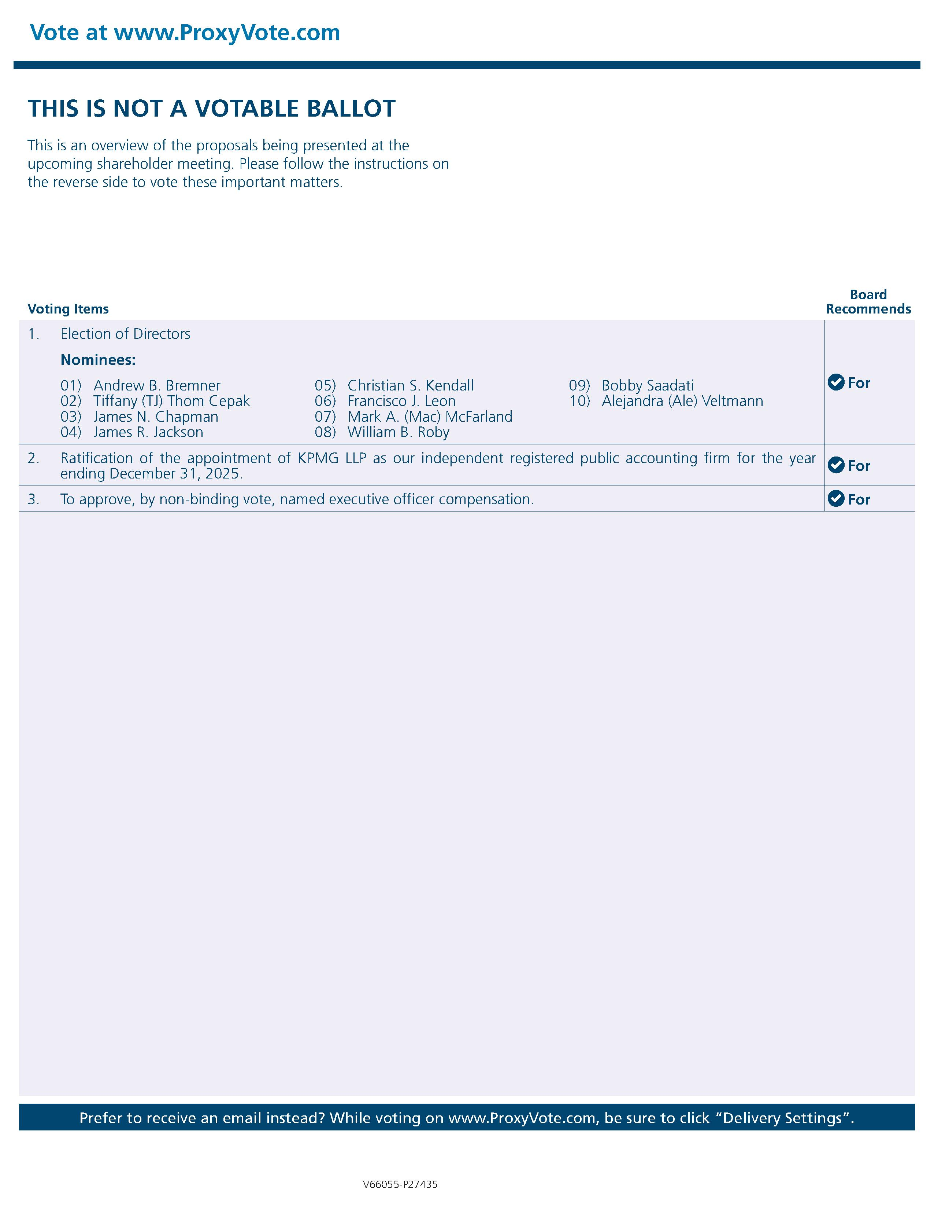

Vote at www.ProxyVote.com THIS IS NOT A VOTABLE BALLOT This is an overview of the proposals being presented at the upcoming shareholder meeting. Please follow the instructions on the reverse side to vote these important matters. Voting Items Board Recommends 1. Election of Directors Nominees: 01) Andrew B. Bremner 02) Tiffany (TJ) Thom Cepak 03) James N. Chapman 04) James R. Jackson 05) Christian S. Kendall 06) Francisco J. Leon 07) Mark A. (Mac) McFarland 08) William B. Roby 09) Bobby Saadati 10) Alejandra (Ale) Veltmann For 2. Ratification of the appointment of KPMG LLP as our independent registered public accounting firm for our fiscal year ending December 31, 2025. For 3. To approve, by non-binding vote, named executive officer compensation. For 4 Prefer to receive an email instead? While voting on www.ProxyVote.com, be sure to click "Delivery Settings". V66055-P27435

