UNITED STATES
SECURITIES AND EXCHANGE COMMISSION
Washington, D.C. 20549
SCHEDULE 14A INFORMATION
Proxy Statement Pursuant to Section 14(a) of
the Securities Exchange Act of 1934 (Amendment No. )
Filed by the Registrant ☒
Filed by a Party other than the Registrant ☐
Check the appropriate box:
☐ | Preliminary Proxy Statement
☐ | Confidential, for Use of the Commission Only (as permitted by Rule 14a-6(e)(2))
☐ | Definitive Proxy Statement
☒ | Definitive Additional Materials
☐ | Soliciting Material under §240.14a-12
CALIFORNIA RESOURCES CORPORATION
(Name of Registrant as Specified In Its Charter)
(Name of Person(s) Filing Proxy Statement, if other than the Registrant)
Payment of Filing Fee (Check the appropriate box):

☒ | No fee required.

☐ | Fee computed on table below per Exchange Act Rules 14a-6(i)(1) and 0-11.
 | (1) | Title of each class of securities to which transaction applies:

 | (2) | Aggregate number of securities to which transaction applies:

 | (3) | Per unit price or other underlying value of transaction computed pursuant to Exchange Act Rule 0-11 (set forth the amount on which the filing fee is calculated and state how it was determined):

 | (4) | Proposed maximum aggregate value of transaction:

 | (5) | Total fee paid:

☐ | Fee paid previously with preliminary materials.

☐ | Check box if any part of the fee is offset as provided by Exchange Act Rule 0-11(a)(2) and identify the filing for which the offsetting fee was paid previously. Identify the previous filing by registration statement number, or the Form or Schedule and the date of its filing.
 | (1) | Amount Previously Paid:

 | (2) | Form, Schedule or Registration Statement No.:

 | (3) | Filing Party:

 | (4) | Date Filed:

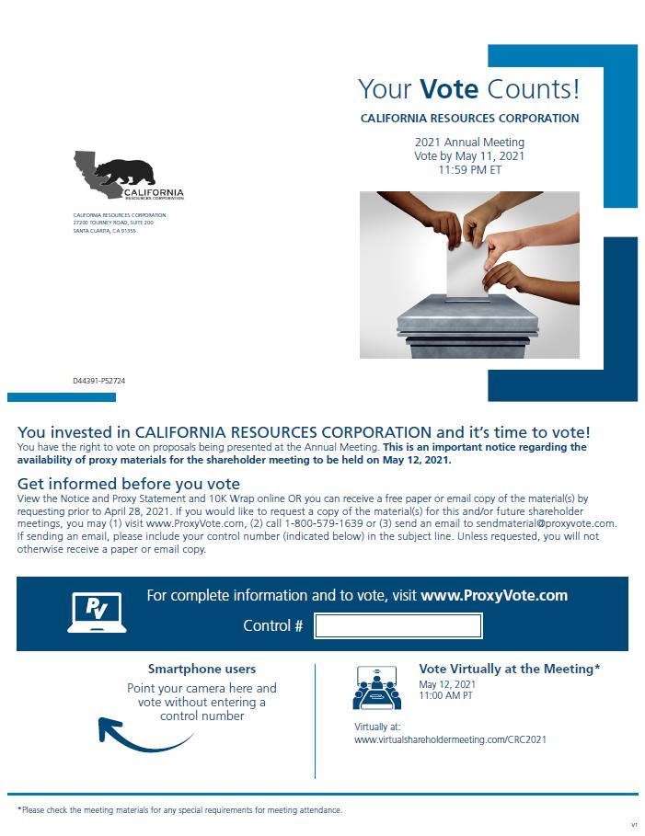
CALIFORNIA RESOURCES CORPORATION 27200 Tourney Road, Suite 200 Santa Clarita, CA 91355 Your Vote Counts! California Resources Corporation 2021 Annual Meeting Vote by Mail 11, 2021 11:59 PM ET D44391-P52724 You invested in CALIFORNIA RESOURCES CORPORATION and it’s time to vote! You have the right to vote on proposals being presented at the Annual Meeting. This is an important notice regarding the availability of proxy materials for the shareholder meeting to be held on May 12, 2021. Get informed before you vote View the Notice and Proxy Statement and 10K Wrap online OR you can receive a free paper or email copy of the material(s) by requesting prior to April 28, 2021. If you would like to request a copy of the material(s) for this and/or future shareholder meetings, you may (1) visit www.ProxyVote.com, (2) call 1-800-579-1639 or (3) send an email to sendmaterial@proxyvote.com. If sending an email, please include your control number (indicated below) in the subject line. Unless requested, you will not otherwise receive a paper or email copy. For complete information and to vote, visit www.ProxyVote.com Control # Smartphone users Point your camera here and vote without entering a control number Vote Virtually at the Meeting* May 12, 2021 11:00 AM PT Virtually at: www.virtualshareholdermeeting.com/CRC2021 *Please check the meeting materials for any special requirements for meeting attendance. V1

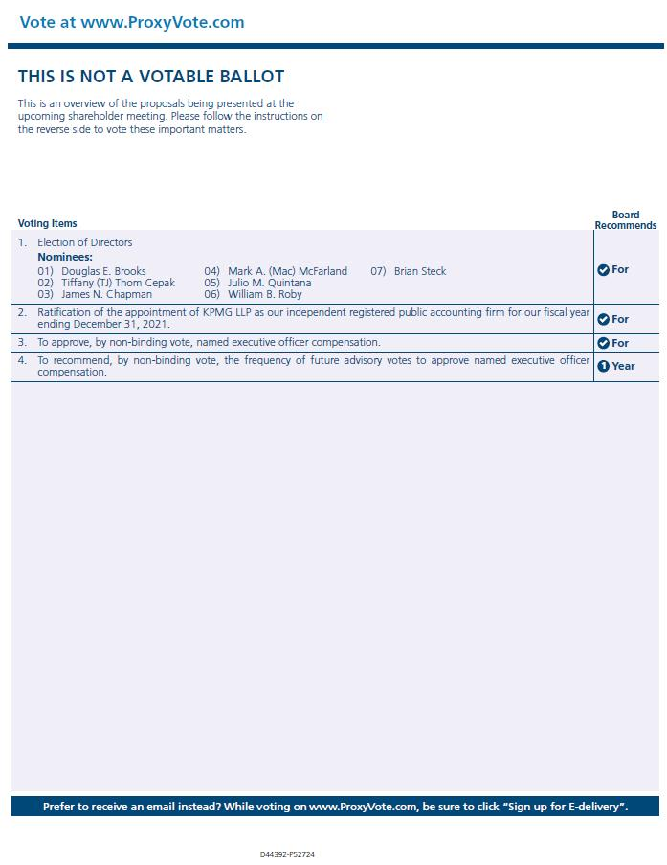
Vote at www.ProxyVote.com THIS IS NOT A VOTABLE BALLOT This is an overview of the proposals being presented at the upcoming shareholder meeting. Please follow the instructions on the reverse side to vote these important matters. Voting Items Board Recommends 1. Election of Directors Nominees: 01) Douglas E. Brooks 02) Tiffany (TJ) Thom Cepak 03) James N. Chapman 04) Mark A. (Mac) McFarland 05) Julio M. Quintana 06) William B. Roby 07) Brian Steck For 2. Ratification of the appointment of KPMG LLP as our independent registered public accounting firm for our fiscal year ending December 31, 2021. For 3. To approve, by non-binding vote, named executive officer compensation. For 4. To recommend, by non-binding vote, the frequency of future advisory votes to approve named officer compensation. 1 Year Prefer to receive an email instead? While voting on www.ProxyVote.com, be sure to click “Sign up for E-delivery”. D44392-P52724

